­­­

CampusNexus

Student Self-Service Student Accounts: Build an Online Payment Process Using Forms Builder and Workflow

Campus Management Corp.

Web Site

[www.campusmanagement.com](http://www.campusmanagement.com/)

Contact Information

Phone: 1.561.923.2500

Sales/Support: 1.561.999.9904

Toll Free: 1.800.483.9106

Facsimile: 1.561.999.0096

Address

Campus Management Corp.

5201 Congress Ave

Boca Raton, FL 33487 USA

Copyright

© 2016 Campus Management Corp.  All rights reserved.  Campus Management Corp, Campus Management, the Campus Management logo, CampusVue, Talisma, CampusLink, CampusNet and CampusCare are registered trademarks or service marks of Campus Management Corp. and/or its affiliates, and may be registered in the U.S., other countries, or both.  Other third party trademarks or service marks are property of their respective owners.  Information is subject to change.

Contents

Resources 1

Angular JS 1

Understanding OData 3

Validation Regex property in Forms Builder 3

Log File Location & Names 3

Agenda 4

Introduction 5

Course Objectives 5

Target Audience 5

Course Prerequisites 5

Lesson 1: Create a Student Self-Service Form and Supporting Workflow for Accepting an Online Payment 6

Exercise: Create an Online Payment Form and Supporting Workflow 6

Lesson 2: Validate the Form and Supporting Workflow 90

Exercise: Validate the Student Self-Service Form and Supporting Workflow for Accepting an Online Payment 91

# Resources

[www.mycampusinsight.com](http://www.mycampusinsight.com)

**Note**: If you do not have a MyCampusInsight login, contact your Customer Enablement Manager.

<https://github.com/campusmanagement>

<http://community.campusmgmt.com>

## Angular JS

<https://docs.angularjs.org/guide/introduction>:

AngularJS is a structural framework for dynamic web apps. It lets you use HTML as your template language and lets you extend HTML's syntax to express your application's components clearly and succinctly. AngularJS's data binding and dependency injection eliminate much of the code you would otherwise have to write. In addition, it all happens within the browser, making it an ideal partner with any server technology.

AngularJS is what HTML would have been, had it been designed for applications. HTML is a great declarative language for static documents. It does not contain much in the way of creating applications, and as a result building web applications is an exercise in what do I have to do to trick the browser into doing what I want?

The impedance mismatch between dynamic applications and static documents is often solved with:

* **a library** - a collection of functions, which are useful when writing web apps. Your code is in charge and it calls into the library when it sees fit. E.g., jQuery.
* **frameworks** - a particular implementation of a web application, where your code fills in the details. The framework is in charge and it calls into your code when it needs something app specific. E.g., durandal, ember, etc.

AngularJS takes another approach. It attempts to minimize the impedance mismatch between document centric HTML and what an application needs by creating new HTML constructs. AngularJS teaches the browser new syntax through a construct we call directives. Examples include:

* Data binding, as in {{}}.
* DOM control structures for repeating, showing and hiding DOM fragments.
* Support for forms and form validation.
* Attaching new behavior to DOM elements, such as DOM event handling.
* Grouping of HTML into reusable components.

**Angular JS Resources**

<https://www.w3schools.com/js/js_comparisons.asp>

<https://teropa.info/images/angular_expressions_cheatsheet.pdf>

<https://docs.angularjs.org/guide/expression>

## Understanding OData

<http://www.odata.org/getting-started/understand-odata-in-6-steps/>

OData (Open Data Protocol) is a standard that defines the best practice for building and consuming RESTful APIs. OData helps you focus on your business logic while building RESTful APIs without having to worry about the approaches to define request and response headers, status codes, HTTP methods, URL conventions, media types, payload formats and query options etc. OData also guides you about tracking changes, defining functions/actions for reusable procedures and sending asynchronous/batch requests etc. Additionally, OData provides facility for extension to fulfil any custom needs of your RESTful APIs.

OData RESTful APIs are easy to consume. The OData metadata, a machine-readable description of the data model of the APIs, enables the creation of powerful generic client proxies and tools. Some of them can help you interact with OData even without knowing anything about the protocol.

To learn more about the OData query syntax, see [http://www.OData.org/](http://www.odata.org/) and look for "Basic Tutorial” and "Advanced Tutorial”.

## Validation Regex property in Forms Builder

***Validation Regex*** is the regular expression pattern to validate the input. Use site like <http://RegExLib.com> to search and test ***Regex*** patterns, or construct your own with ***Regex*** tools like [Expresso](https://www.codeproject.com/Articles/3669/Expresso-A-Tool-for-Building-and-Testing-Regular-E). If the user input does not produce a Regex match, the "***Validation message***" will be displayed.

***Examples***:

***Regex*** that enforces a minimum of 11 digits for a phone number where the first digit must be "1": 1\d{10}

***Regex*** that enforces a phone number in the format (###)###-####: ^\([0-9]{3}\)[0-9]{3}\-[0-9]{4}$

***Regex***that matches a hyphen-separated social security number: ^\d{3}-\d{2}-\d{4}$

## Log File Location & Names

Log files for Forms Builder are located at:

\\server\c$\logs - (where server is the hostname for your environment)  
Look for FormsBuilderRenderer-*date*.txt & FormsBuilderDesigner-*date*.txt

# Agenda

|  |  |  |
| --- | --- | --- |
| **Time** | **Topic** | **Activity** |
| 8:30 – 8:45 AM | Course Overview and Introductions |  |
| 8:45 – 9:00 AM | Student Self-Service Online Payment Process Overview | Demo |
| 9:00 - 10:00 AM | Lesson 1: Create a Student Self-Service Form and Supporting Workflow for Accepting an Online Payment | Exercise: Create an Online Payment Form and Supporting Workflow |
| 10:00 – 10:15 AM | **Break** |  |
| 10:15 - 11:30 AM | Lesson 1: Create a Student Self-Service Form and Supporting Workflow for Accepting an Online Payment Continued |  |
| 11:30 - 12:00 PM | Lesson 2: Validate the Form and Supporting Workflow | Exercise: Validate the Student Self-Service Form and Supporting Workflow for Accepting an Online Payment |

# Introduction

This is an advanced, hands-on session. Participants will learn how to build a student self-service Online Payment Process using Forms Builder, Workflow, and CampusNexus Student.

## Course Objectives

Upon completion of this session, participants will be able to:

* Build an Online Payment Form Sequence
* Automate the Online Payment Process utilizing Workflow and CampusNexus Student configurations

## Target Audience

Technical Business Analysts, System Administrators, Database Programmer, IT staff members

## Course Prerequisites

Prerequisite Knowledge:

* Understanding of Business Processes
* Understanding of CampusNexus Student Application and Schema and/or CampusNexus CRM Application and Schema
* Aware of .NET Technologies and Understanding of VB.Net
* Create Variables, Assign Data Types, and a Basic Understanding of Development Languages
* Awareness of:
  + Windows Workflow Foundation (4.5)
  + CSS Themes
* SQL Knowledge
  + Ability to create SQL jobs, call Stored procedures and Write Queries
* General Development Knowledge of Variables, Arguments, Control Logic, Exception Handling, Debugging etc.

# Lesson 1: Create a Student Self-Service Form and Supporting Workflow for Accepting an Online Payment

In this lesson, you will create an Application for Graduation process where the student will electronically sign the application as well as submit an Online Payment for the Graduation Fee.

## Exercise: Create an Online Payment Form and Supporting Workflow

1. Navigate to ***Google Chrome*** and Launch ***Designer*** from the ***Bookmarks Bar***.



1. ***Sign in*** using the following credentials:

***administrator***

***testing***

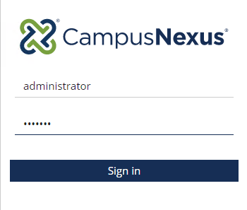

1. Select the ***Form Designer*** to start creating your form.

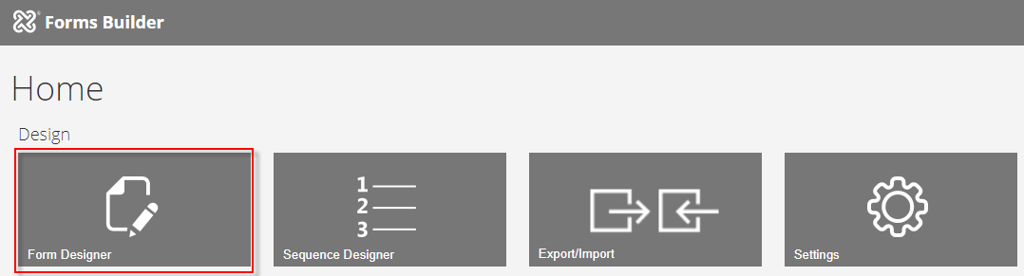

1. Select ***New.*** A ***1 Column*** panel is added to the ***Layout*** pane in the Designer.

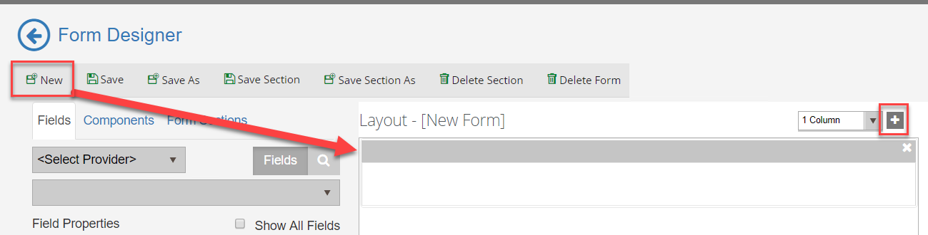

1. From the ***Components*** tab, drag an ***HTML*** component into the panel of the ***Layout*** pane.

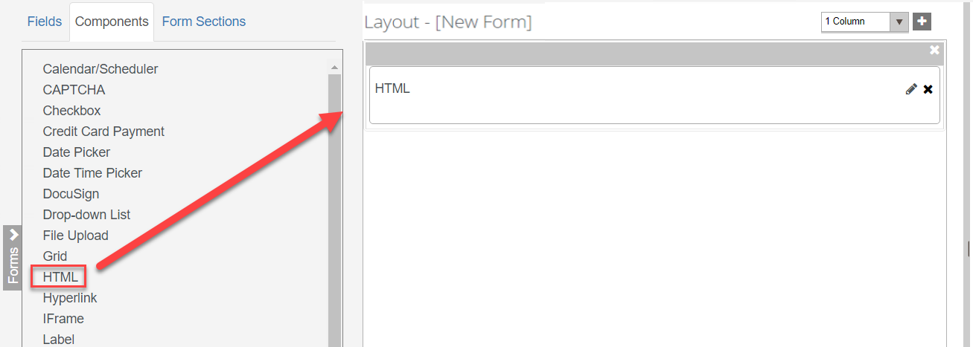

1. Enter the following for the ***HTML*** component in the ***HTML*** property of the ***Control Property Settings*** pane:

***<h3 style="color:#000066"><b>Application for Graduation</b></h3>***

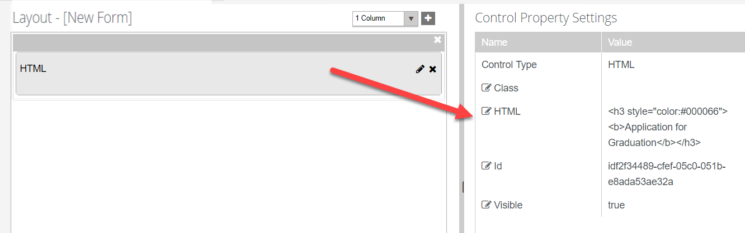

1. Click the ***+ and*** select the column option to add a ***2 Column*** panel to the ***Layout*** pane.

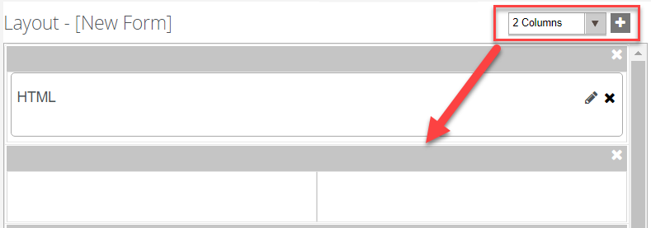

1. From the ***Components*** tab, drag two ***HTML*** components into the panel of the ***Layout*** pane.

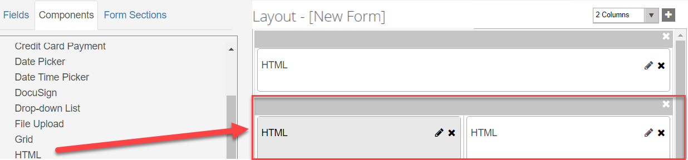

1. For the first ***HTML*** component, enter the following in the ***HTML*** property of the ***Control Property Settings*** pane:

***<b>Student Information:</b>***

***Note:*** The second ***HTML*** component is used as a place holder so we will not enter anything in the ***Control Property Settings*** pane for the second component.

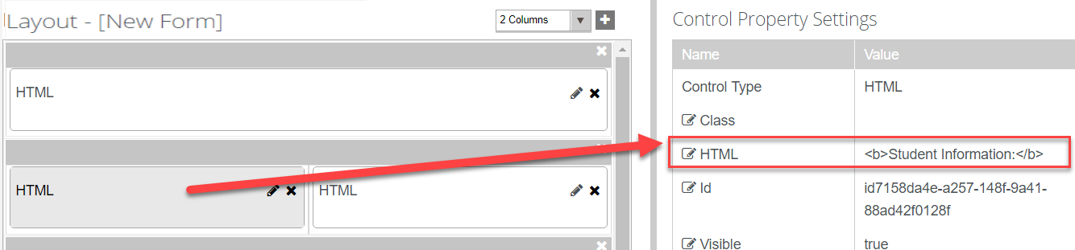

1. Select the ***Fields*** tab and under ***Student*** select the ***Student*** entity. Drag the following fields into the second panel below the ***HTML*** components as shown below:

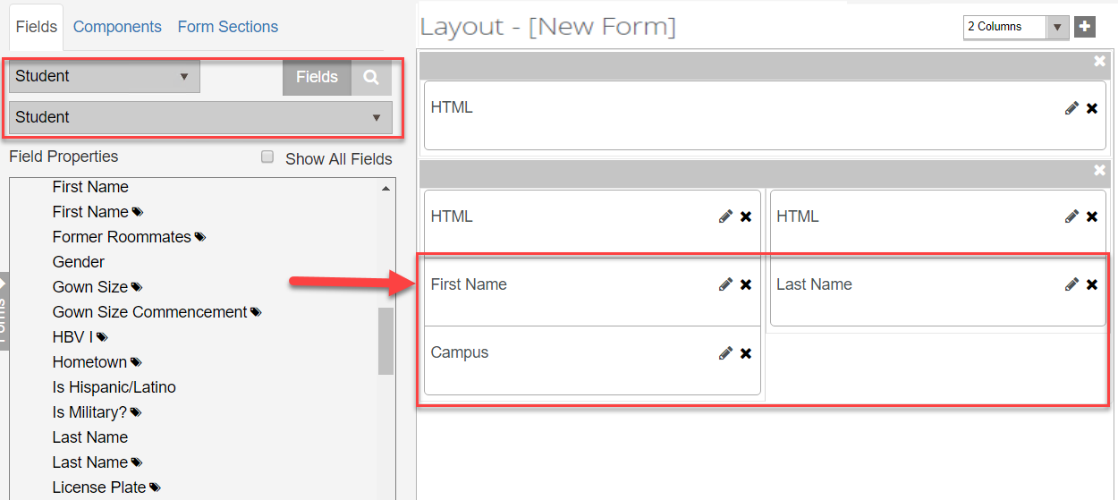

1. Make sure the ***Read-only*** property in the ***Control Property Settings*** pane is set to ***true*** for the ***First Name*** and ***Last Name*** fields.

 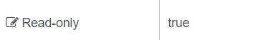

1. Make sure the ***Required*** property in the ***Control Property Settings*** pane is set to ***false*** for the ***First Name*** and ***Last Name*** fields.

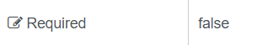

1. Make sure the ***Disabled*** property in the ***Control Property Settings*** pane is set to ***true*** for the ***Campus*** field.

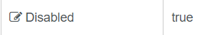

1. Make sure the ***Required*** property in the ***Control Property Settings*** pane is set to ***false*** for the ***Campus*** field.



1. From the ***Components*** tab, drag a ***Drop-down List*** component into the second panel of the ***Layout*** pane next to the ***Campus*** field as shown below.

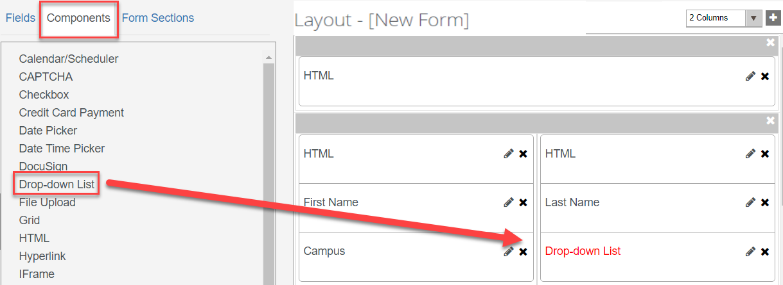

1. Select the ***pencil icon*** on the component to edit the ***Short Description.*** Update it to read ***Program*** and click ***Save.***

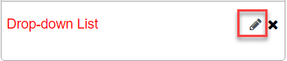

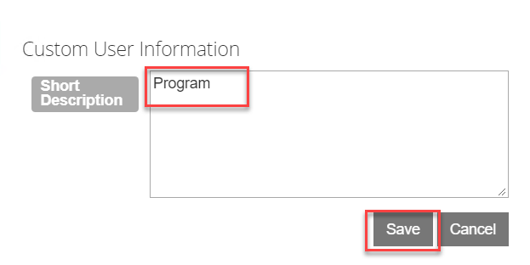

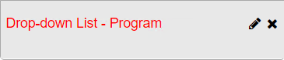

1. Update the properties for the ***Drop-down List - Program*** field in the ***Control Property Settings*** pane:

***Label- Program Version***

***Lookup Display Member – ProgramVersionName (We want to display the Name of the Program Version in our drop-down list.)***

***Lookup Query – StudentEnrollmentPeriods?$filter=Student/Id eq {{vm.models.studentEntity.Id}}&$select=Id,ProgramVersionName&$expand=Student($select=Id) (We want to filter the program versions for the student.)***

***Lookup Sort Member – ProgramVersionName (We want to sort our drop-down list by the Program Version Name.)***

***Lookup Value Member – Id (We will lookup our values based on the Id for the Student.)***

***Model – vm.models.studentEnrollmentPeriodEntity.Id (We will return the studentEnrollmentPeriodEntity.Id to pass back into our WF.)***

***Product – Student (This specifies the product we are querying the data from.)***

***Required – true (This makes the field required.)***

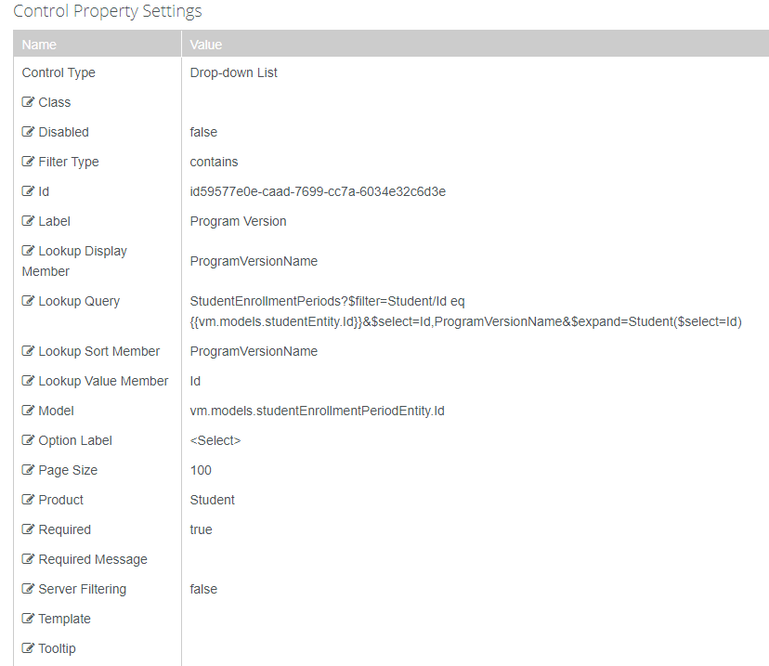

1. Click the ***+ and*** select the column option to add a ***1 Column*** panel to the ***Layout*** pane.

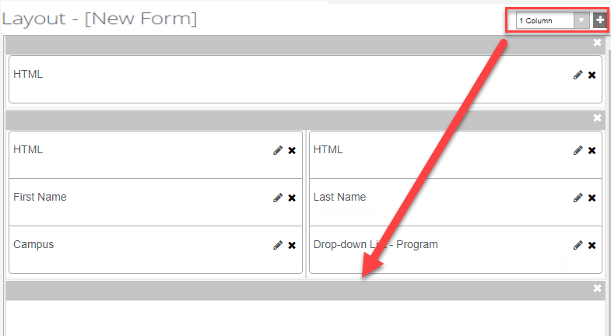

1. From the ***Components*** tab, drag an ***HTML*** component into the panel of the ***Layout*** pane.

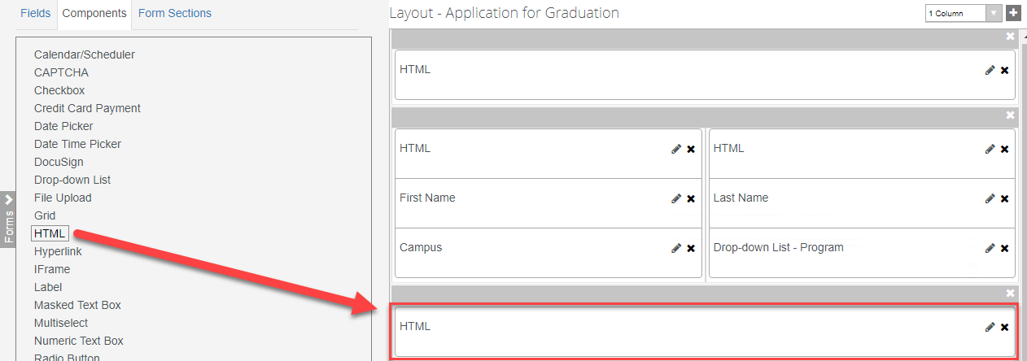

1. For the ***HTML*** component, enter the following in the ***HTML*** property of the ***Control Property Settings*** pane:

**<b>Name to be Displayed on Diploma:</b>**

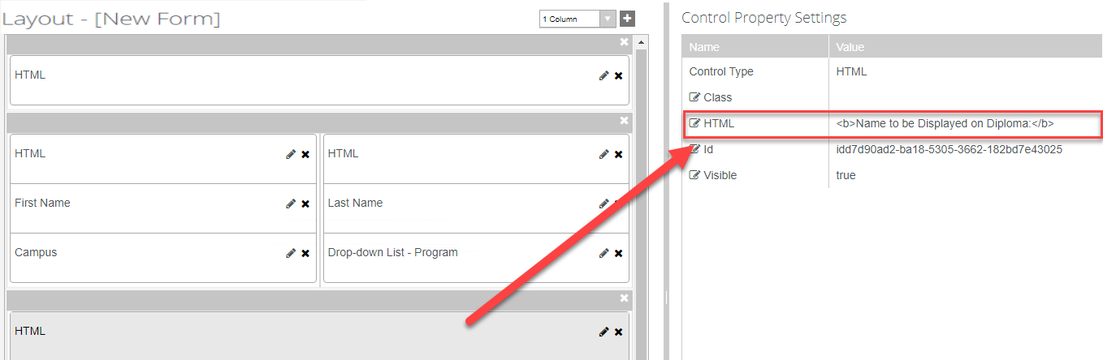

1. Select the ***Fields*** tab and under ***Student*** select the ***Student*** entity. Drag the ***Diploma Name*** field into the panel below the ***HTML*** component as shown below:

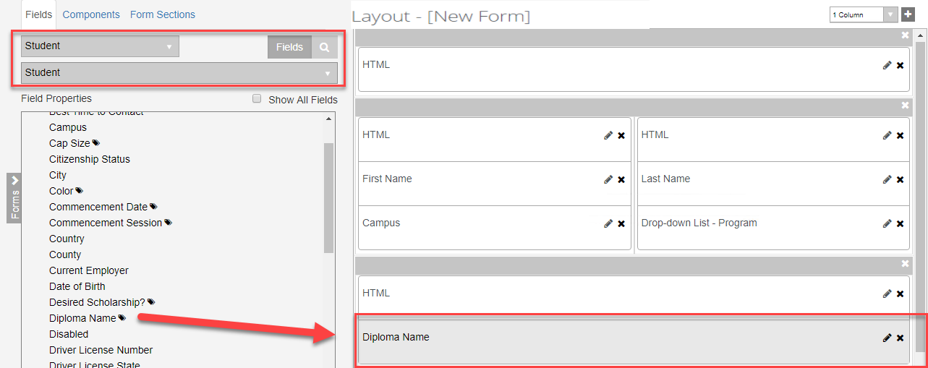

1. Make sure the ***Required*** property in the ***Control Property Settings*** pane is set to ***true*** for the ***Diploma Name*** field.

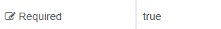

1. Click the ***+ and*** select the column option to add a ***1 Column*** panel to the ***Layout*** pane.

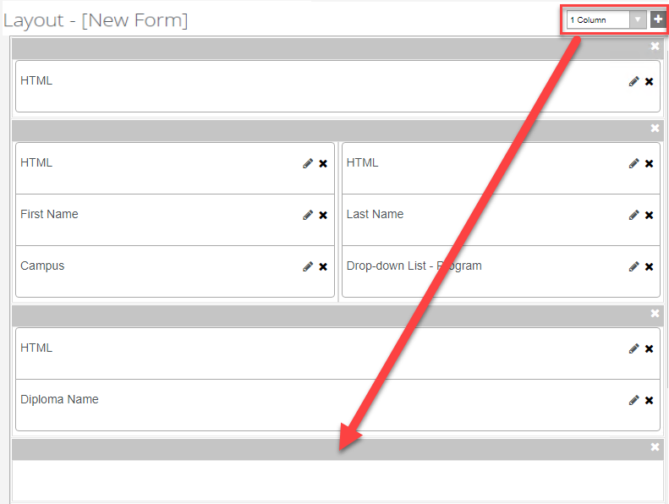

1. From the ***Components*** tab, drag an ***HTML*** component into the panel of the ***Layout*** pane.

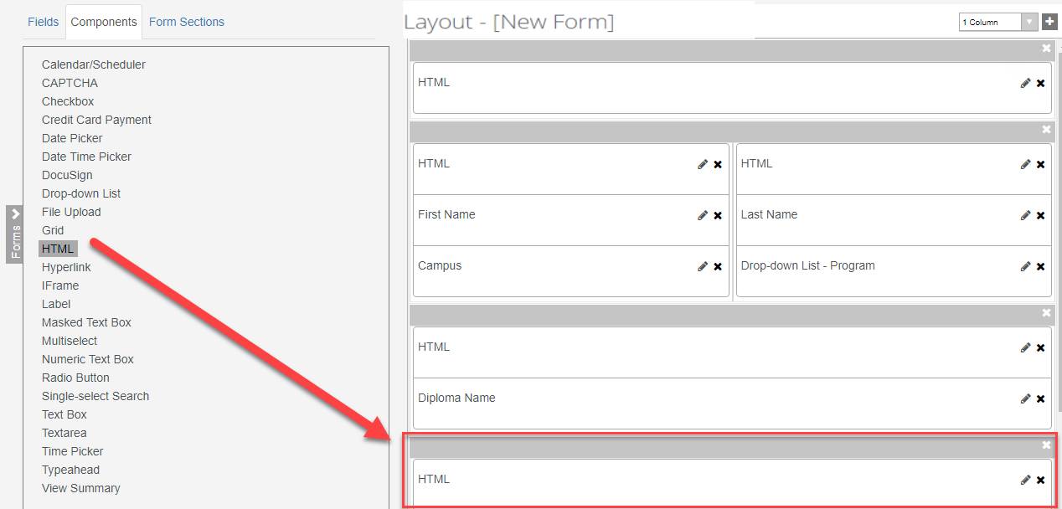

1. For the ***HTML*** component, enter the following in the ***HTML*** property of the ***Control Property Settings*** pane:

***<b>Mailing Address for Diploma:</b>***

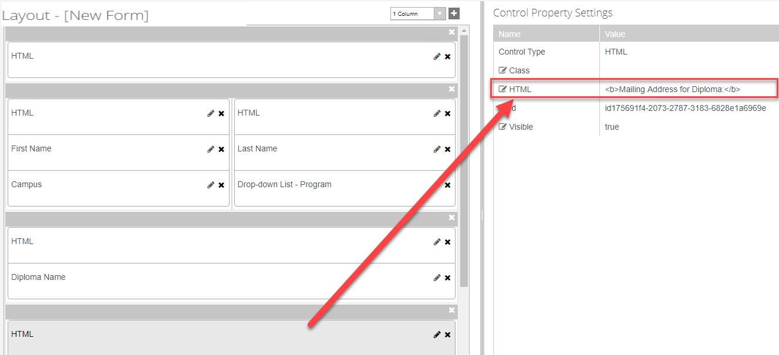

1. Select the ***Fields*** tab and under ***Student*** select the ***Student Relationship Address*** entity. Drag the ***Street Address*** field into the panel below the ***HTML*** component as shown below:

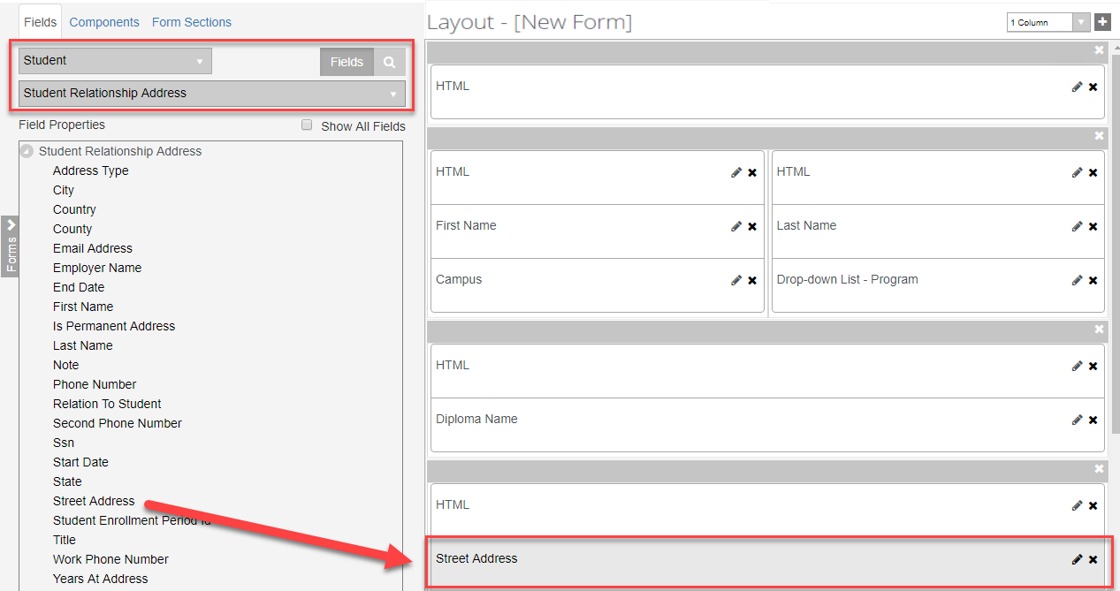

1. Make sure the ***Required*** property in the ***Control Property Settings*** pane is set to ***true*** for the ***Street Address*** field.



1. Click the ***+ and*** select the column option to add a ***3 Column*** panel to the ***Layout*** pane.

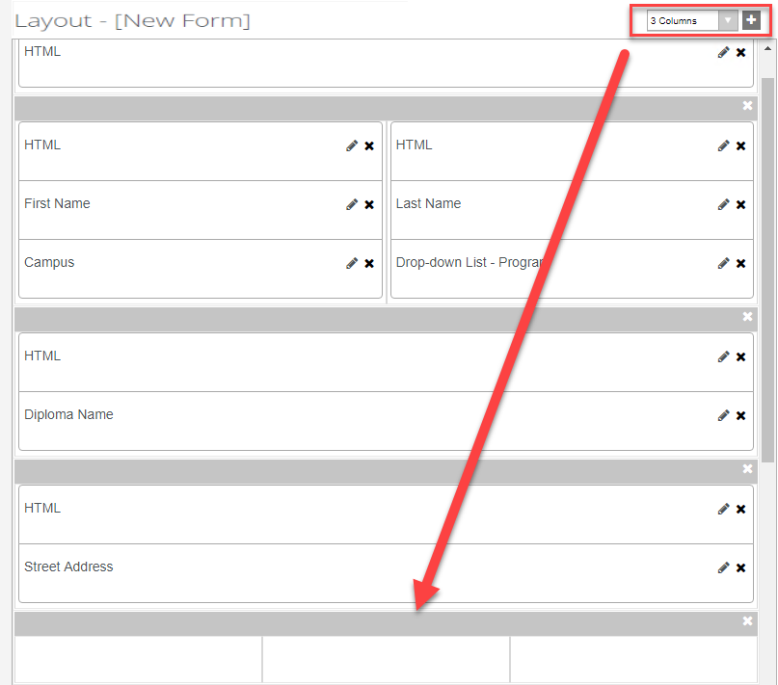

1. Select the ***Fields*** tab and under ***Student*** select the ***Student Relationship Address*** entity. Drag the ***City, State,*** and ***ZIP Code/Postal Code*** fields into the panel as shown below:

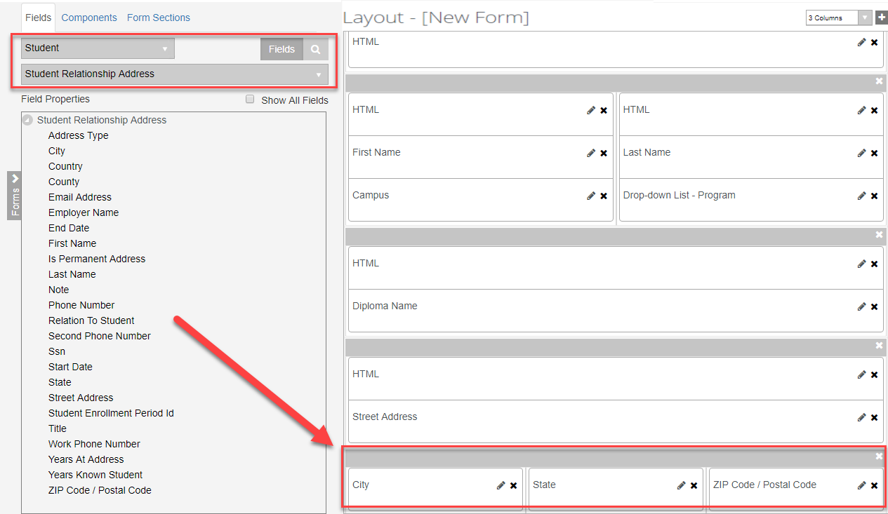

1. Make sure the ***Required*** property in the ***Control Property Settings*** pane is set to ***true*** for the ***City, State,*** and ***ZIP Code/Postal Code*** fields.



1. Click the ***+ and*** select the column option to add a ***3 Column*** panel to the ***Layout*** pane.

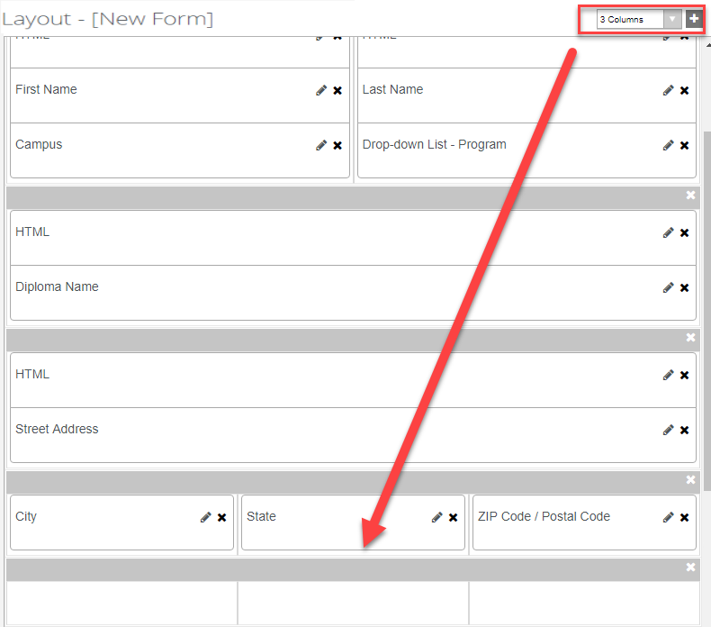

1. From the ***Components*** tab, drag three ***HTML*** components into the panel of the ***Layout*** pane.

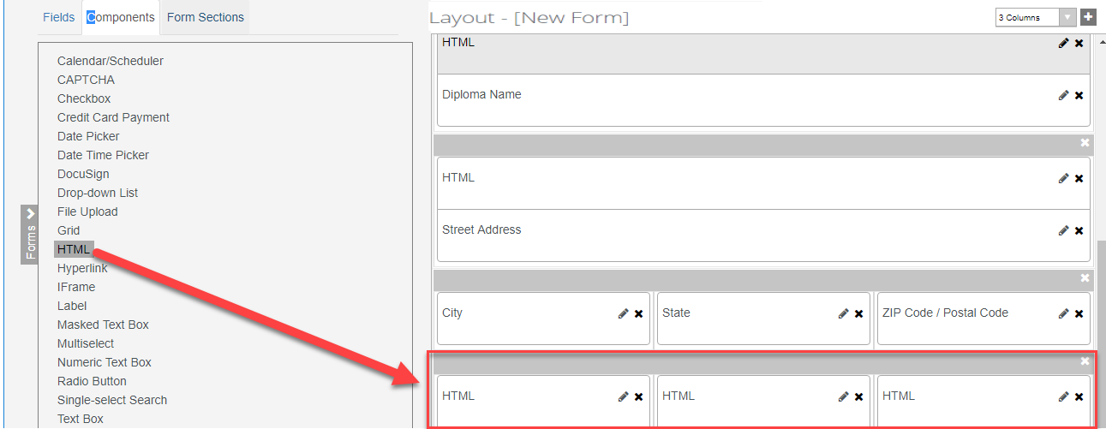

1. For the first ***HTML*** component, enter the following in the ***HTML*** property of the ***Control Property Settings*** pane:

***<b>Information Needed for Commencement Ceremony:</b>***

***Note:*** The second and third ***HTML*** components are used as place holders so we will not enter anything in the ***Control Property Settings*** pane for these components.

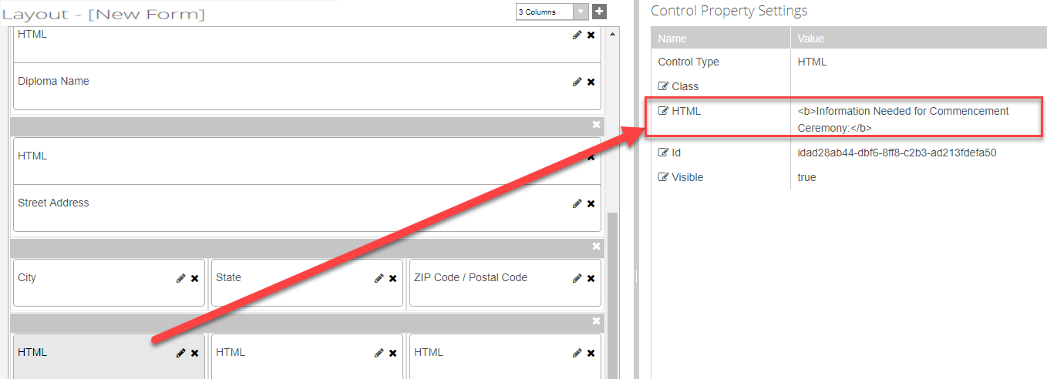

1. Select the ***Fields*** tab and under ***Student*** select the ***Student*** entity. Drag the ***Commencement Session, Cap Size,*** and ***Gown Size Commencement*** fields into the panel below the ***HTML*** components as shown below:

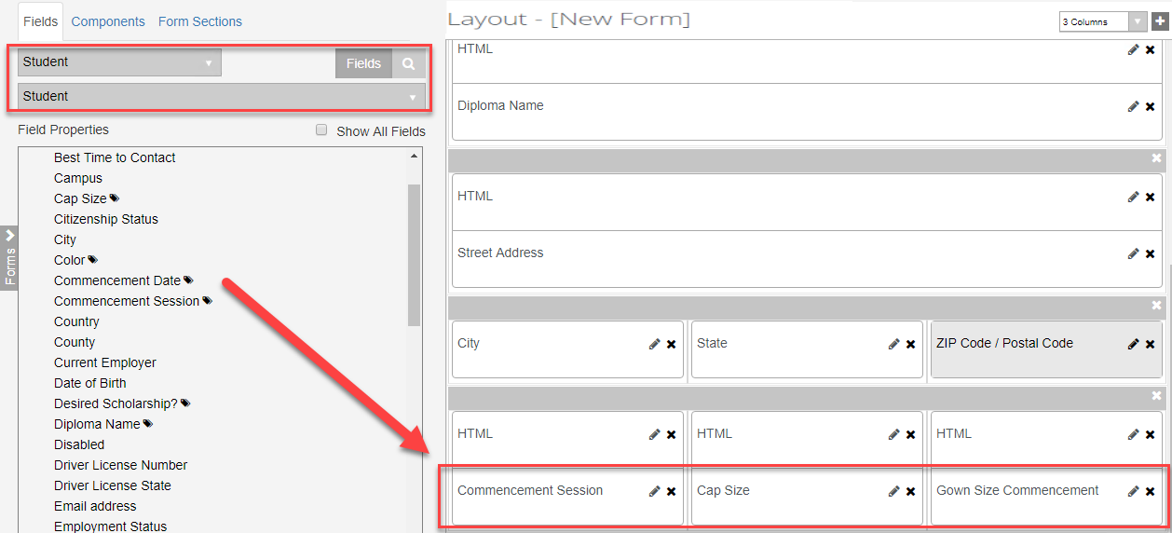

1. Make sure the ***Required*** property in the ***Control Property Settings*** pane is set to ***true*** for the ***Commencement Session, Cap Size,*** and ***Gown Size Commencement*** fields.



1. Click the ***+ and*** select the column option to add a ***2 Column*** panel to the ***Layout*** pane.

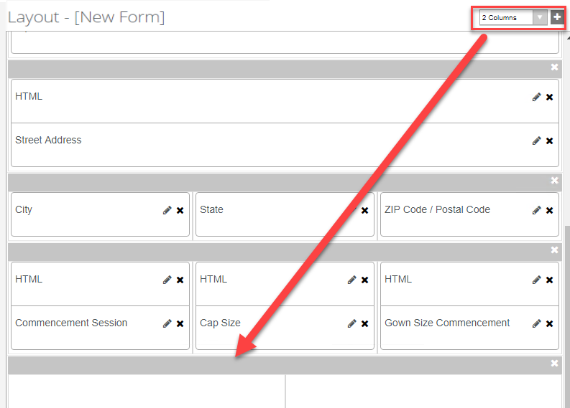

1. From the ***Components*** tab, drag two ***HTML*** components into the panel of the ***Layout*** pane.

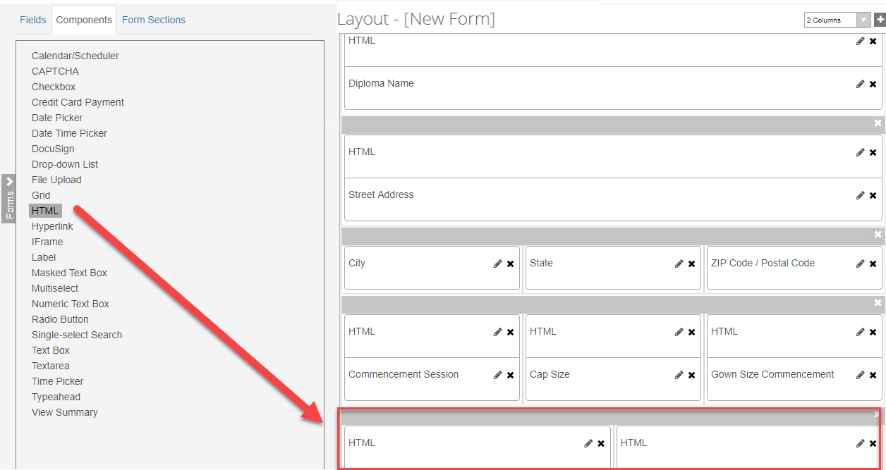

1. For the first ***HTML*** component, enter the following in the ***HTML*** property of the ***Control Property Settings*** pane:

***<b>By clicking Continue, you will be redirected to pay a $75 graduation fee. Once payment is received you will be required to electronically sign the Application for Graduation.</b>***

***Note:*** The second ***HTML*** component is used as a place holder so we will not enter anything in the ***Control Property Settings*** pane for this component.

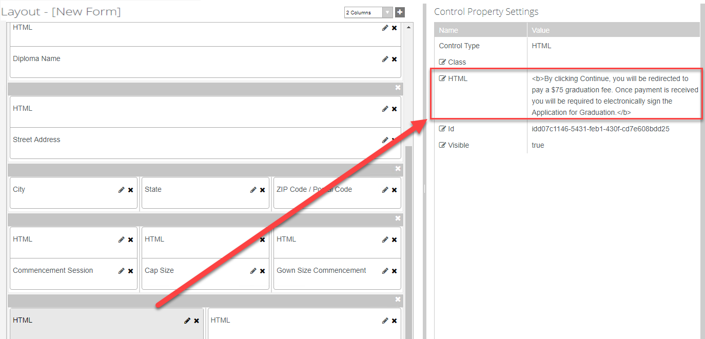

1. From the ***Components*** tab, drag two ***DocuSign*** components into the panel of the ***Layout*** pane below the ***HTML*** components.

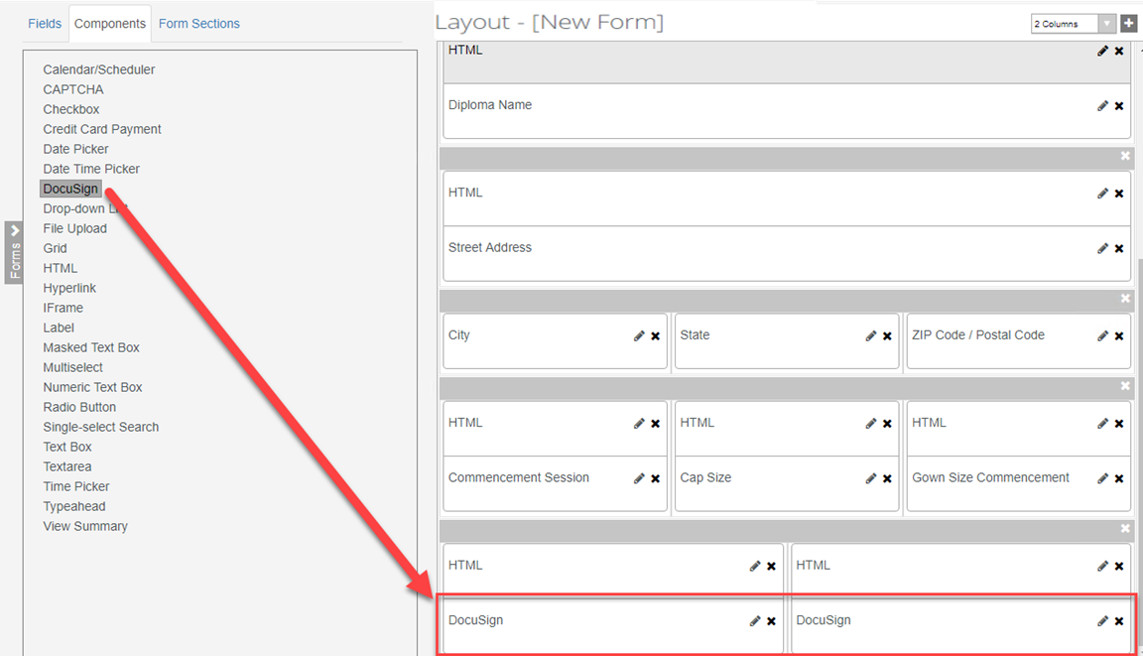

1. Update the properties in the ***Control Property Settings*** pane as shown below for the first ***DocuSign*** component:

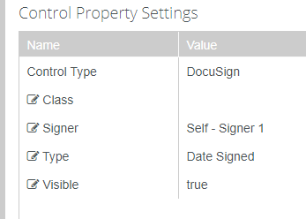

1. Update the properties in the ***Control Property Settings*** pane as shown below for the second ***DocuSign*** component:

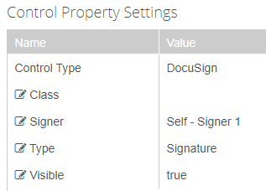

1. ***Save*** and name your Form with your initials at the end as shown below.

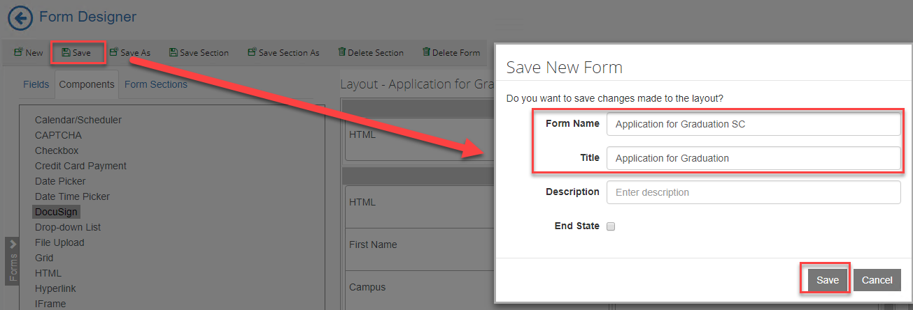

1. Change the column drop-down to ***2 Columns*** and select ***New*** to create a new form with a ***2 Column*** panel.

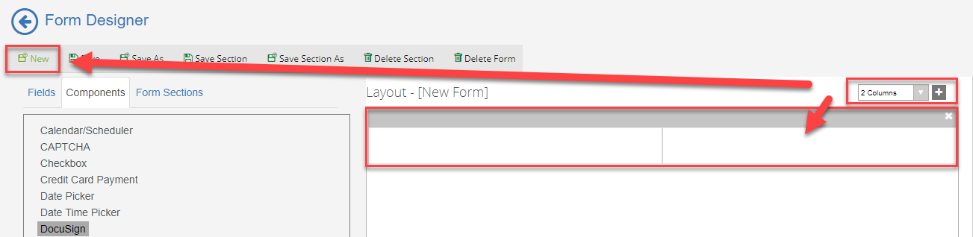

1. Add a ***3 Column*** and ***1 Column*** panel to the ***Layout*** pane.

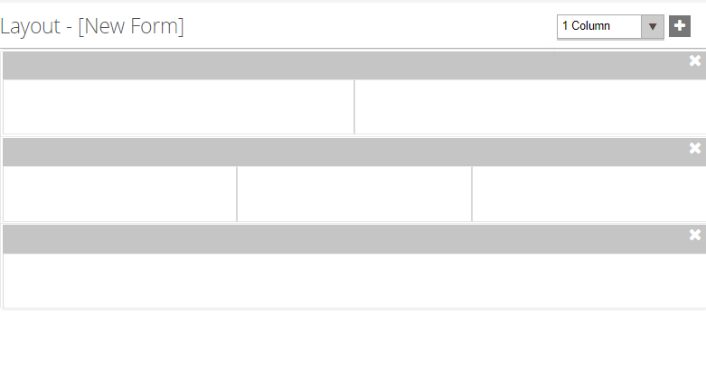

1. Select the ***Fields*** tab and under ***Student*** select the ***Student*** entity. Drag the following fields into the first panel as shown below:

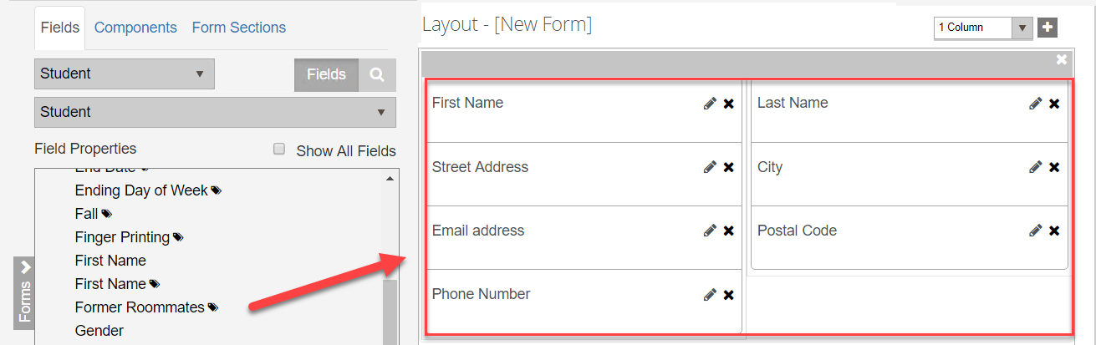

1. Select the ***Fields*** tab and under ***Student*** select the ***Admissions Deposit*** entity. Drag the following properties into the second panel as shown below:

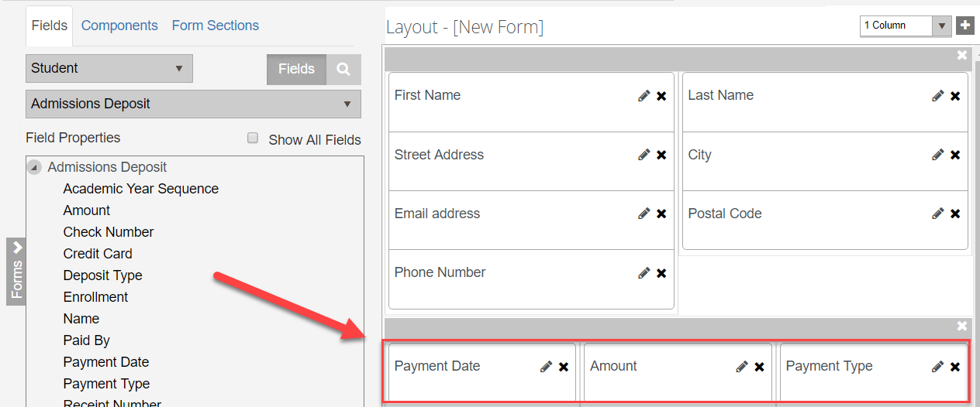

1. Make sure the ***Required*** property in the ***Control Property Settings*** pane is set to ***true*** for the ***Payment Date*** field on the form.

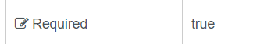

1. Make the ***Read-only*** property ***true*** for the ***Amount*** field.

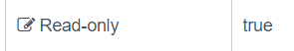

1. Make the ***Disabled*** property ***true*** for the ***Payment Type*** field.

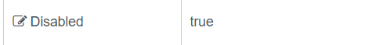

1. From the ***Components*** tab, drag a ***Credit Card Payment*** component and an ***HTML*** component into the last panel of the ***Layout*** pane.

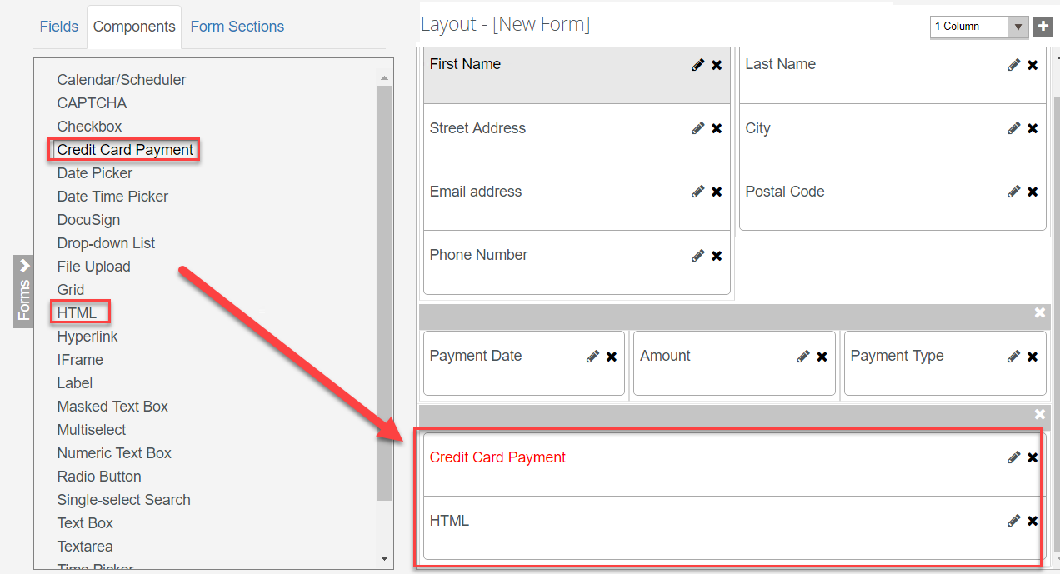

1. Update the properties for the ***Credit Card Payment*** component in the ***Control Property Settings*** pane as shown below:

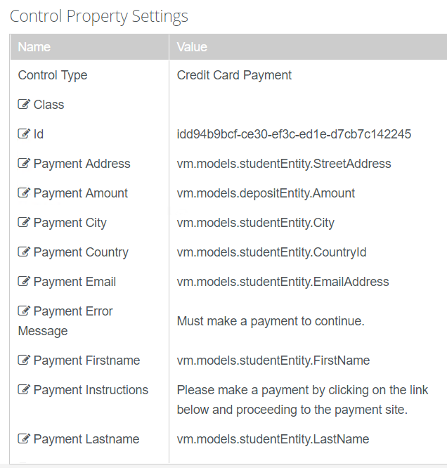

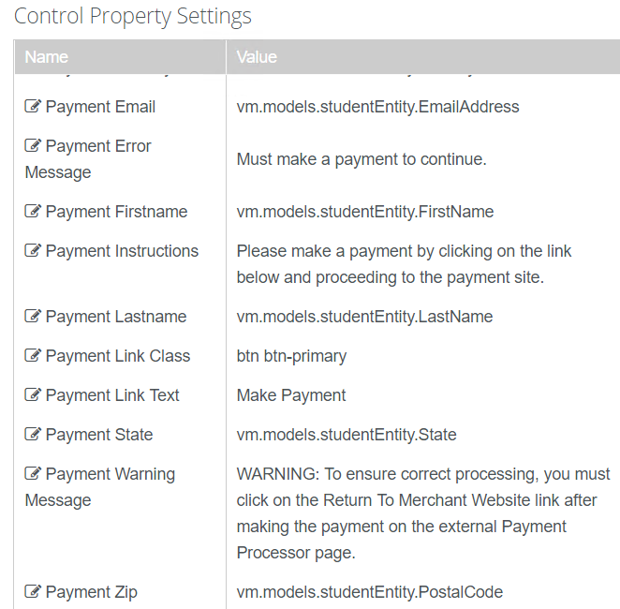

1. Enter the following for the ***HTML*** component in the ***HTML*** property of the ***Control Property Settings*** pane:

***<style> .navbar-default { display: none} </style>***

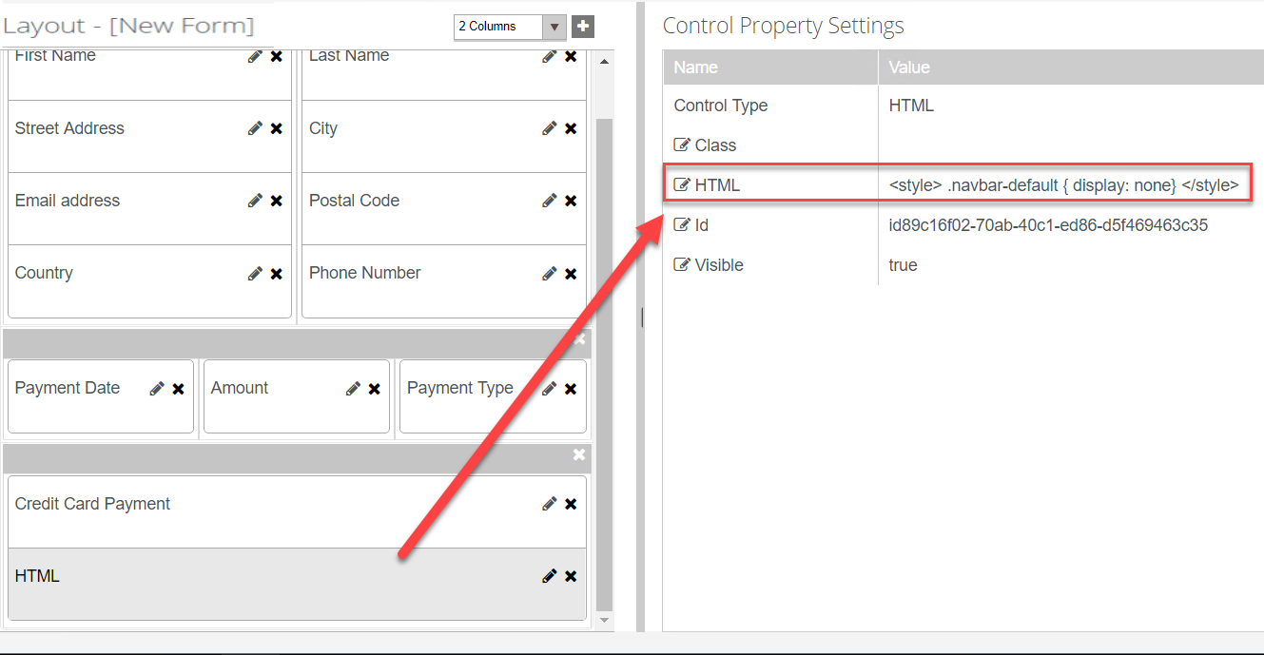

1. ***Save*** and name your Form with your initials at the end as shown below.

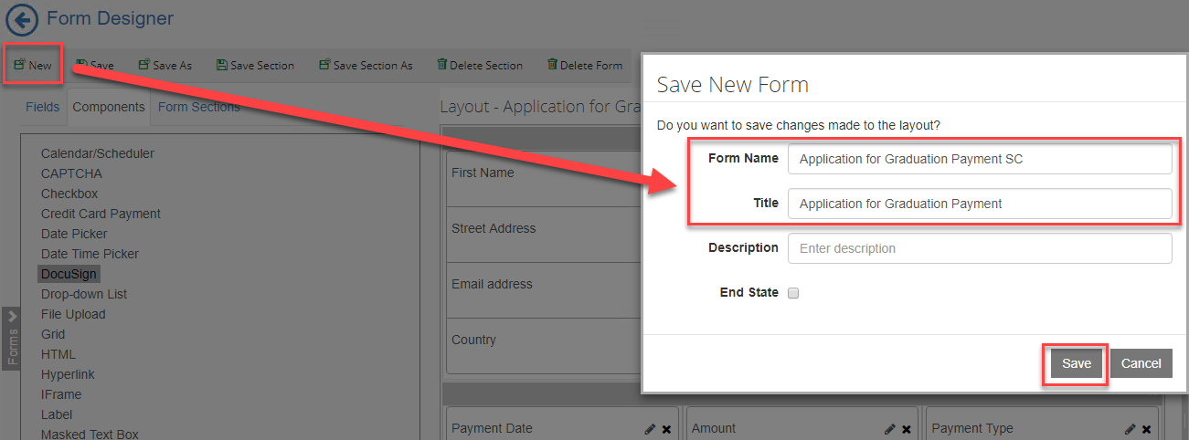

1. On the top left bar, click on the ***arrow*** to navigate out of Form Designer.

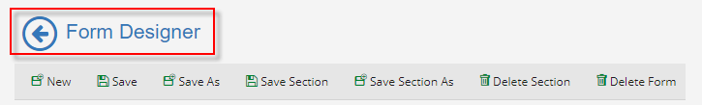

1. Select ***Sequence Designer*.**

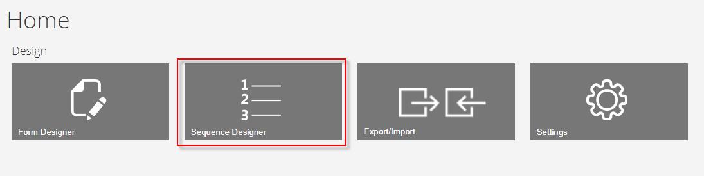

1. Select ***New*** and a new panel will be created for you to drag your forms into for creating your sequence.

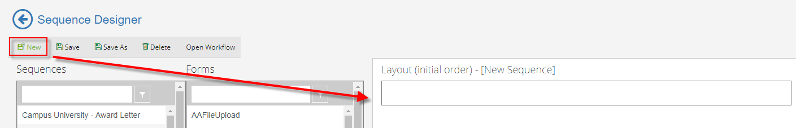

1. From the ***Forms*** column drag your forms in the ***New Sequence*** panel in the ***Layout*** pane in the order shown below.

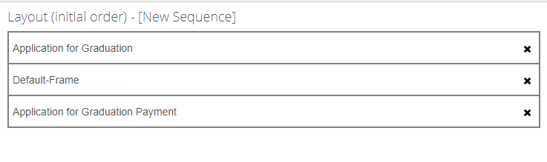

1. In the ***Properties*** pane, update the properties as shown below and select ***Save.***

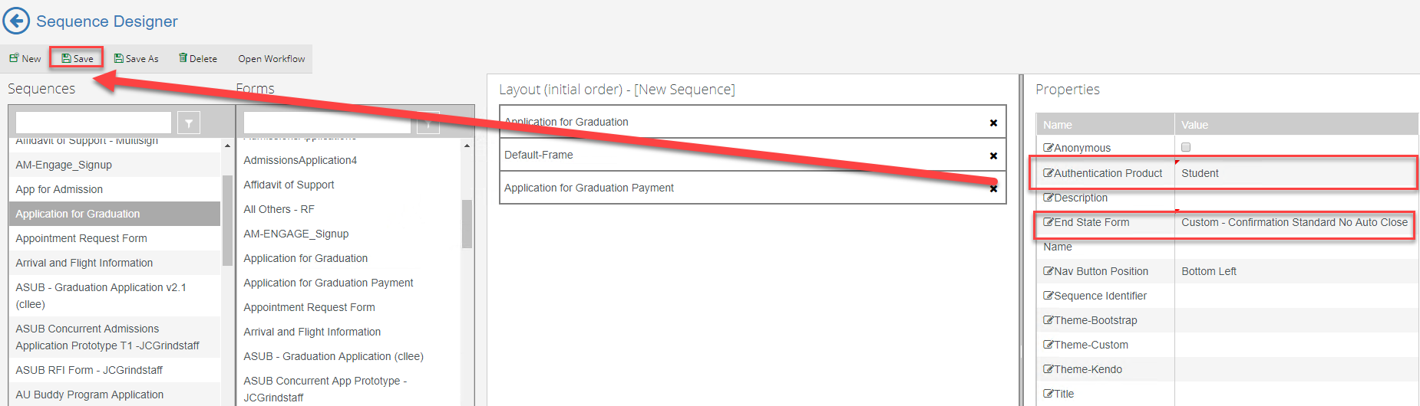

1. ***Save*** the Sequence with Your initials at the end as shown below.

**NOTE: DO NOT PUT EXTRA SPACES OR DASHES IN THE SEQUENCE NAME.**

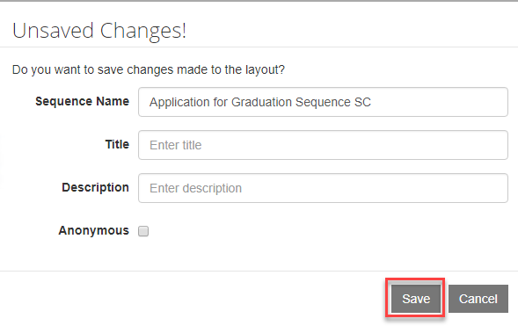

1. Once saved, select the ***Sequence*** in the ***Sequence pane*** and select ***Open Workflow*.**

**Note:** This will open Workflow Composer and create the State Machine Workflow shell for us to start creating our supporting workflow for the form. You can also open up the Workflow directly from Workflow Composer.

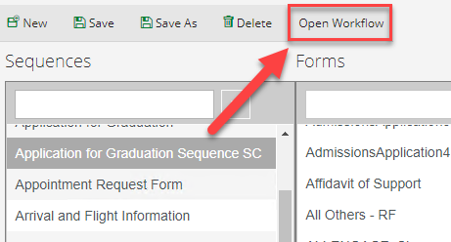

1. Rename the ***StateMachine******Flow*** to ***StateMachine-Application for Graduation*.** You can do this by double-clicking on the title at the top.

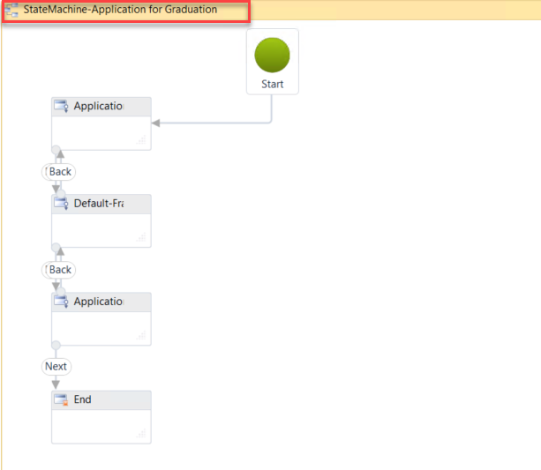

1. Select the second sequence in the state machine flow to give it the focus and hit the right arrow on your keyboard to move the sequence to the right. This helps to organize our state machine flow to better navigate.

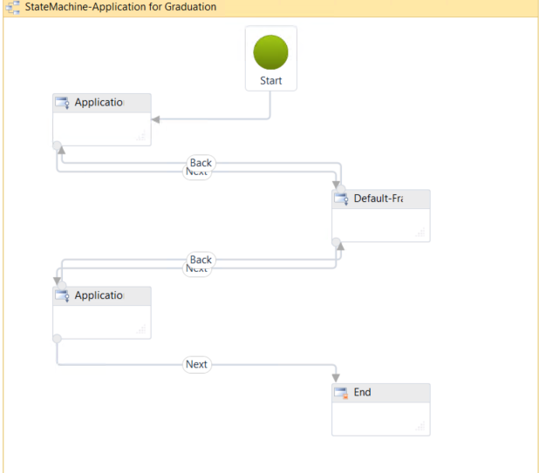

1. ***Double-click*** the first sequence in the state machine flow. This will allow you to go to the first transition in your form. We can specify in this section what we want to occur when the student enters the form.

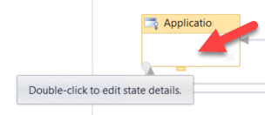

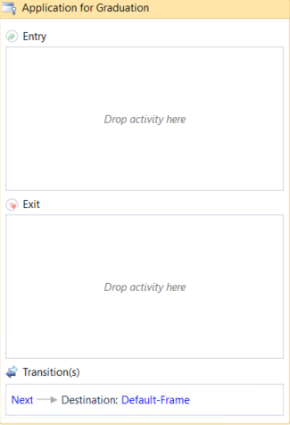

1. We want to organize our Workflow by adding containers to specify what we are doing in each section. This will allow us to better understand and visualize the logic occurring within the Workflow.
2. Drag a ***Sequence*** activity onto the designer in the ***Entry*** section of the activity. Rename the sequence to ***Initialize and Find Values*.**

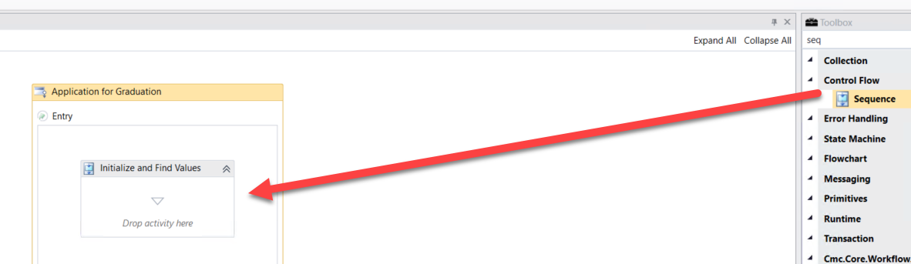

1. Drag three ***Sequence*** activities onto the designer in the ***Initialize and Find Values*** Sequence. Rename each ***Sequence*** activity as shown below.

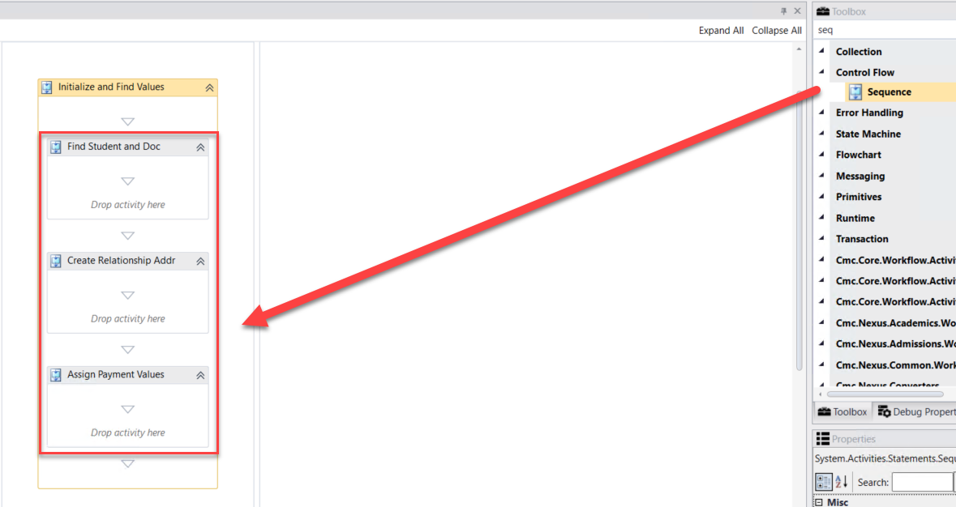

1. The first thing that we want to do is find the student that is completing the form in order to initialize the form and display values back to our ***Application for Graduation Form*** as needed. We will then continue finding and assigning other values that we will need for the form as the student moves through the sequence.

1. Drag the ***LookupUser*** activity onto the designer into the ***Find Student and Doc Sequence***. We use this activity to find the student completing the form.

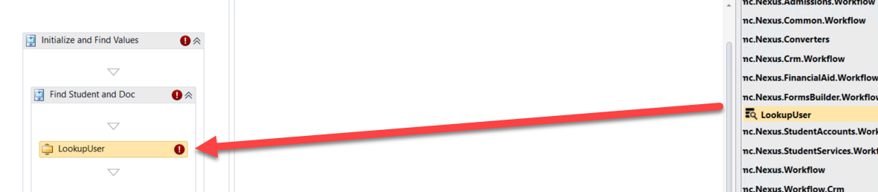

1. Create a variable:

* ***Name: studentid***
* ***Variable type: Int32***
* ***Scope: StateMachine-Application for Graduation***

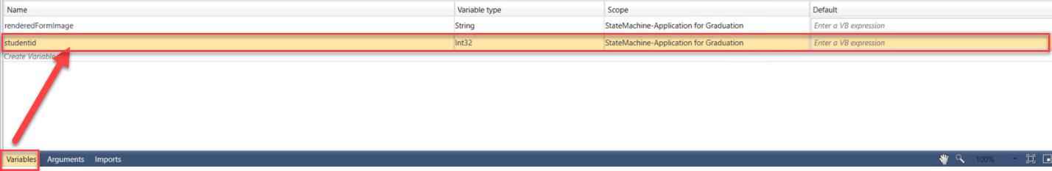

1. Complete the properties for the ***LookupUser*** activity as shown below:

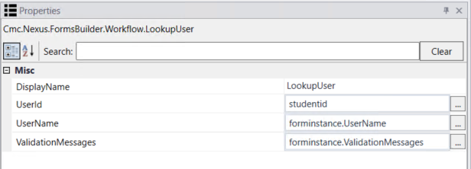

1. We then want to get the data from the ***studentEntity*** so we can display it back to our form. We use the ***GetEntity*** activity since we already have the student in the ***CampusNexus Student*** database.
2. Drag the ***GetEntity*** activity onto the designer below the ***LookupUser*** activity.

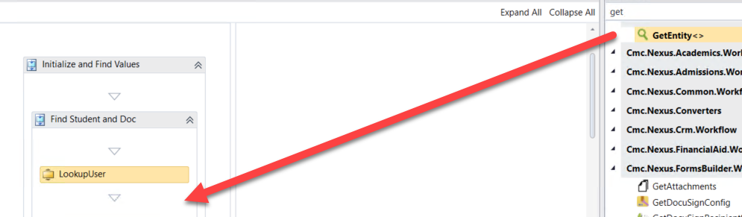

1. When the box pops up, ***Browse for Types*.**

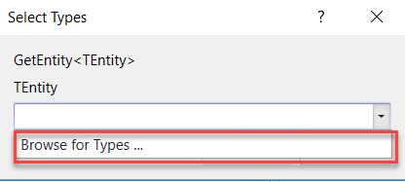

1. Navigate to: ***Cmc.Nexus.Common.Contracts>Cmc.Nexus.Common.Entities>StudentEntity and click OK***.

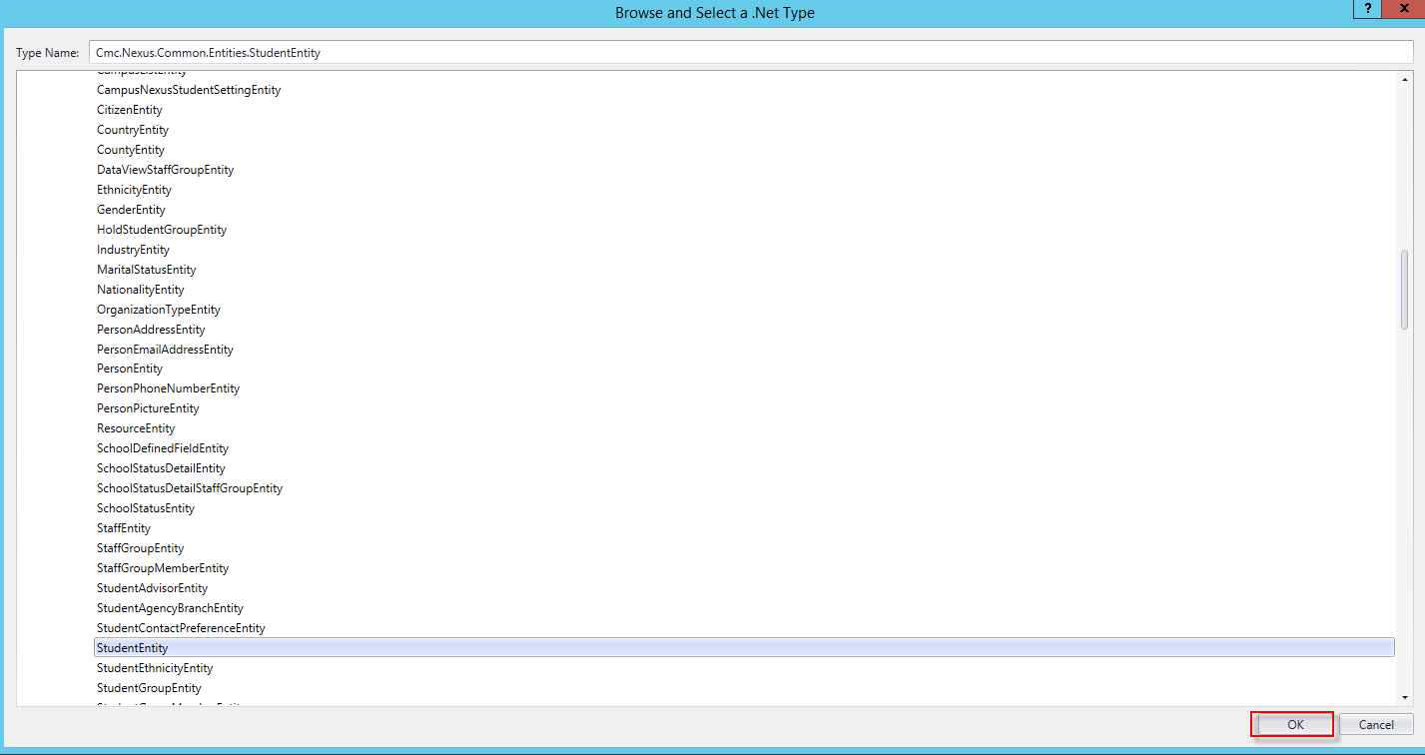

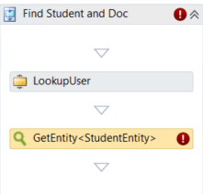

1. Specify the properties in the ***Properties pane*** for the ***GetEntity*** activity.

**Note:** The ***EntityId***is your variable of ***studentid*** and the Result is the ***studentEntity***.

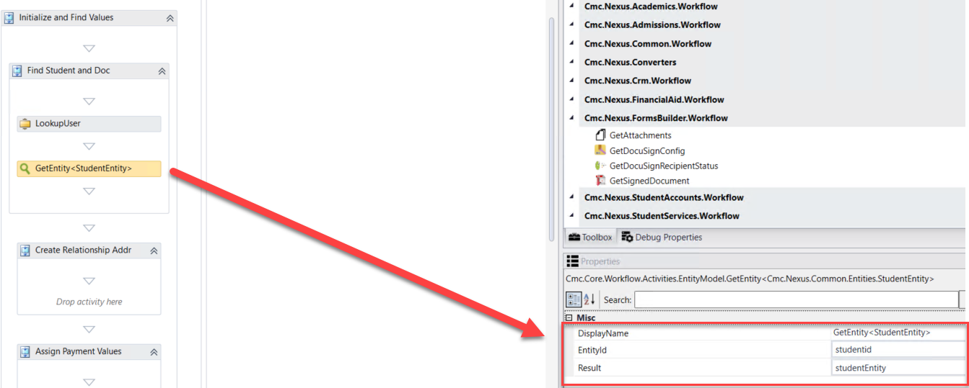

1. Now we need to find the document we have configured in CampusNexus Student that will be used for ***Application for Graduation.*** Eventually, when the form sequence is completed by a student, we will attach a pdf to the specified document in the student's Document Center. Drag a ***LookupReferenceItem*** activity into the ***Find Student and Doc*** sequence below the ***GetEntity*** activity and rename the activity to ***Find Document.***

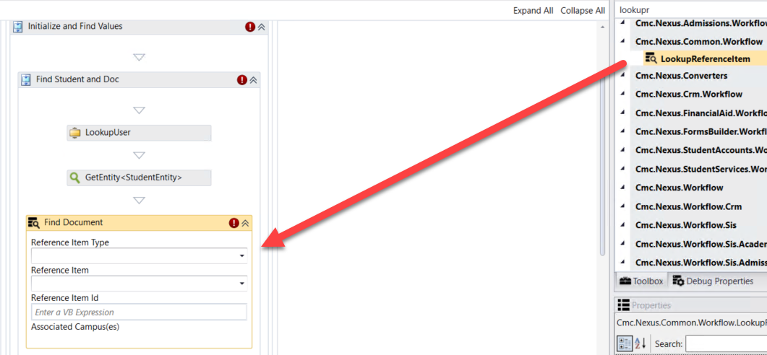

1. Populate the values for the activity as shown below:

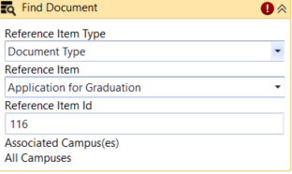

1. Create a variable:

* ***Name: Ref***
* ***Variable type: ReferenceItem (You will need to Browse for Types: Cmc.Nexus.Common.Contracts>Cmc.Nexus.Common.Services>ReferenceItem)***
* ***Scope: StateMachine-Application for Graduation***

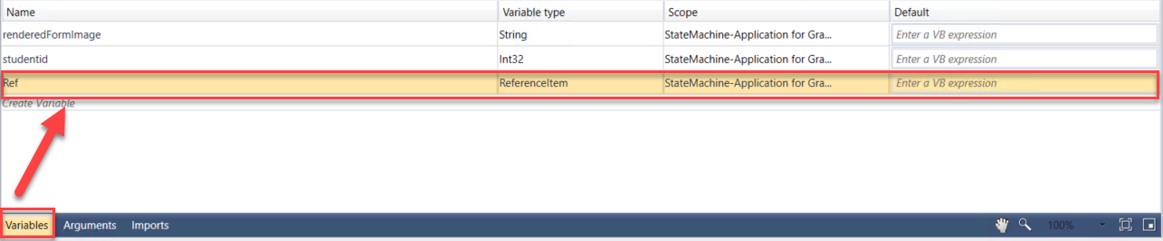

1. Assign the variable created in the step above to the ***ReferenceItem*** property in the***Properties pane*** for the ***Find Document ReferenceItem*** activity as shown below:

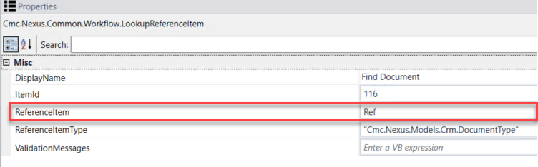

1. We now want to see if the document that we looked up above is associated to the student record in ***CampusNexus Student***. Create a ***variable*** as follows:

* ***Name: GradApp***
* ***Type: You will have to browse for the type. In the drop-down select Array of [T] then select Browse for Types….***
* ***Browse for:***
* ***Cmc.Nexus.Crm.Contracts>Cmc.Nexus.Crm.Entities>DocumentEntity and click OK***
* ***Scope: StateMachine-Application for Graduation***

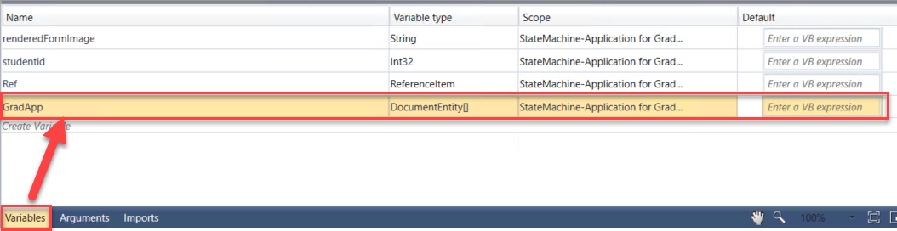

1. Drag the ***LookupStudentDocuments*** activity onto the designer into the ***Find Student and Doc*** sequence below the ***Find Document LookupReferenceItem*** activity. Rename the activity to ***Lookup Document for Student.***

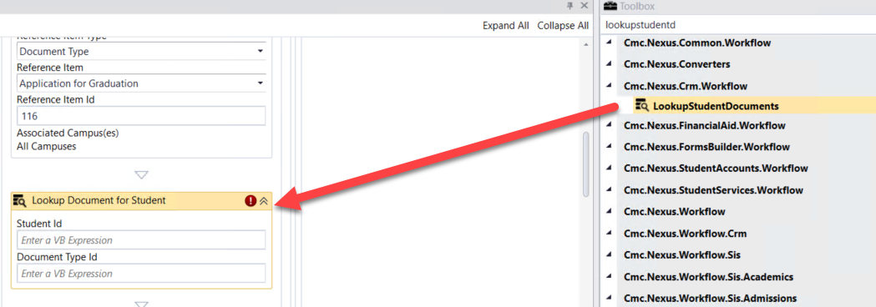

1. Update the properties for the ***Lookup Document for Student LookupStudentDocuments*** activity in the ***Properties Pane*** as shown below:

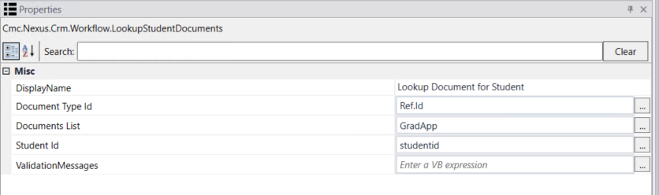

1. In our ***Application for Graduation*** Sequence, we will be adding an address for the student in the ***Addresses Folder*** in ***CampusNexus Student*** for mailing the diploma. We need to create the entity so once we collect the data from the student on the form we can save the values back to the database.
2. Drag a ***CreateEntity*** activity onto the designer in the ***Create Relationship Addr Sequence*** activity.

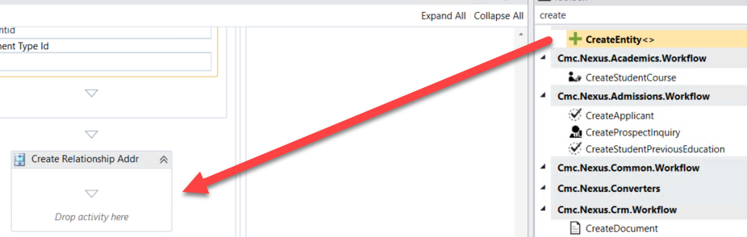

1. When the box pops up, ***Browse for Types*.**

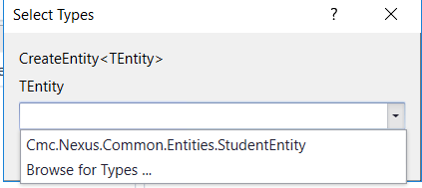

1. Navigate to: ***Cmc.Nexus.Common.Contracts>Cmc.Nexus.Common.Entities>StudentRelationshipAddressEntity and click OK***.

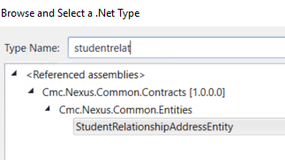

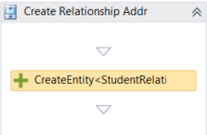

1. Specify the properties in the ***Properties pane*** for the ***CreateEntity*** activity as shown below:

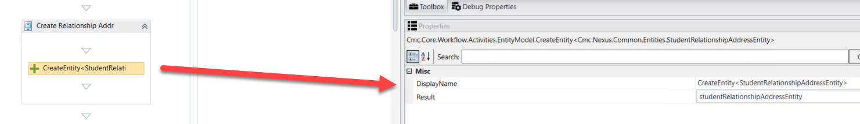

1. Drag four ***Assign*** activities onto the Designer in the ***Create Relationship Addr Sequence*** activity below the ***CreateEntity*** activity. Update the properties as follows:

* ***Display Name***:  ***Map ID's***; ***studentRelationshipAddressEntity.StudentId= studentEntity.Id***
* ***Display Name: Assign Address Type;***

***studentRelationshipAddressEntity.AddressTypeId=26***

* ***Display Name: Assign Address First Name;***

***studentRelationshipAddressEntity.FirstName=studentEntity.FirstName***

* ***Display Name: Assign Address Last Name;***

***studentRelationshipAddressEntity.LastName=studentEntity.LastName***

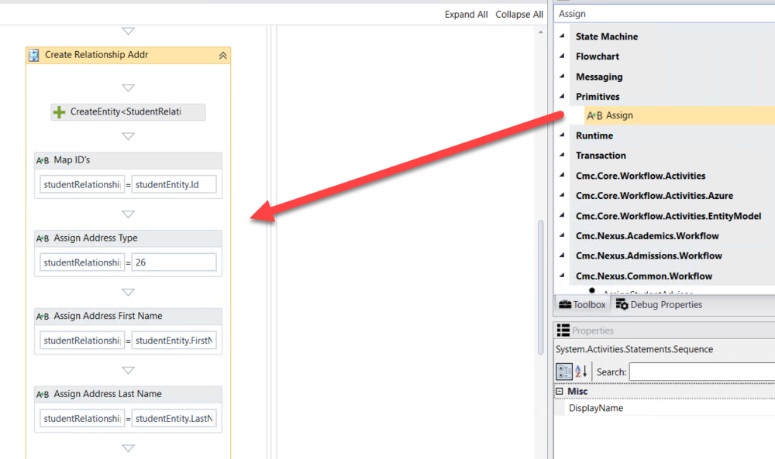

1. In our ***Application for Graduation S***equence, we will be collecting a graduation fee from the student. We need to create the entity and assign default values so we can collect the payment and update the values back to the database.
2. Drag a ***CreateEntity*** activity onto the designer in the ***Assign Payment Values Sequence*** activity.

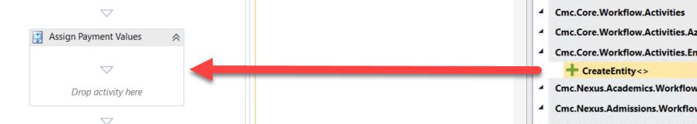

1. When the box pops up, ***Browse for Types*.**



1. Navigate to: ***Cmc.Nexus.Admissions.Contracts>Cmc.Nexus.Admissions.Entities>DepositEntity and click OK***.

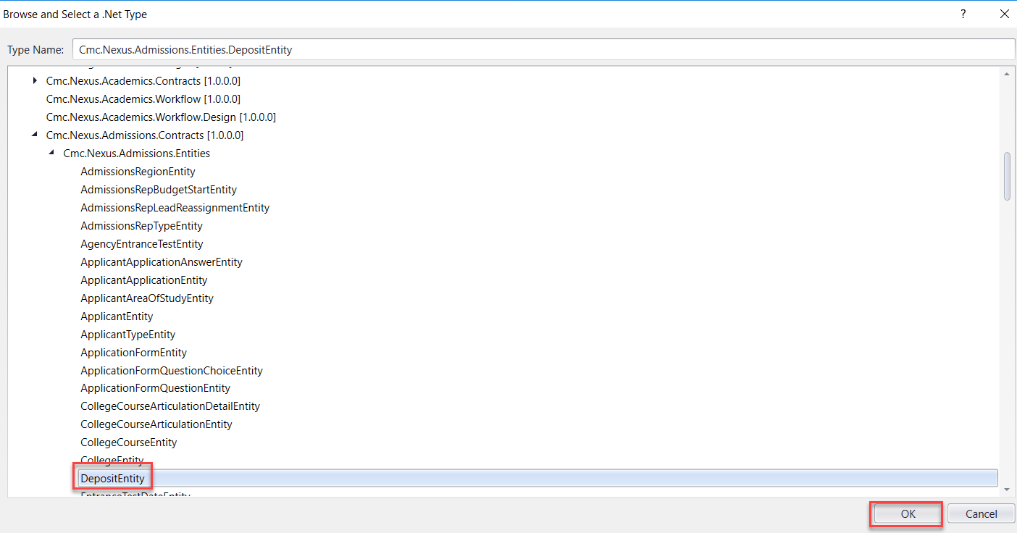

1. Specify the properties in the ***Properties pane*** for the ***CreateEntity*** activity as shown below:

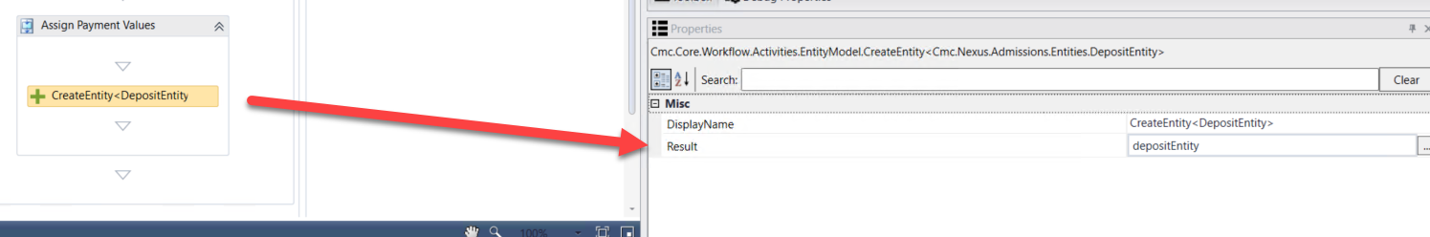

1. Drag three ***Assign*** activities onto the Designer in the ***Assign Payment Values Sequence*** activity below the ***CreateEntity*** activity. Update the properties as follows:

* ***Display Name***:  ***Assign Amount Received Date***; ***depositEntity.DepositReceivedDate=datetime.Now***
* ***Display Name: Assign Amount;***

***depositEntity.Amount=75.00d***

* ***Display Name: Assign Payment Type Credit Card;***

***depositEntity.PaymentType="Credit Card"***

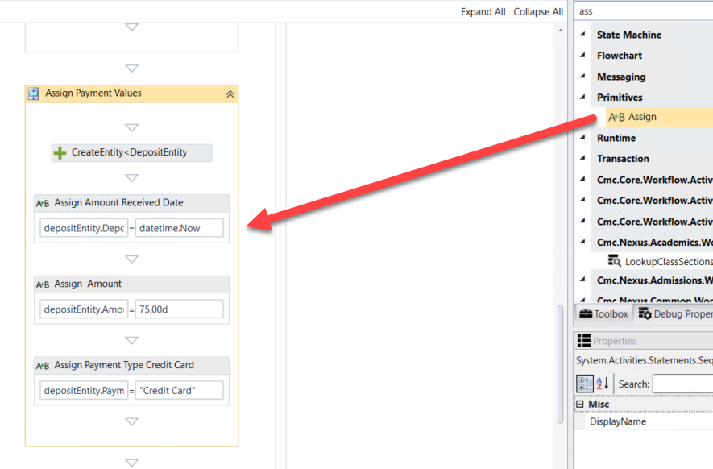

1. Click ***Next*** at the bottom of the form to enter the next transition of your ***Application for Graduation Sequence***.

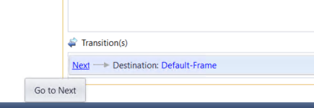

1. Rename the ***WaitForFormBookmark*** activity and the Next button transition text to ***Continue***.

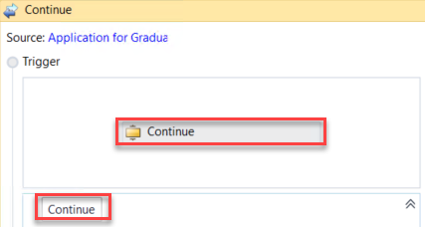

1. Once the student has completed the Application for Graduation Form, we want to Save the data back to the database. We will then have the student electronically sign, pdf the form, and collect the payment. To save the data collected on the form for the ***StudentEntity***, drag a ***SaveEntity*** below the ***Continue WaitForFormBookmark*** activity.

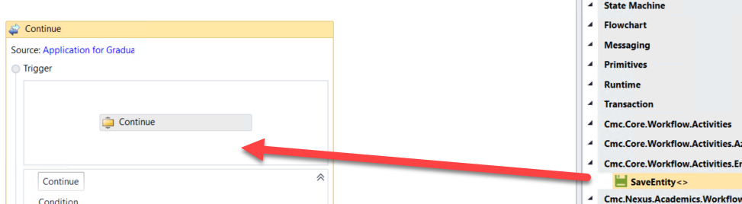

1. When the box pops up, ***Browse for Types*.**



1. Navigate to: ***Cmc.Nexus.Common.Contracts>Cmc.Nexus.Common.Entities>StudentEntity and click OK.***

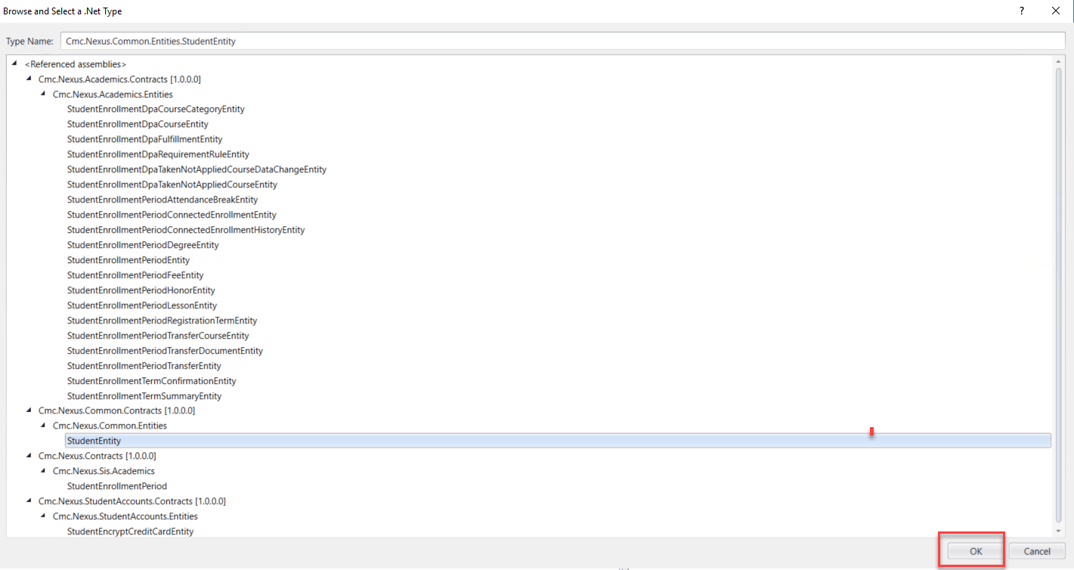

1. A ***Sequence*** activity is created around the two activities. Rename the ***Sequence*** to: ***Save Student Data***

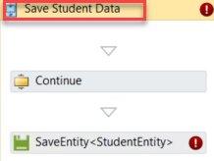

1. Specify the properties in the ***Properties pane*** for the ***SaveEntity*** activity.

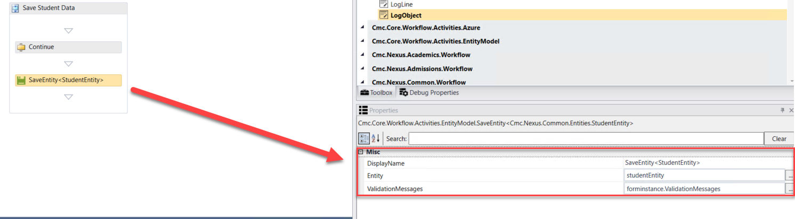

1. We now want to log the values from the ***StudentEntity***. Drag the ***LogObject*** activity onto the designer below the ***SaveEntity*** activity.

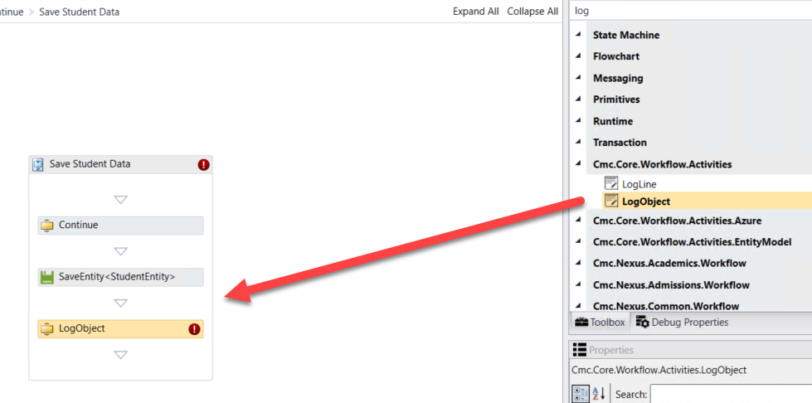

1. Specify the properties in the ***Properties pane*** for the ***LogObject*** activity.

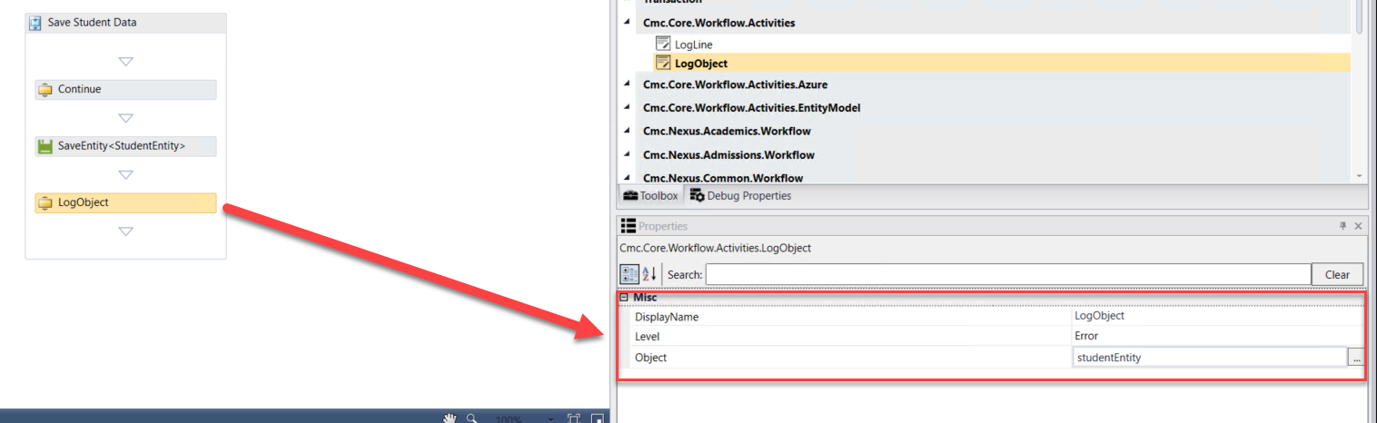

1. To save the data collected on the form for the ***StudentRelationshipAddressEntity***, drag a ***SaveEntity*** below the ***LogObject*** activity.

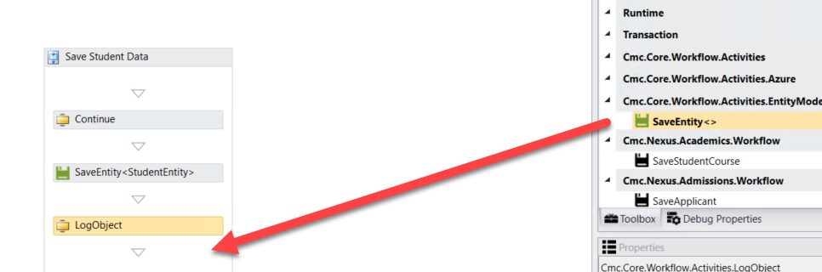

1. When the box pops up, ***Browse for Types*.**



1. Navigate to: ***Cmc.Nexus.Common.Contracts>Cmc.Nexus.Common.Entities>StudentRelationshipAddressEntity and click OK.***

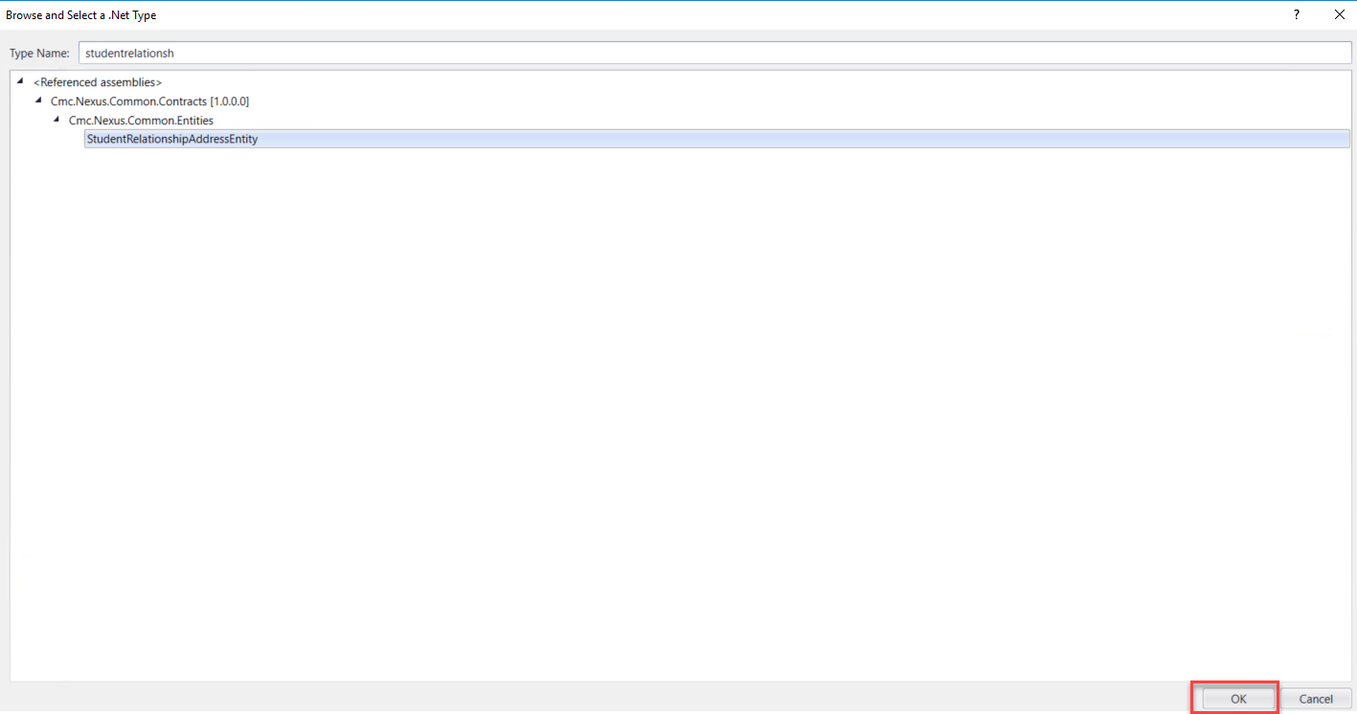

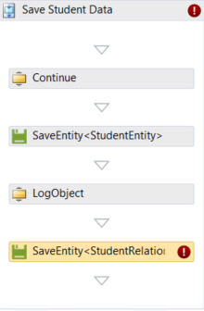

1. Specify the properties in the ***Properties pane*** for the ***SaveEntity*** activity.

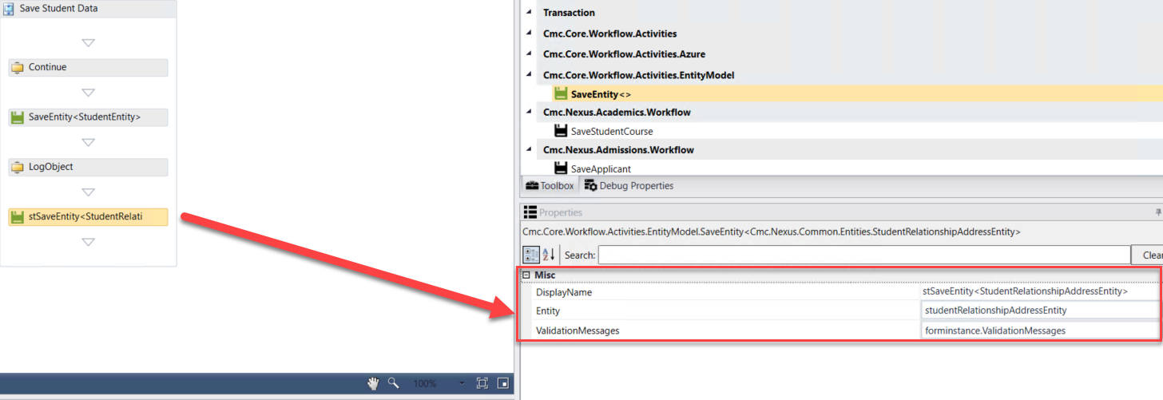

1. We now want to log the values from the ***StudentRelationshipAddressEntity***. Drag the ***LogObject*** activity onto the designer below the ***SaveEntity*** activity.

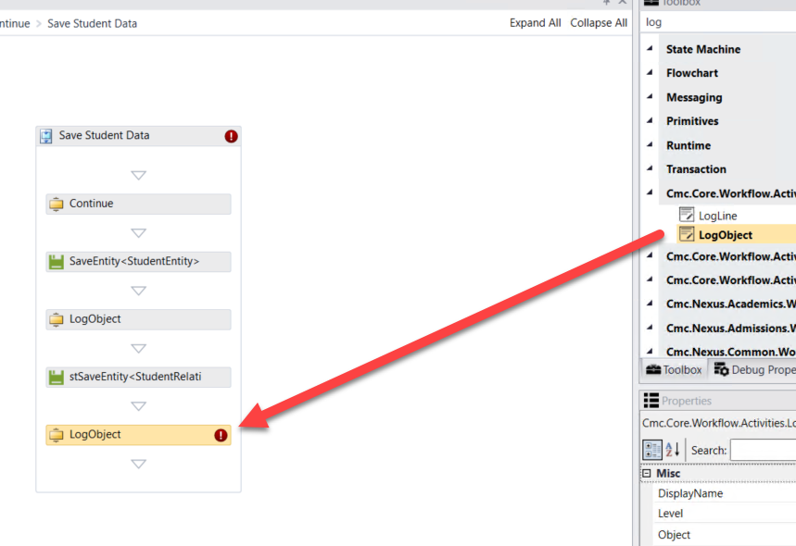

1. Specify the properties in the ***Properties pane*** for the ***LogObject*** activity.

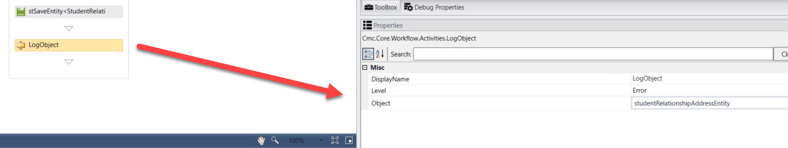

1. Select ***Default-Frame*** at the bottom of the form to enter the ***Default-Frame*.** This is where we will insert the logic to convert the form sequence to a pdf and integrate with DocuSign.

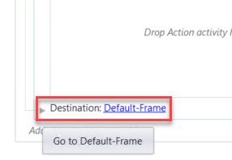

1. Upon entry to this form we will be assigning all the values for printing our form(s) to pdf and for the DocuSign values that are needed. Drag each of the following activities onto the form in the Entry section and complete all properties/values for each as defined below.
2. Drag a ***Sequence*** activity into the Entry section and rename it to: ***Print PDF get DocuSign Config***
3. Drag an ***Assign*** activity into the sequence.

* ***Rename to: Assign URL***
* ***Create a variable: Name: URL, Type: string, Scope: StateMachine-Application for Graduation***
* ***Assign Activity Values: URL = forminstance.RendererBaseUrl + "#/viewCreator/" + formInstance.WorkflowDefinitionId.ToString + "/forms=Application+for+Graduation+Sequence+SC"***

**Note**: After forms=, it should be the exact name of your form where the + is used for any spaces.

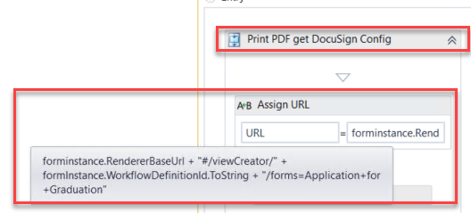

1. Drag a ***Persist*** activity beneath the ***Assign URL*** activity.
2. Drag a ***PrintUrltoPdf*** activity beneath the ***Persist*** activity.

* ***Create a variable: Name: Pdf, Type: Byte[], Scope: StateMachine-Application for Graduation***
* ***Complete the PrintUrltoPdf properties:***

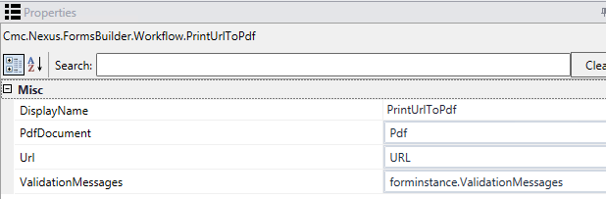

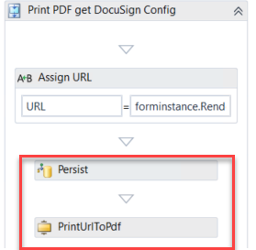

1. Drag a ***LogLine*** activity beneath the ***PrintUrlToPdf***activity.

* ***Rename the activity: Log Pdf URL***
* ***Text: Environment.NewLine + “Log URL” + URL.tostring***
* ***Level: Error***

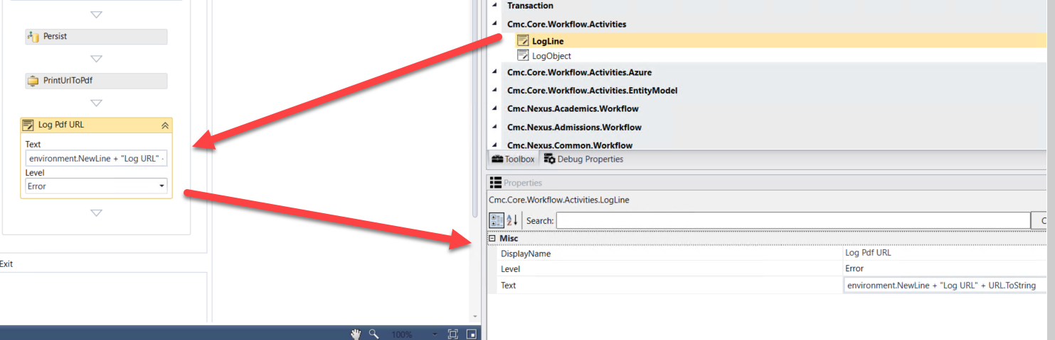

1. Drag a *Sequence* below the ***Log Pdf URL Logline*** activity and ***Rename*** the Sequence to: ***DocuSignConfig***
2. Create the following ***variables***:

* ***Name: DocuSignConfig, Type: Cmc.Nexus.FormsBuilder.Entities.DocuSignConfig, Scope: StateMachine-Application for Graduation***
* ***Name: DocuSignDocument, Type: Cmc.Nexus.FormsBuilder.Entities.DocuSignDocument, Scope: StateMachine-Application for Graduation, Default: New DocuSignDocument***
* ***Name: DocuSignRecipient, Type: Cmc.Nexus.FormsBuilder.Entities.DocuSignRecipient, Scope: StateMachine-Application for Graduation, Default: New DocuSignRecipient***
* ***Name: DocuSignRequest, Type: Cmc.Nexus.FormsBuilder.Entities.DocuSignRequest, Scope: StateMachine-Application for Graduation***
* ***Name: SignedDocument, Type: Cmc.Nexus.FormsBuilder.Entities.DocuSignDocument, Scope: StateMachine-Application for Graduation***

1. Create the following argument.

* ***Name: frameUrl, Direction: In/Out, ArgumentType: String***

1. Drag the ***GetDocuSignConfig*** activity into the ***DocuSignConfig*** sequence.

* ***Complete the properties for the activity as shown below.***

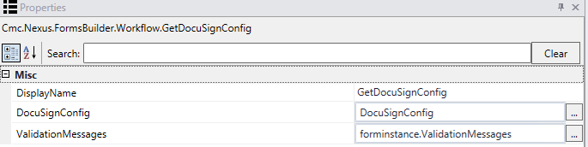

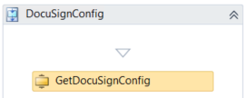

1. Drag a ***LogLine*** activity beneath the ***GetDocuSignConfig*** activity.

* ***Rename the activity: Log DocuSign Config values***
* ***Text: Environment.NewLine + “Assigning DocuSign Values” + Environment.NewLine***
* ***Level: Error***

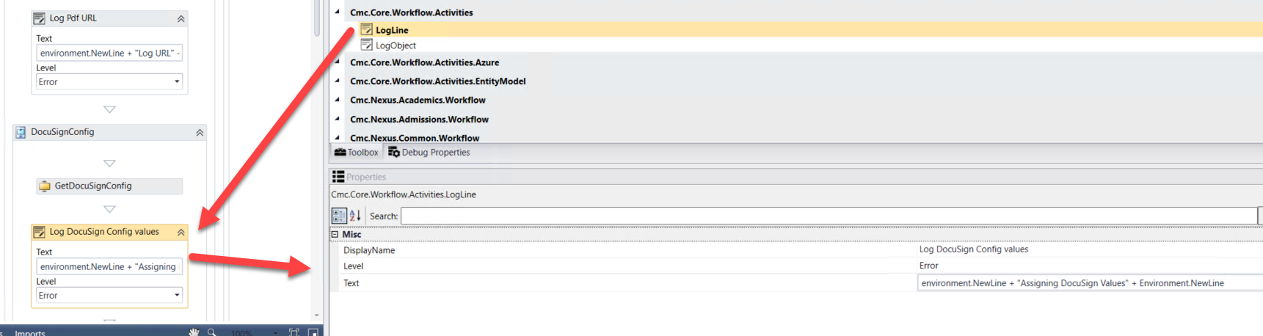

1. Drag nine***Assign*** activities beneath the ***Log DocuSign Config values LogLine*.** Assign the following values:

* ***DocuSignConfig.EmailSubject = “CMC Campus DocuSign Testing” (Rename the activity to Assign Email Subject)***
* ***DocuSignConfig.ReturnUrl = forminstance.RendererBaseUrl + “#/docusigncomplete” (Rename the activity to Assign URL)***
* ***DocuSignConfig.BasePath = “***[***https://demo.docusign.net/restapi***](https://demo.docusign.net/restapi)***”***
* ***(Rename the activity to Assign Base Path)***
* ***DocuSignDocument.DocumentId = “1” (Rename the activity to Assign Document ID)***
* ***DocuSignDocument.Name = “Application for Graduation” (Rename the activity to Assign Document Name)***
* ***DocuSignDocument.Content = Pdf (Rename the activity to Assign Document Content)***
* ***DocuSignRecipient.Name = studentEntity.FirstName + studentEntity.LastName (Rename the activity to Assign Recipient Name)***
* ***DocuSignRecipient.Email = studentEntity.EmailAddress (Rename the activity to Assign Recipient Email)***
* ***DocuSignRecipient.SignerId = “1” (Rename the activity to Assign Signer ID)***

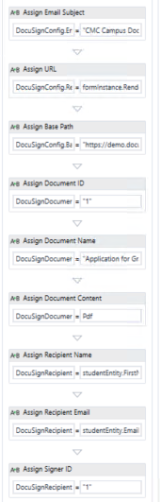

1. Drag the ***CreateDocuSignRequest*** activity beneath the last ***Assign*** activity. Complete the properties for the activity as shown below.

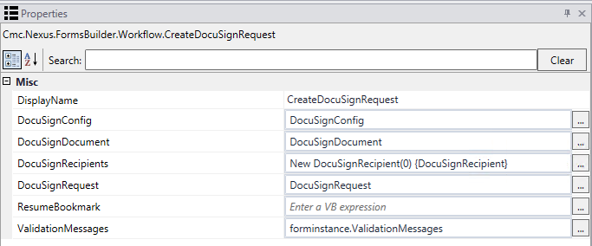

1. Drag an ***Assign*** activity below the ***CreateDocuSignRequest*** activity.

* ***Rename the activity to Assign URL.***
* ***Assign the value: frameUrl = DocuSignRequest.Url***

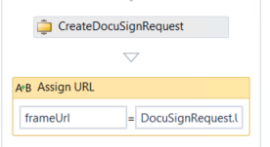

1. Drag a ***LogLine*** activity beneath the ***Assign URL*** activity.

* ***Rename the activity: Log DocuSign Config values***
* ***Text: Environment.NewLine + “DocuSign Values Assigned” + Environment.NewLine***
* ***Level: Error***

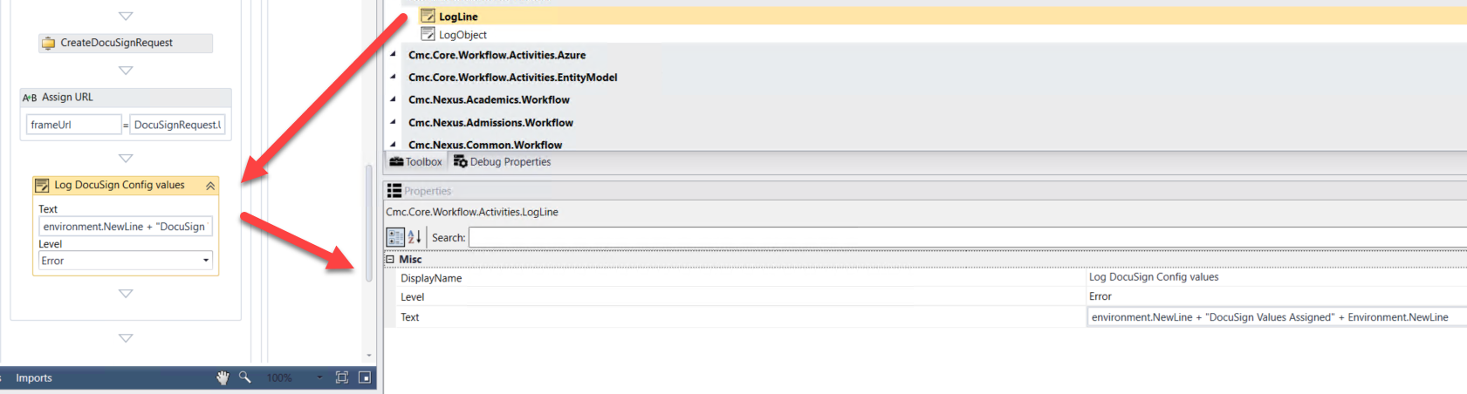

1. Select ***Next*** at the bottom of the form to go to the next transition.

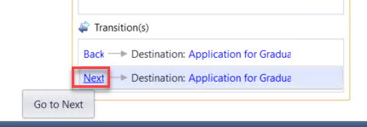

1. Rename the ***WaitForFormBookmark*** activity and the ***Next*** button text to ***Continue.***

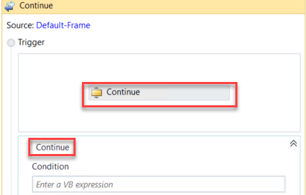

1. At the bottom of the screen, select to enter the ***Application for Graduation Payment*** form.

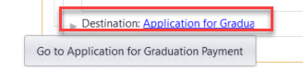

1. Select ***Next*** to transition to the ***Application for Graduation Payment*** form.

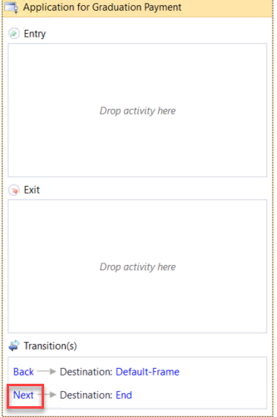

1. Rename the ***WaitForFormBookmark*** activity and the Next button transition text to ***Submit***.

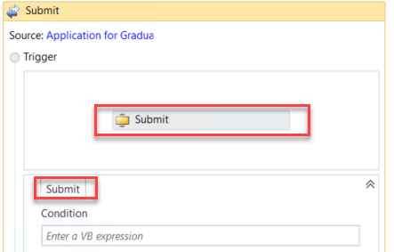

1. Drag an ***If*** activity below the ***Submit WaitForFormBookmark*** activity. Rename the activity and the sequence that was created around both activities to ***Verify Payment Info.*** Enter the following for the ***Condition*** of the ***If*** activity:

***String.IsNullOrEmpty(forminstance.PaymentInfo.TransactionId)***

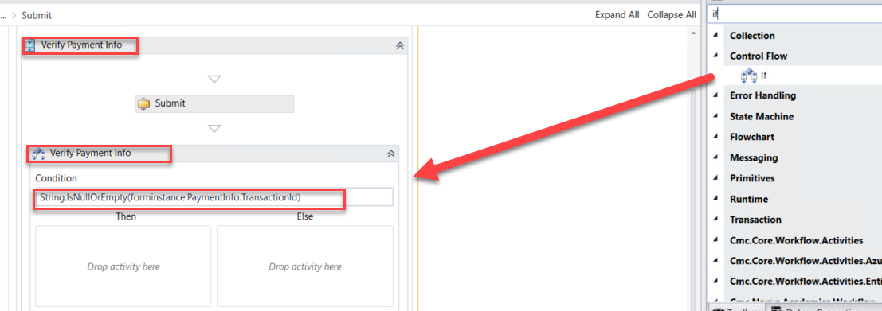

1. Drag a ***CreateValidationItem*** activity into the ***Then*** section of the ***Verify Payment Info If*** activity. Update the following properties for the activity:

* ***Message: "Something went wrong with the payment processing. Please contact customer service to confirm that your payment was processed correctly."***
* ***Messages: forminstance.ValidationMessages***

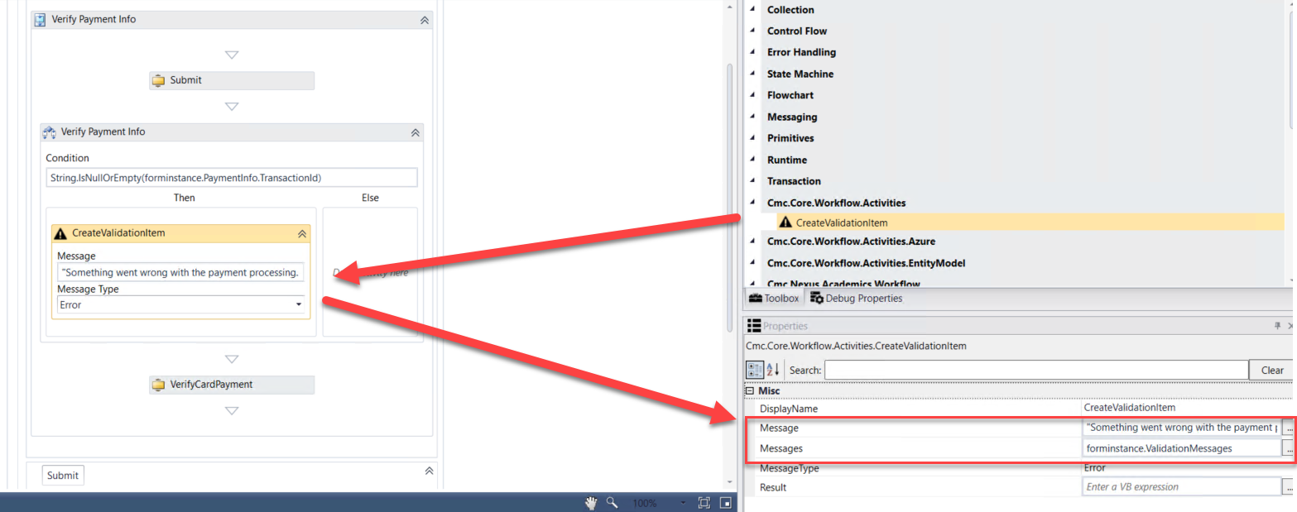

1. Drag a ***LogLine*** activity in the ***Else*** portion of the ***Verify Payment Info If*** activity.

* ***Rename the activity: Payment Processed***
* ***Text: Environment.NewLine + Environment.NewLine + "Payment was processed." +Environment.NewLine + Environment.NewLine***
* ***Level: Error***

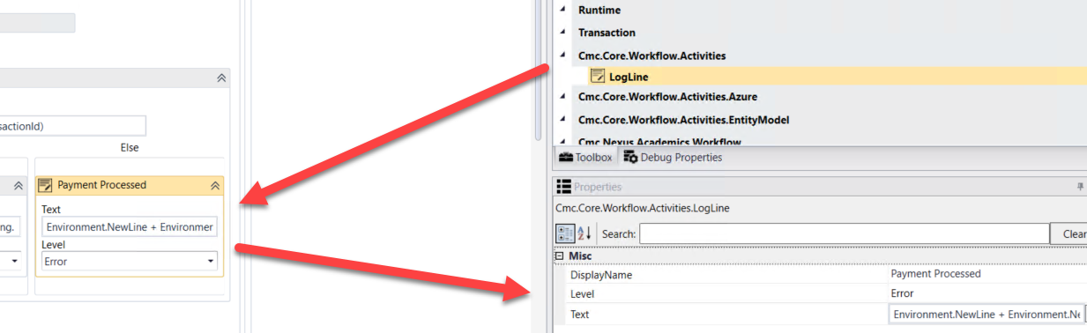

1. Drag the ***VerifyCardPayment*** activity below the ***Verify Payment Info If*** activity. Update the properties for the activity as shown below:

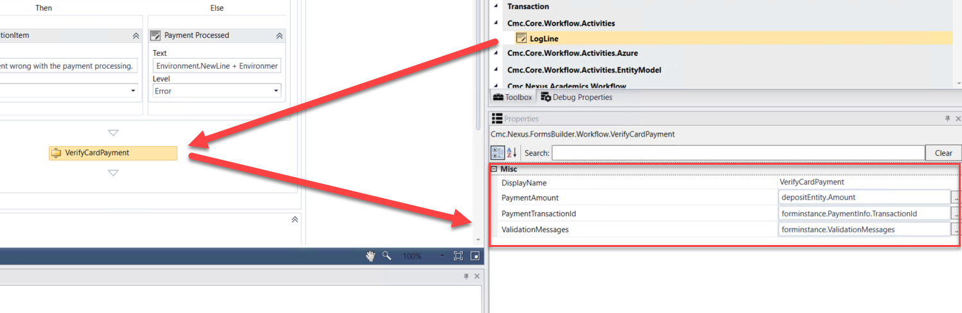

1. Select the ***Submit WaitForFormBookmark*** activity and update the ***TransitionType*** property to ***MoveForward.***

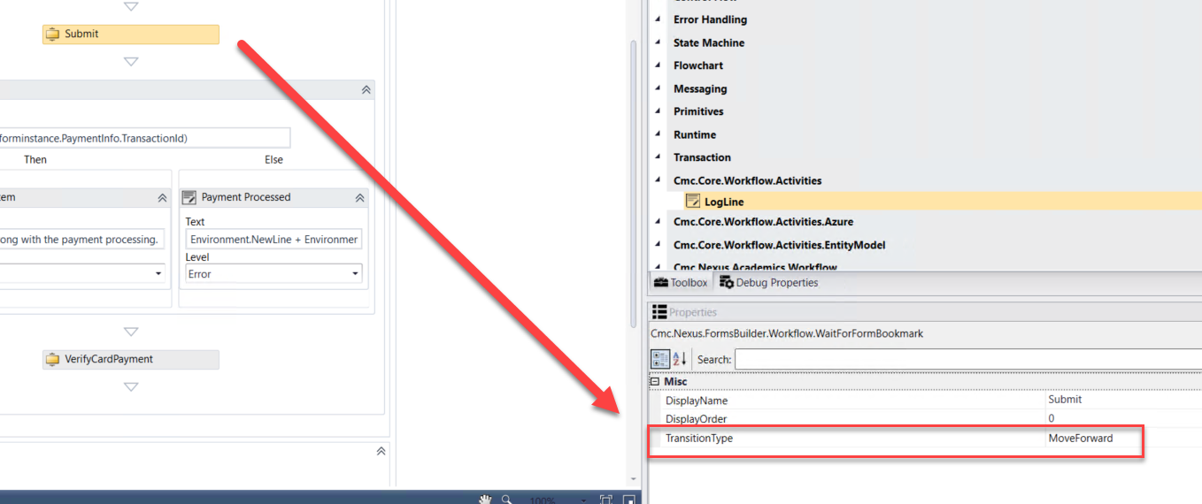

1. Enter the following for the ***Condition*** in your transition.

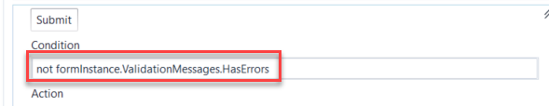

1. Drag a ***Sequence*** activity into the ***Action*** section of your transition. Rename the activity to ***Process Request.***

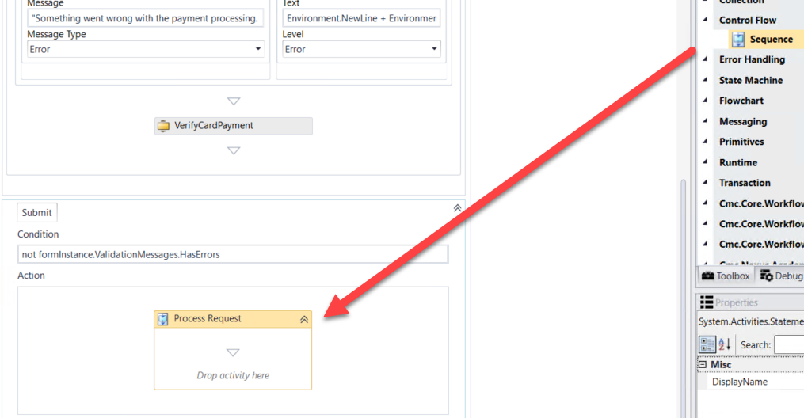

1. Drag two ***Sequence*** activities into the ***Process Request Sequence*** activity. Rename each activity as shown below.

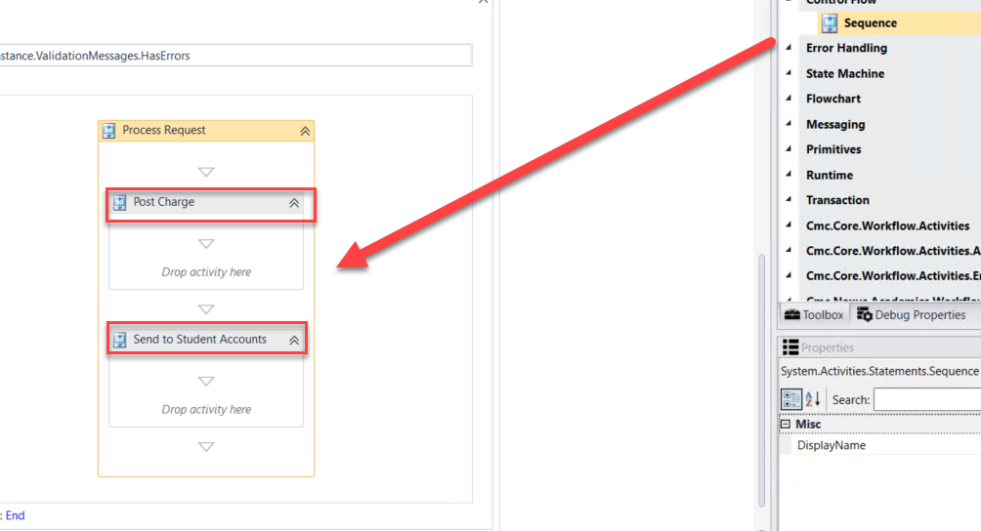

1. Drag the ***LookupCurrentEnrollmentPeriod*** activity into the ***Post Charge*** sequence. Rename the activity to ***Get Enrollment ID.***

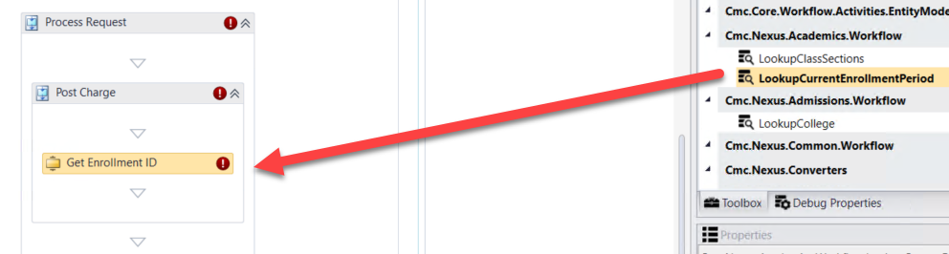

1. Create a ***variable:***

* Name: ***currEnroll***
* Variable type:  ***StudentEnrollmentPeriodEntity (You will need to browse for Cmc.Nexus.Academics.Contracts>Cmc.Nexus.Academics.Entities>StudentEnrollmentPeriodEntity)***
* Scope: ***StateMachine-Application for Graduation***

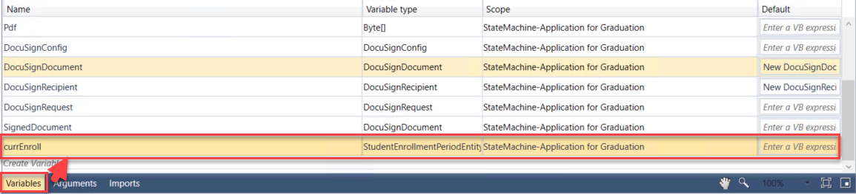

1. Complete the properties for the ***Get Enrollment ID LookupCurrentEnrollmentPeriod*** activity as shown below.

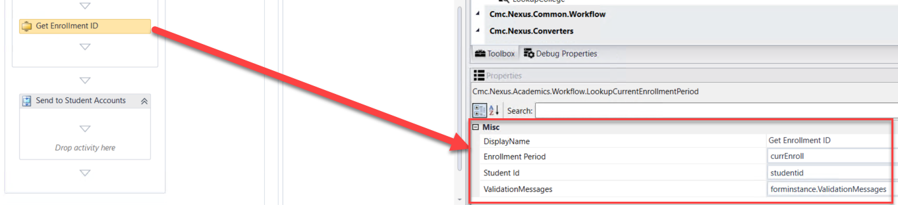

1. Drag the ***CreateCharge*** activity located under the ***Cmc.Nexus.StudentAccounts.Workflow*** entity in the ***Toolbox*** below the ***Get Enrollment ID LookupCurrentEnrollmentPeriod*** activity. Complete the properties as shown below:

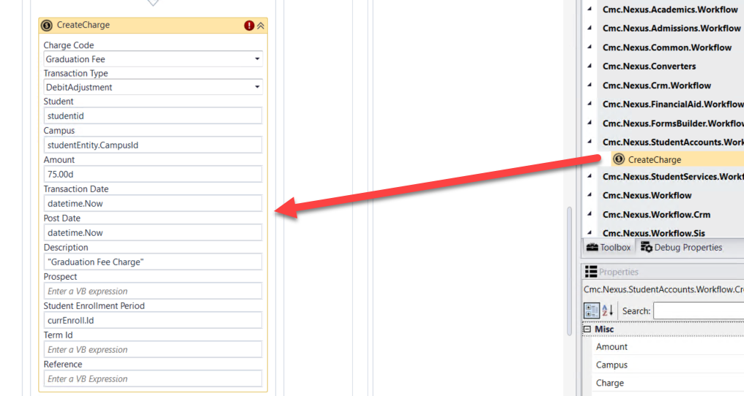

1. Create a ***variable:***

* Name: ***Fee***
* Variable type: ***StudentAccountTransactionEntity*** (You will need to browse for ***Cmc.Nexus.StudentAccounts.Contracts>Cmc.Nexus.StudentAccounts.Entities>StudentAccountTransactionEntity***)
* Scope: ***StateMachine-Application for Graduation***

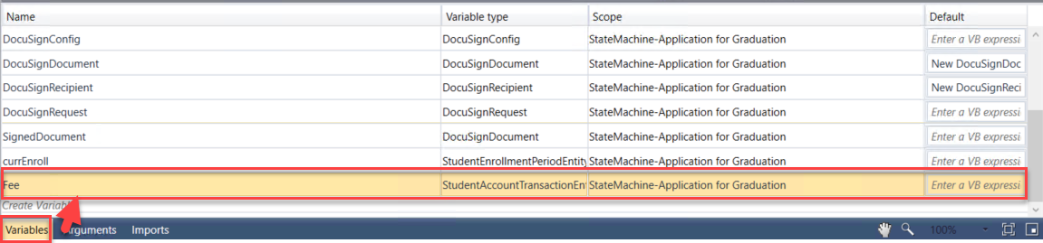

1. Assign the ***Fee*** variable to the ***Charge*** property for the ***CreateCharge*** activity.

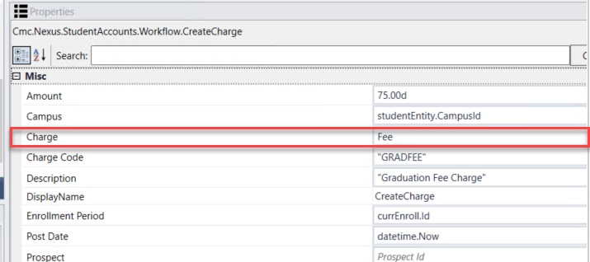

1. Drag the ***SaveCharge*** activity located under the ***Cmc.Nexus.StudentAccounts.Workflow*** entity in the ***Toolbox*** below the ***CreateCharge*** activity. Update the properties for the activity as shown below.

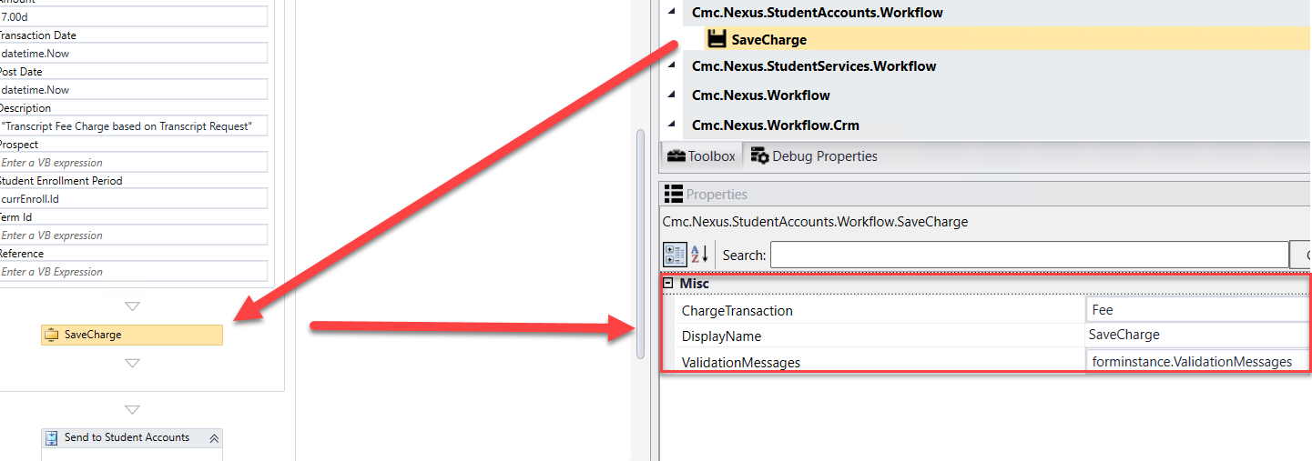

1. Drag the ***GetServiceInstance<>*** activity into the ***Send to Student Accounts*** sequence.

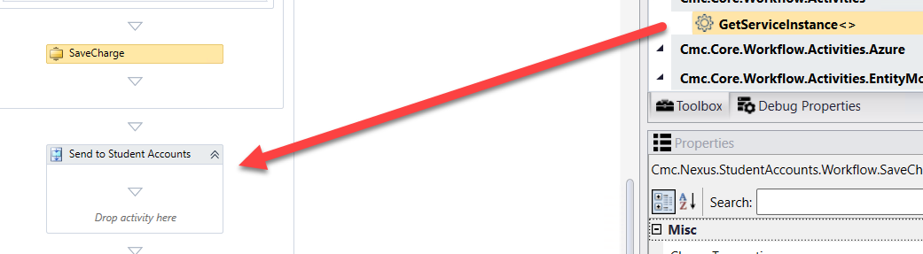

1. When the box pops up, ***Browse for Types*.**



1. Navigate to: ***Cmc.Nexus.StudentAccounts.Contracts>Cmc.Nexus.StudentAccounts.Services>IStudentAccountTransactionService and click OK***.

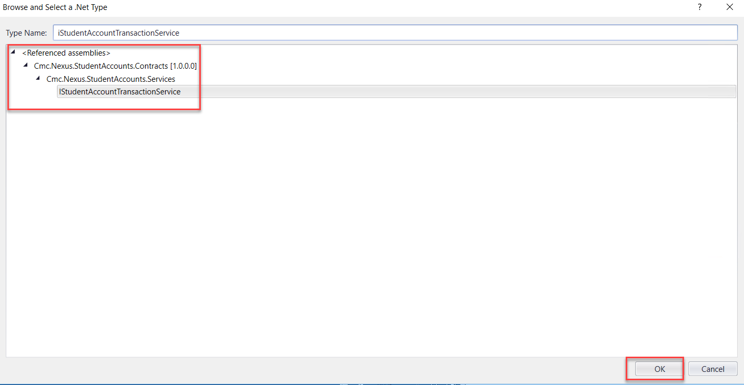

1. Create a ***variable:***

* Name: ***AcctSvc***
* Variable type: ***IStudentAccountTransactionService (You will need to browse for Cmc.Nexus.StudentAccounts.Contracts>Cmc.Nexus.StudentAccounts.Services> IStudentAccountTransactionService)***
* Scope: ***StateMachine-Application for Graduation***

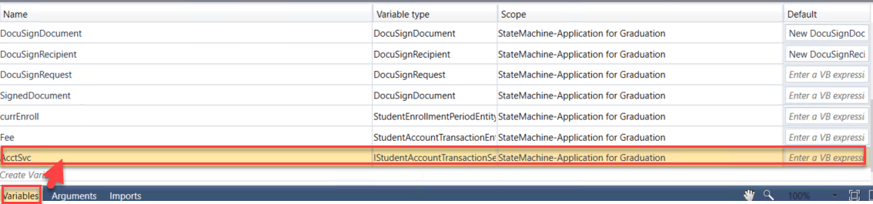

1. Update the properties for the ***GetServiceInstance<>*** activity as shown below.

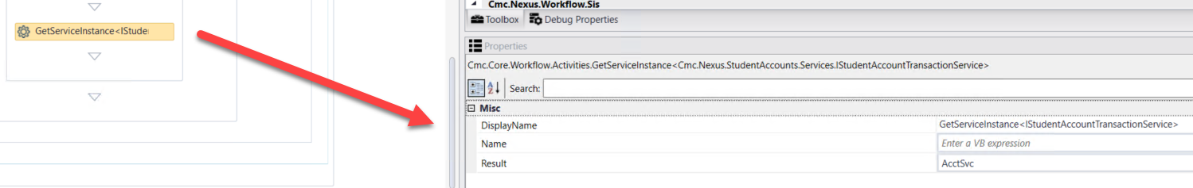

1. Create the following variables:
2. **Variable:**

* **Name: postRequest**
* **Variable type: PostAccountTransactionPaymentRequest (You will need to browse for Cmc.Nexus.StudentAccounts.Contracts>Cmc.Nexus.StudentAccounts.Services>PostAccountTransactionPaymentRequest)**
* **Scope: StateMachine-Application for Graduation**
* **Default: New PostAccountTransactionPaymentRequest**

1. ***Variable***:

* ***Name: postResponse***
* ***Variable type: PostAccountTransactionPaymentResponse (You will need to browse for Cmc.Nexus.StudentAccounts.Contracts>Cmc.Nexus.StudentAccounts.Services>PostAccountTransactionPaymentResponse)***
* ***Scope: StateMachine-Application for Graduation***

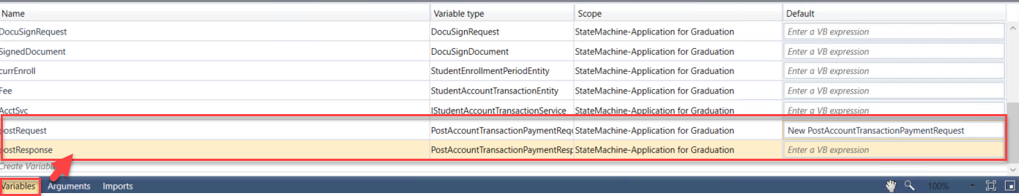

1. Drag seven ***Assign*** activities below the ***GetServiceInstance<>*** activity. Update the properties for the activities as follows:

* ***Display Name: Assign Student ID; postRequest.StudentId = studentid***
* ***Display Name: Assign Amount; postRequest.TransactionAmount = depositEntity.Amount***
* ***Display Name: Assign Date; postRequest.TransactionDate = depositEntity.DepositReceivedDate***
* ***Display Name: Assign Payment Mode; postRequest.PaymentMode = cmc.Nexus.StudentAccounts.Services.PaymentMode.Normal***
* ***Display Name: Assign Type; postRequest.PaymentType = "C"***
* ***Display Name: Assign Description; postRequest.Description = "Credit Card Payment For Graduation"***
* ***Display Name: Assign Enrollment; postRequest.StudentEnrollmentPeriodId = currEnroll.Id***

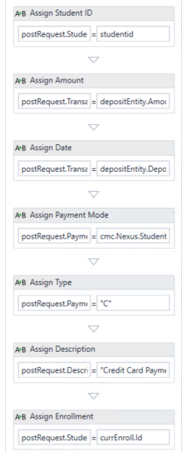

1. We now want to log the values from the ***postRequest***.

Drag the ***LogObject*** activity onto the designer below the last ***Assign*** activity.

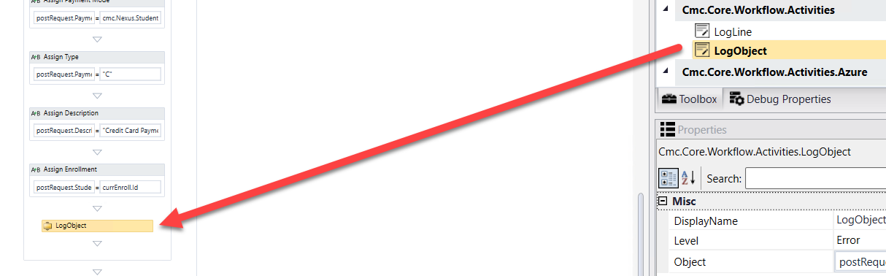

1. Specify the properties in the ***Properties pane*** for the ***LogObject*** activity.

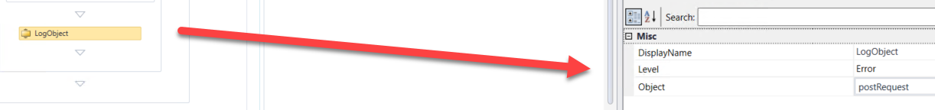

1. Drag an ***Assign*** activity below the ***LogObject*** activity. Update the properties for the activity as follows:

* ***Display Name: Assign Response; postResponse = AcctSvc.PostAccountTransactionPayment(PostRequest)***

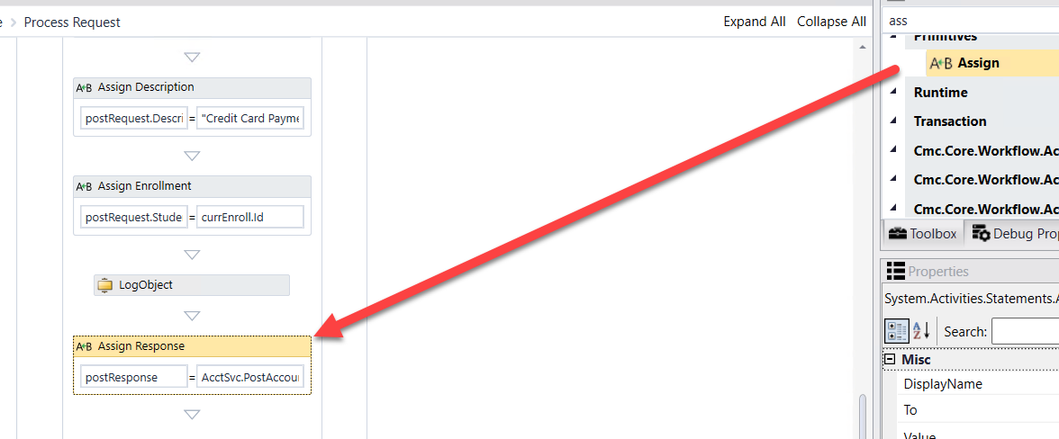

1. We now want to log the values from the ***postResponse***.

Drag the ***LogObject*** activity onto the designer below the ***Assign*** activity.

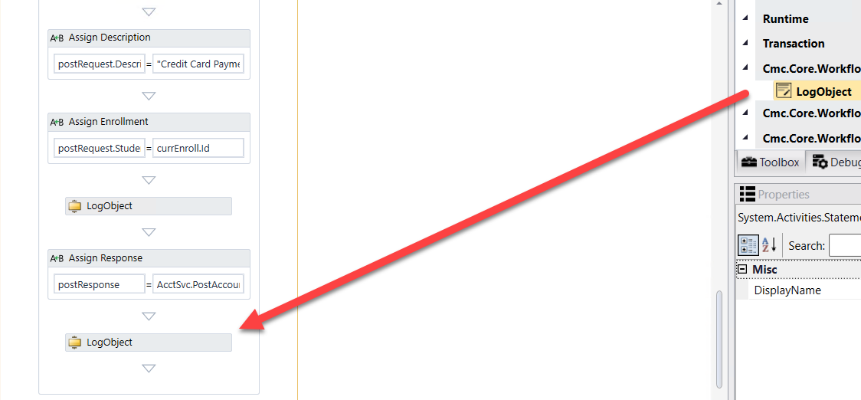

1. Specify the properties in the ***Properties pane*** for the ***LogObject*** activity.

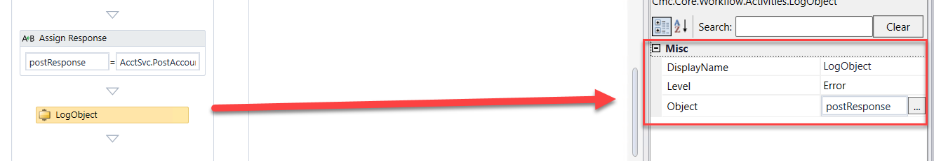

1. At the bottom of the screen, go to the ***End*** state of the form sequence.

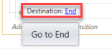

1. We now want to insert the pdf into the student's Document Center in CampusNexus Student as well as send a Task to the advisor for follow-up. Drag a ***Sequence*** activity into the ***Entry*** of the ***End*** state. ***Rename*** the ***Sequence*** activity to ***Attach pdf and send task to staff.***

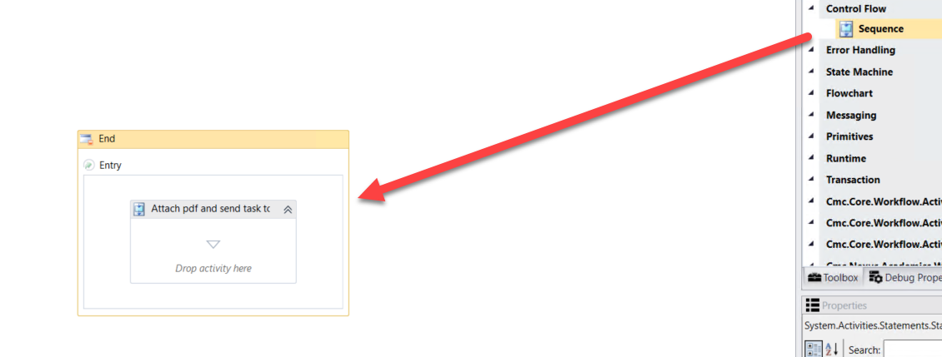

1. Drag two ***Sequence*** activities into the ***Attach pdf and send task to staff Sequence*** activity. ***Rename*** the activities as shown below:

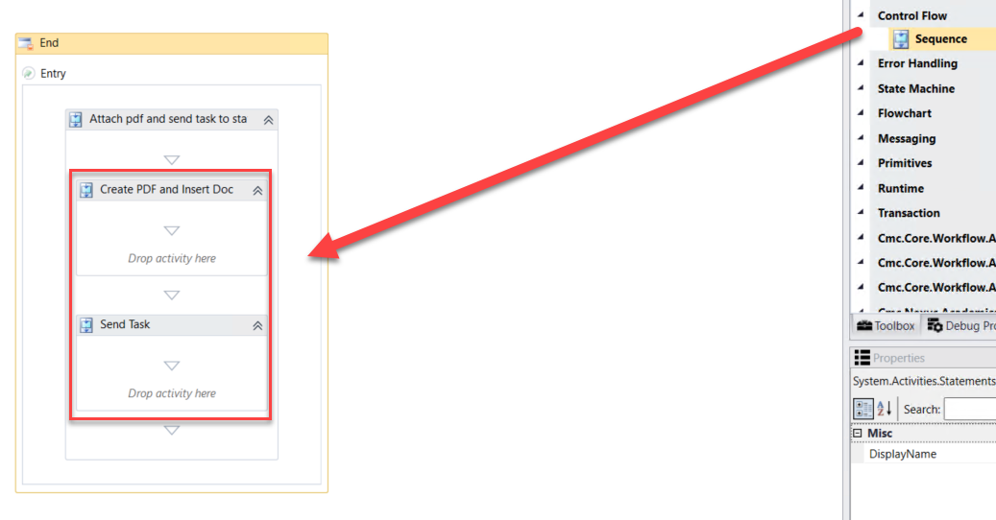

1. Drag a ***LogLine*** activity in the ***Create PDF and Insert Doc Sequence*** activity.

* ***Rename the activity: Get Signed Document***
* ***Text: environment.NewLine + Environment.NewLine + "Get Signed Document" + Environment.NewLine + Environment.NewLine***
* ***Level: Error***

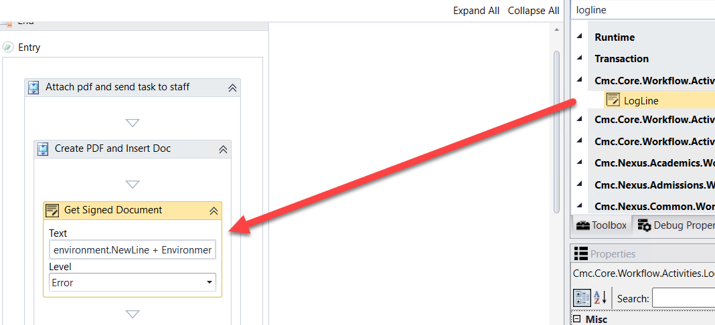

1. Drag the ***GetSignedDocument*** activity below the ***Get Signed Document LogLine*** activity.

* Complete the properties for the ***GetSignedDocument*** activity as shown below.

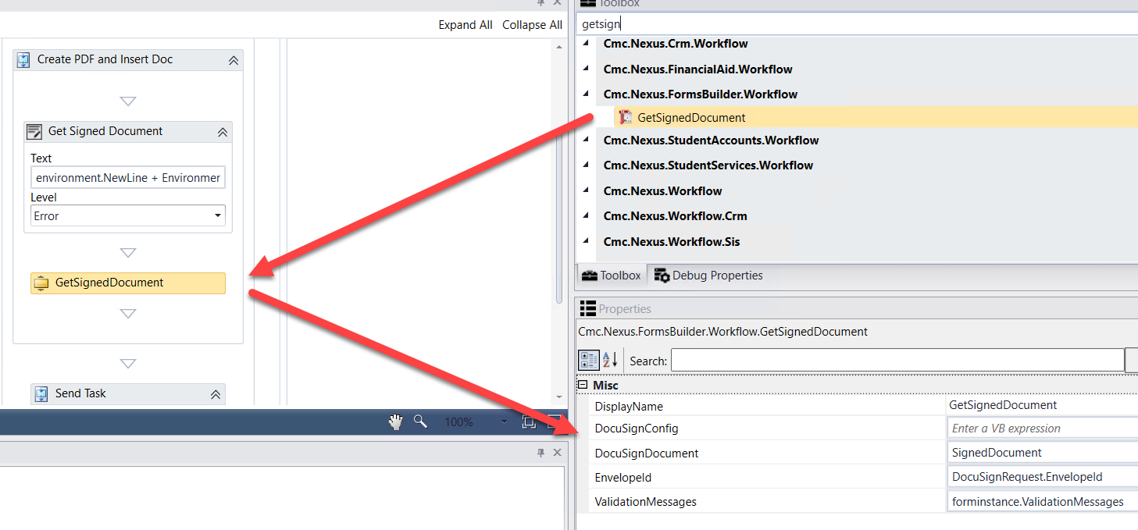

1. Drag a ***LogLine*** activity in the ***Create PDF and Insert Doc Sequence*** activity below the ***GetSignedDocument*** activity.

* ***Rename the activity: Add Doc***
* ***Text: environment.NewLine + Environment.NewLine + "Add/Update Doc for student" + Environment.NewLine + Environment.NewLine***
* ***Level: Error***

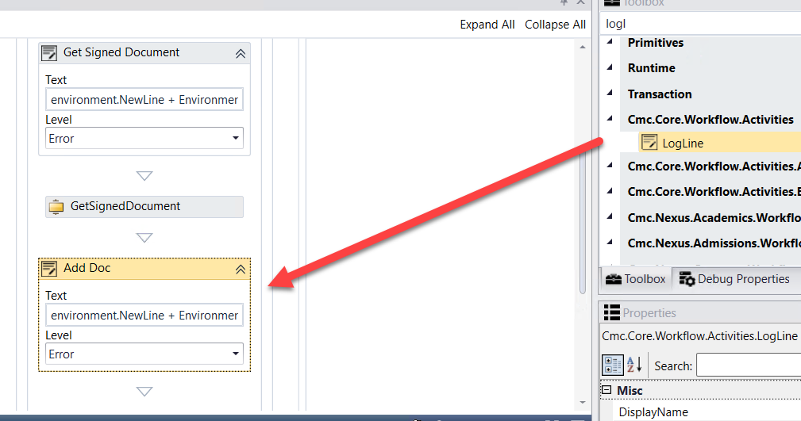

1. Drag an ***If*** activity below the ***GetSignedDocument*** activity.

* ***Rename the activity to: If document exists***
* ***Condition: GradApp.Length>0***

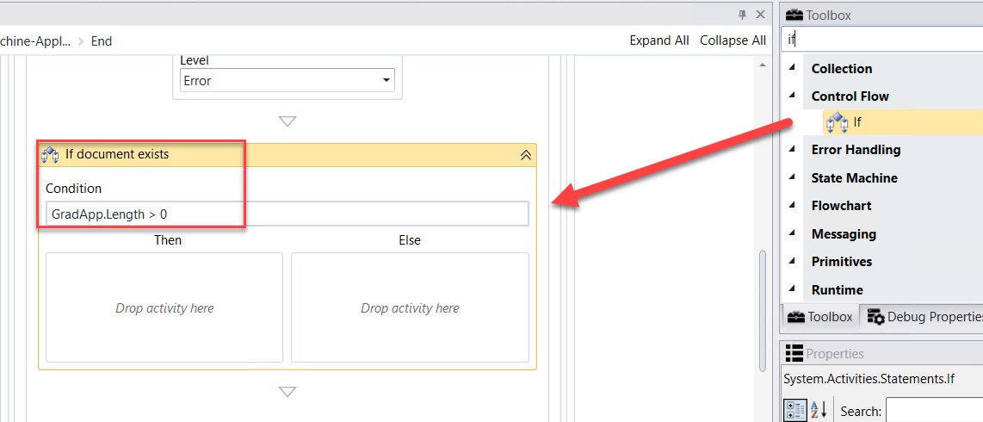

1. Create a ***variable:***

* Name: ***DocumentEntity***
* Variable type: ***DocumentEntity (You will need to browse for Cmc.Nexus.Crm.Contracts>Cmc.Nexus.Crm.Entities>DocumentEntity)***
* Scope: ***StateMachine-Application for Graduation***

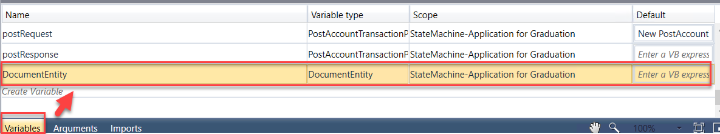

1. Drag a ***GetEntity*** activity in the ***Then*** portion of the ***If*** activity.

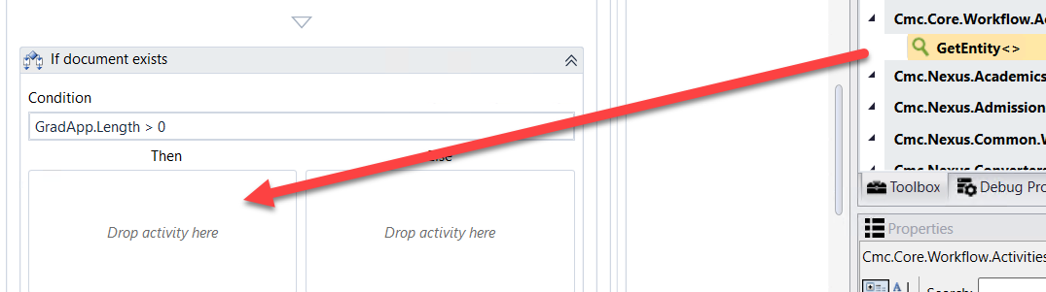

1. ***Browse for Type: Cmc.Nexus.Crm.Contracts>Cmc.Nexus.Crm.Entities>DocumentEntity and Click OK***

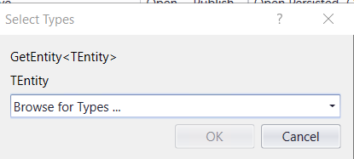

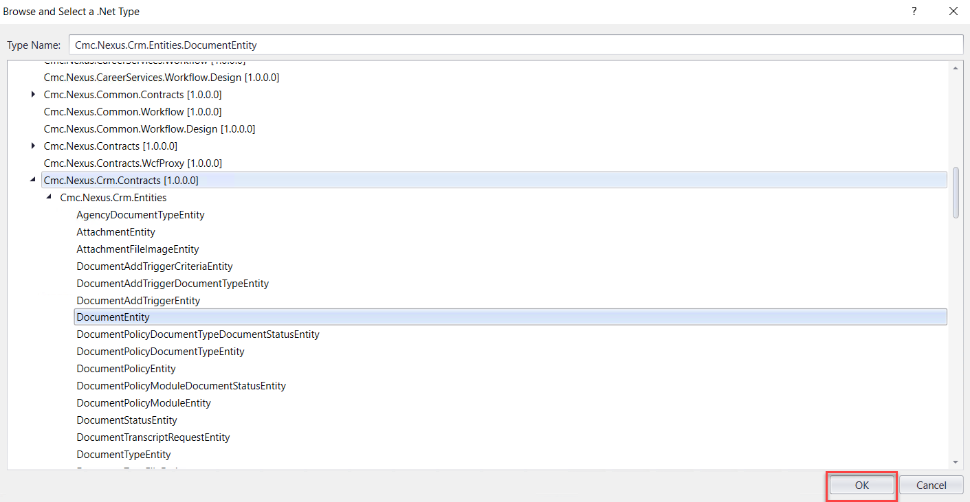

1. Complete the properties as shown below.

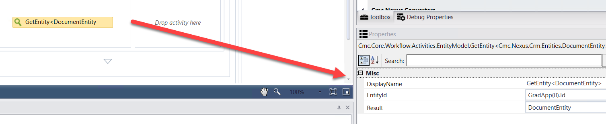

1. Drag the ***CreateDocument*** activity (Located under Cmc.Nexus.Crm.Workflow) into the ***Else*** portion of the ***If*** activity. Complete the activity as shown below.

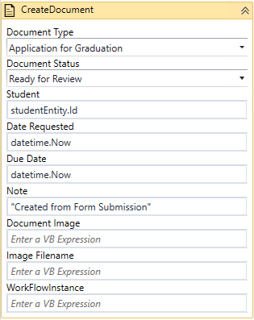

1. In the properties for the ***CreateDocument*** activity, enter ***DocumentEntity*** for the ***Document*** property.

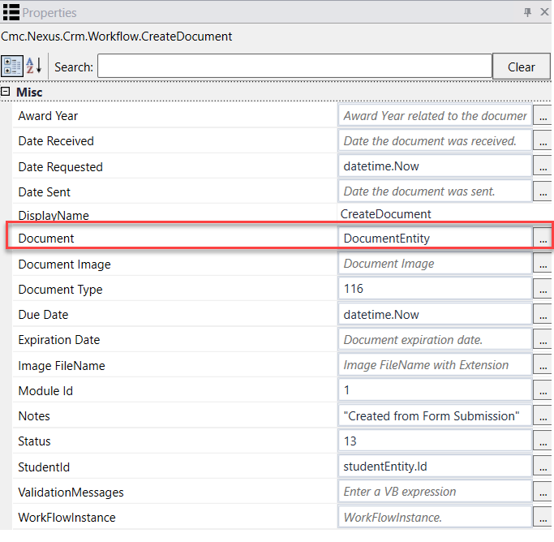

1. Drag a ***Sequence*** activity below the ***If*** activity. ***Rename*** the activity to: ***Assign Doc Values*.**

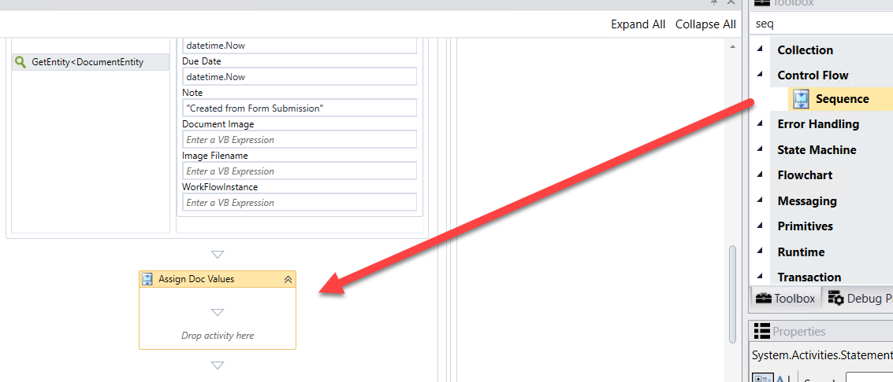

1. Drag ***7******Assign*** activities into the ***Sequence*.** Assign the following values:

* ***DocumentEntity.DocumentImage = SignedDocument.Content (Rename the activity to Assign Document Image)***
* ***DocumentEntity.OriginalFileName = “ApplicationforGraduation.Pdf” (Rename the activity to Assign File Name)***
* ***DocumentEntity.ImageType = “Pdf” (Rename the activity to Assign Image Type)***
* ***DocumentEntity.DocumentStatusId = 13 (Rename the activity to Assign Status)***
* ***DocumentEntity.ReceivedDate = datetime.now (Rename the activity to Assign Received Date)***
* ***DocumentEntity.ApprovedDate = datetime.now (Rename the activity to Assign Approved Date)***
* ***DocumentEntity.IsDocumentAddedManually = true (Rename the activity to Assign Doc Added)***

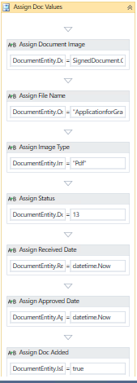

1. Drag the ***SaveDocument*** activity (Located under Cmc.Nexus.Crm.Workflow) below the ***Assign Values*** Sequence. Complete the properties for the activity as shown below:

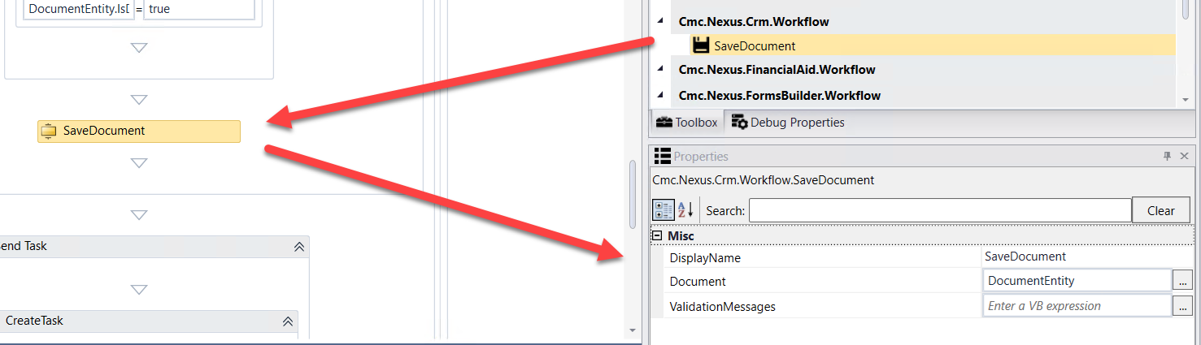

1. Create a ***variable:***

* Name: ***Task***
* Variable type: ***TaskEntity (You will need to browse for Cmc.Nexus.Crm.Contracts>Cmc.Nexus.Crm.Entities>TaskEntity)***
* Scope: ***StateMachine-Application for Graduation***

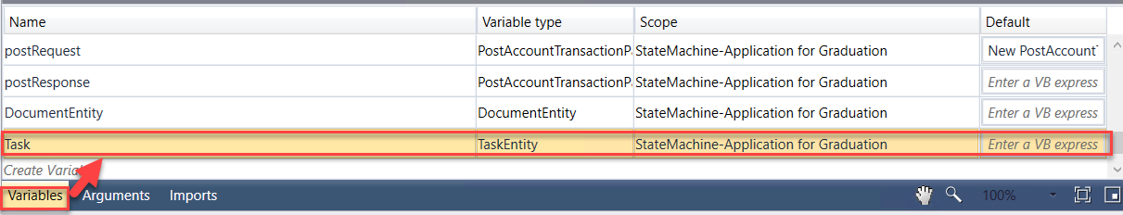

1. Drag the ***CreateTask*** activity (Located under Cmc.Nexus.Crm.Workflow) into the ***Send Task Sequence*** activity. Complete the activity as shown below.

***Note:*** Enter the following for the ***Subject:*** "The student: " + studentEntity.FirstName + " " + studentEntity.LastName + ", having a Student Number of: " + studentEntity.StudentNumber + ", " + "has submitted the Application for Graduation." + "Please review and process accordingly."

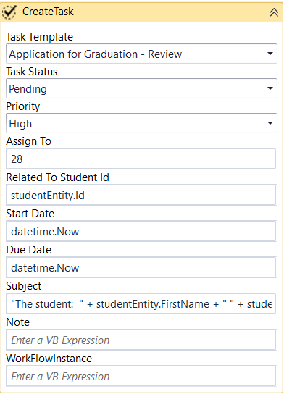

1. In the properties for the ***CreateTask*** activity, enter ***Task*** for the ***Task*** property.

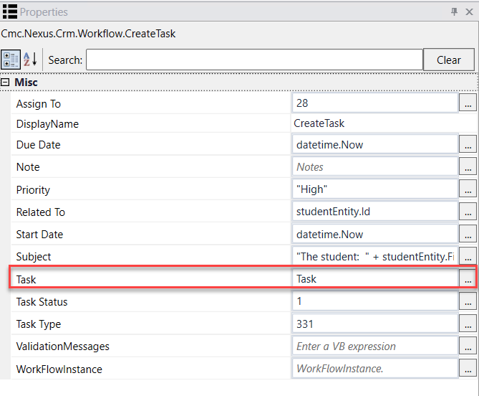

1. Drag the ***SaveTask*** activity (Located under Cmc.Nexus.Crm.Workflow) below the ***CreateTask*** activity. Complete the properties for the activity as shown below:

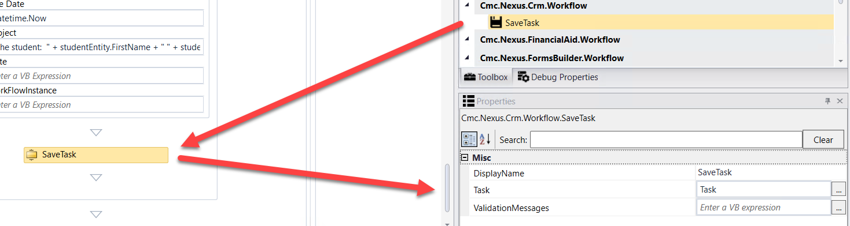

1. Confirm there are no Errors in the Error pane.

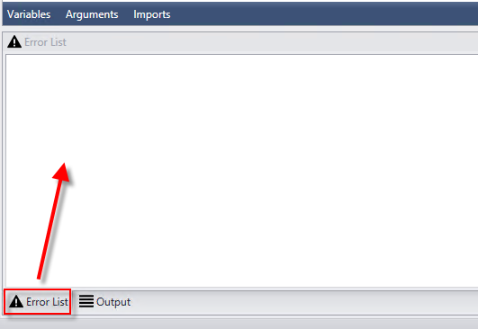

1. ***Save*** your Workflow to: ***C:\CampusNexus\Insight2019***

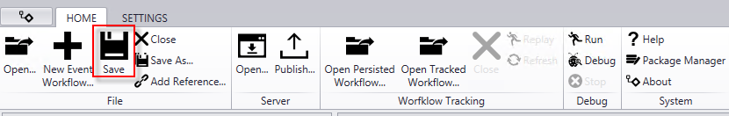

1. ***Publish*** your Workflow. Make sure you select ***Enable This Workflow Version?*** and select ***Publish*.** Select ***OK*** to the confirmation.

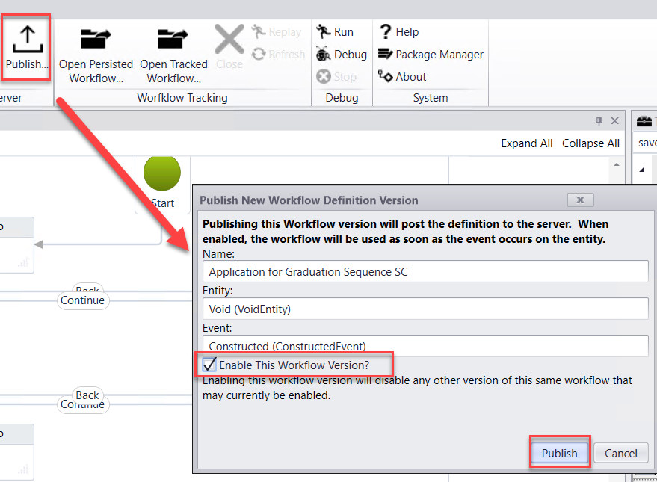

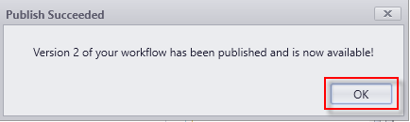

# Lesson 2: Validate the Form and Supporting Workflow

In this lesson, you will validate the Application for Graduation Process by logging in as a student and completing the Application for Graduation Form Sequence. You will then validate the student record in the CampusNexus Web Client to ensure the correlating data was updated and the Application for Graduation was received and the appropriate staff members notified. Also, validate that the charge and the payment for the Graduation Fee was posted to the ledger card for the student.

Process:

* The trigger for the Application for Graduation Process will be when a student is added to a Pending Grad group. In this process, the adding to the group will be manual. However, the advising team can run a report to gather their students that are in the last term and add them to the group that way or a WF can be setup to do this based on credits, etc., and even change the status for the student to Pending Grad.
* Once the student is added to the group, a WF is triggered and the Application for Graduation Document is added to the student's Document Center as Requested-Required. Also, the student is sent an email activity with a link to complete the Application for Graduation and pay the Graduation Fee.
* The student will access the Application for Graduation Form, pay the Graduation Fee and Electronically sign the application.
* The pdf of the Application is added to the document in the Document Center and the status is updated to Ready for Review. The charge and payment for the Grad Fee is posted to the Student's Ledger and the staff member is notified that the student has submitted the Application for Graduation form. Updates in the address folder occur to save the address where the student wants the diploma to be mailed. School Defined Fields are used to store Commencement Information such as gap and gown sizes, term, etc.
* The staff member will then review the form and any related records for the student to ensure and confirm graduation status. Once the Application for Graduation Document is approved and the status updated to On File by the staff member, a WF is triggered to send an email activity to the student on the completed process and the student is also removed from the Pending App group.

## Exercise: Validate the Student Self-Service Form and Supporting Workflow for Accepting an Online Payment

1. Navigate to ***Google Chrom*e** and launch ***Student*** from the ***Bookmarks Bar***.



1. ***Sign in*** using the following credentials:

***administrator***

***testing***

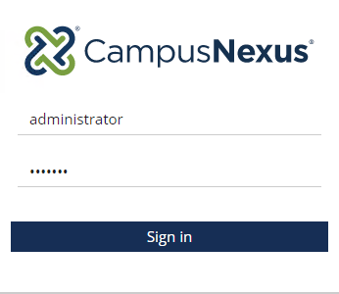

1. Select ***Students*.**



1. Search for student ***Jose Brown*** and click on the student link to open the student record.

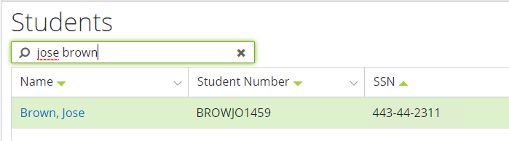

1. Update the student's email address with a valid email that can be checked (Enter a personal email).

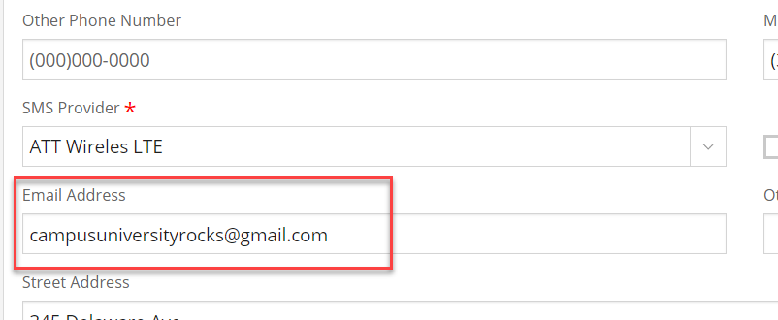

1. Navigate to ***Group Memberships*** under ***Contact Manager.***

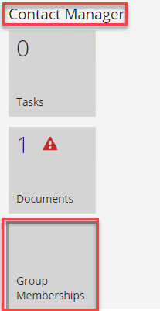

1. Add the student to the ***Pending Grad*** group.

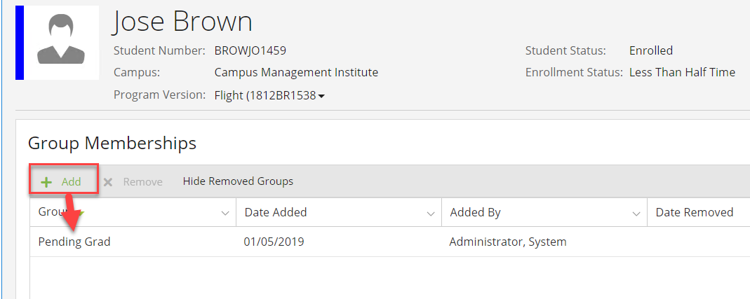

1. Navigate to ***Documents*** under ***Contact Manager*** and verify that the ***Application for Graduation*** was added to the student's Document Center.

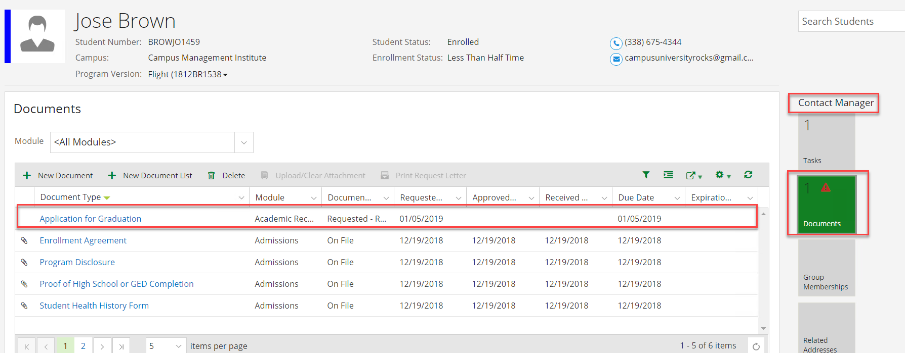

1. Navigate to ***Tasks*** under ***Contact Manager*** and verify that an ***email task*** for ***Application for Graduation*** was added for the student. You will need to change the ***Program Version to: All Program Versions.***

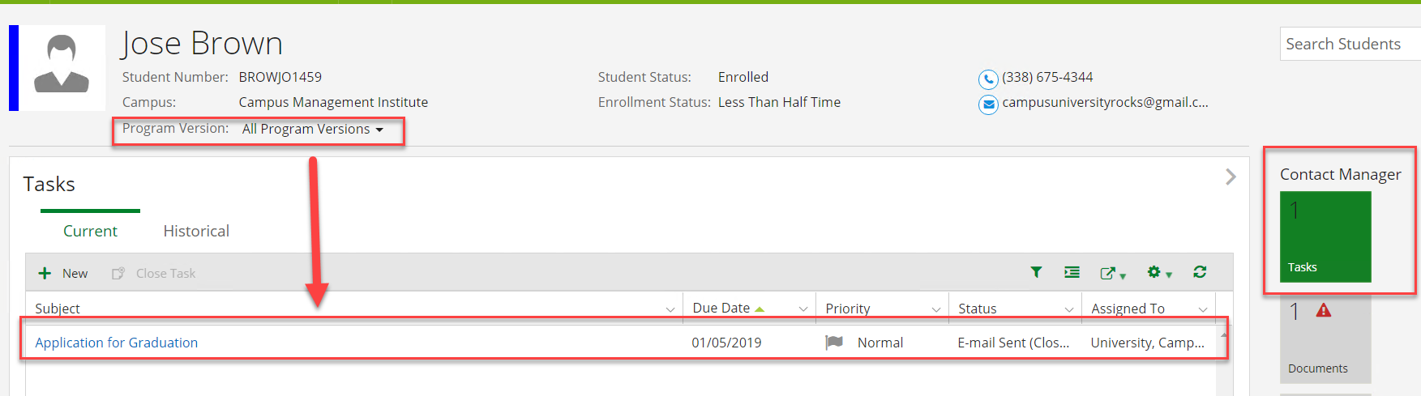

1. Check your email and verify the email to the student was received. Click on the link in the email to access the ***Application for Graduation Form Sequence.***

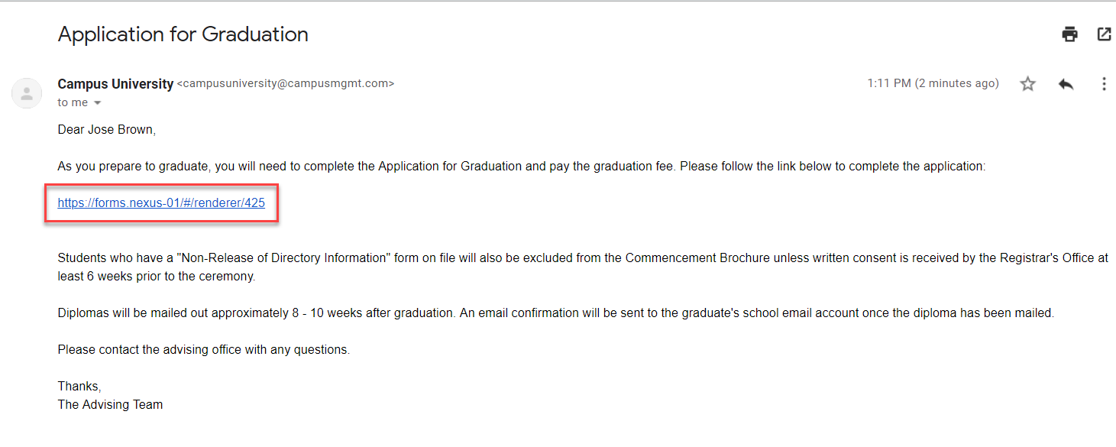

1. You will need to login as the student using:

* ***Username: jose.brown***
* ***Password: nexus123***

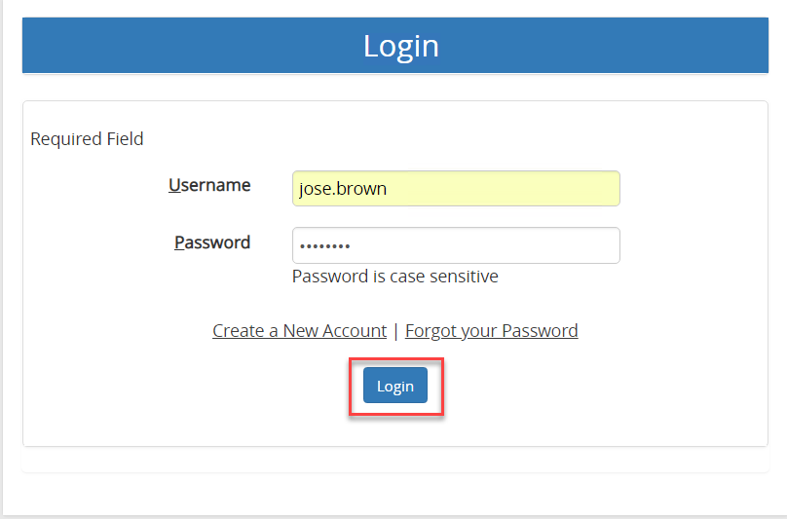

1. Complete the ***Application for Graduation*** as shown below:

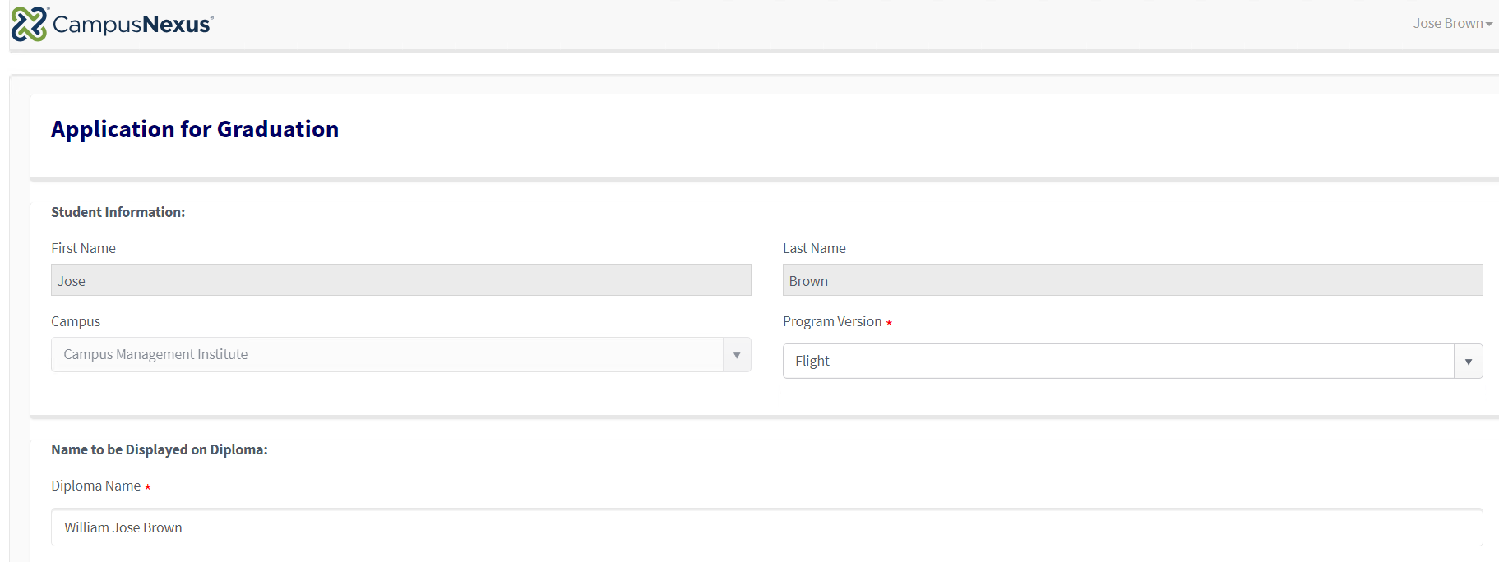

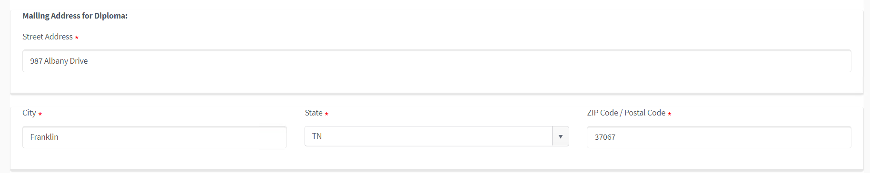

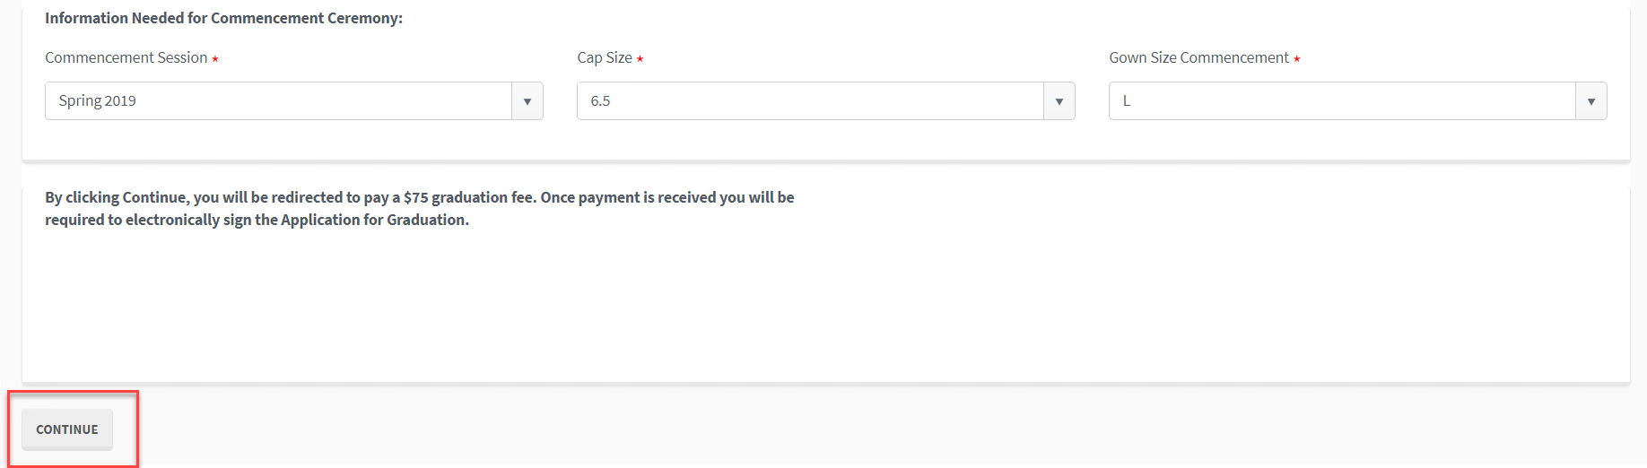

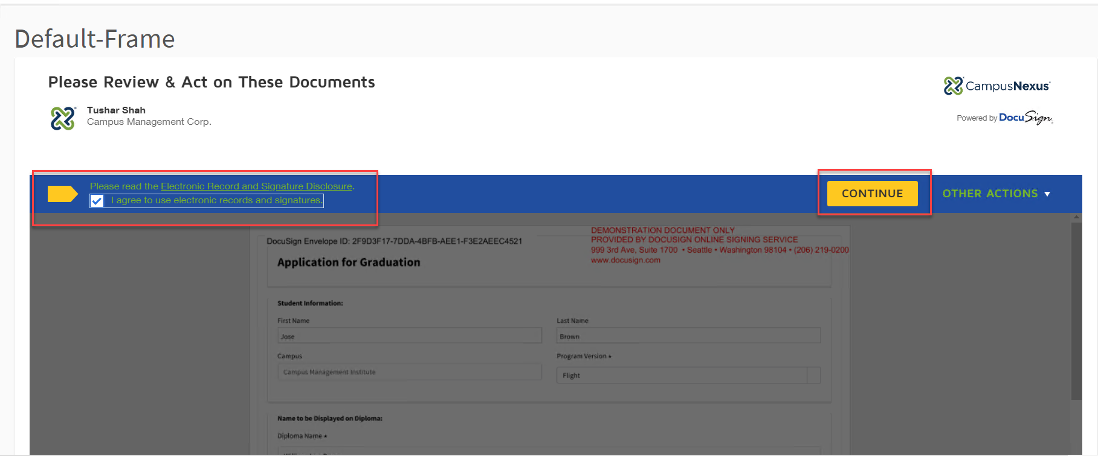

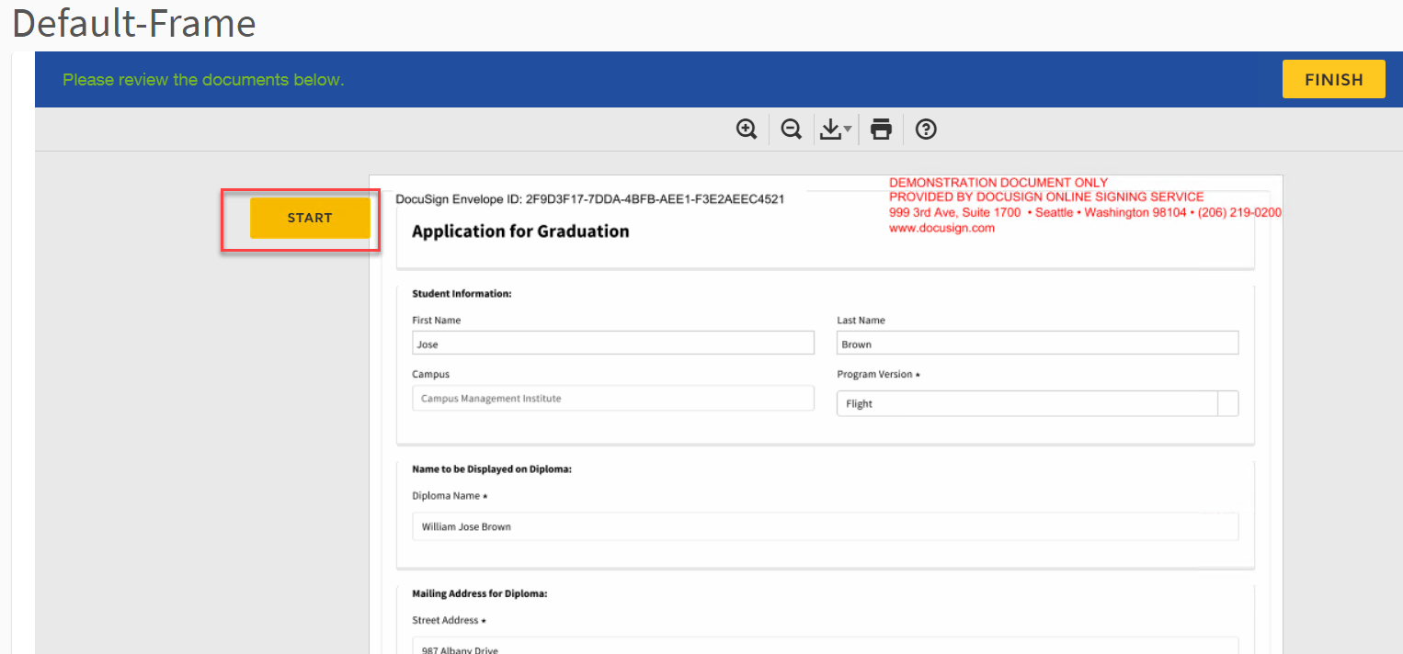

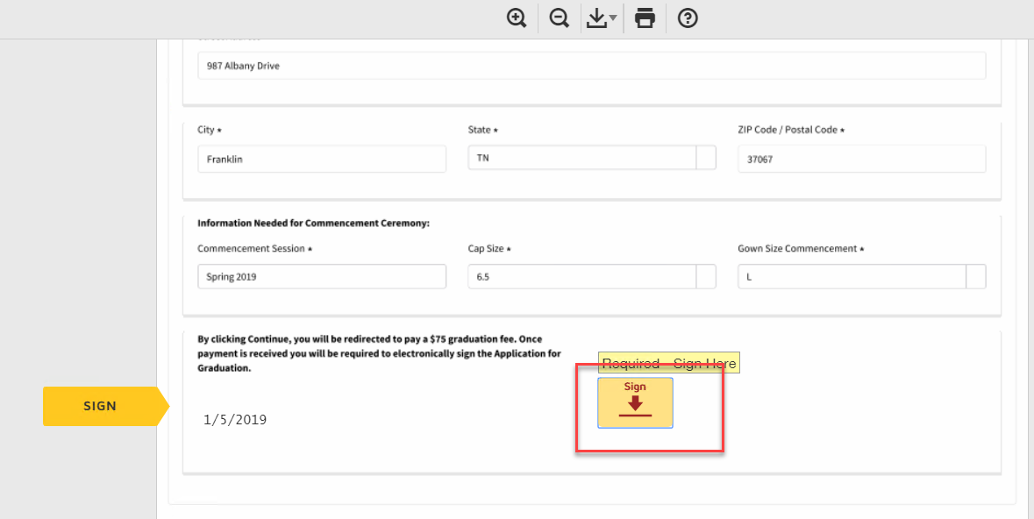

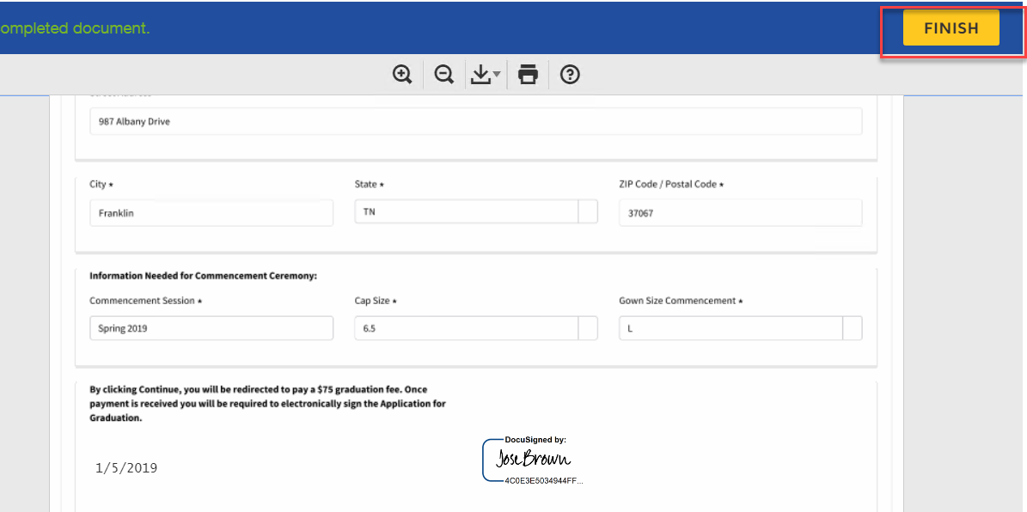

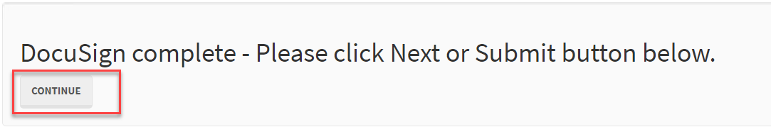

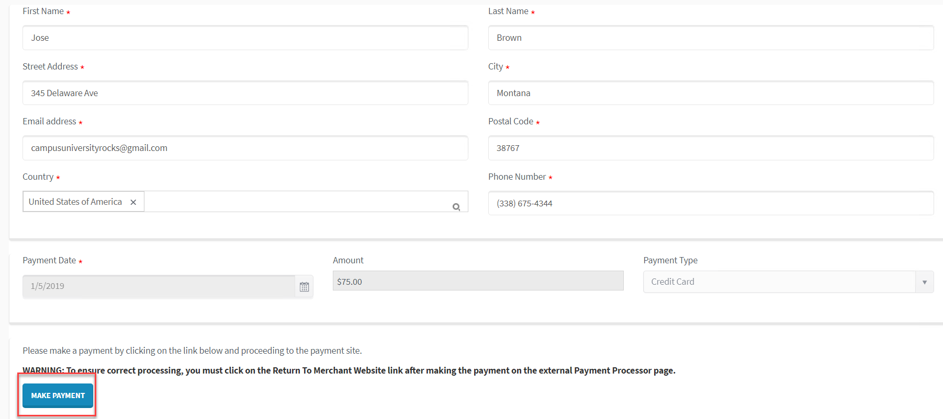

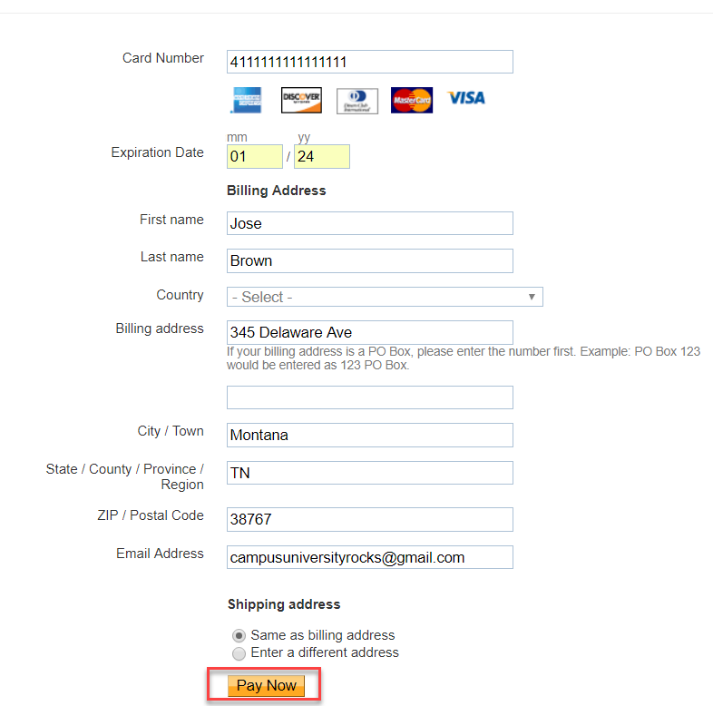

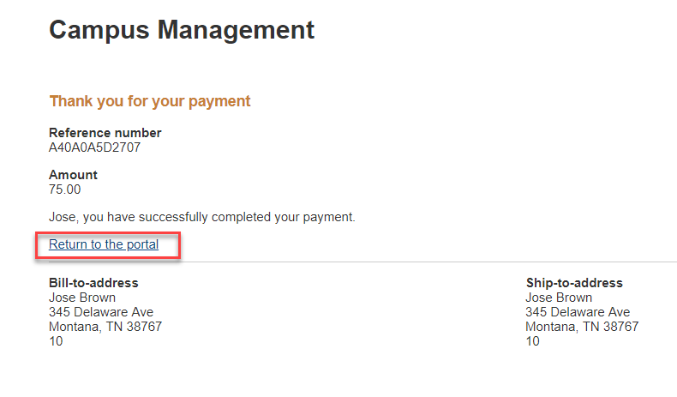

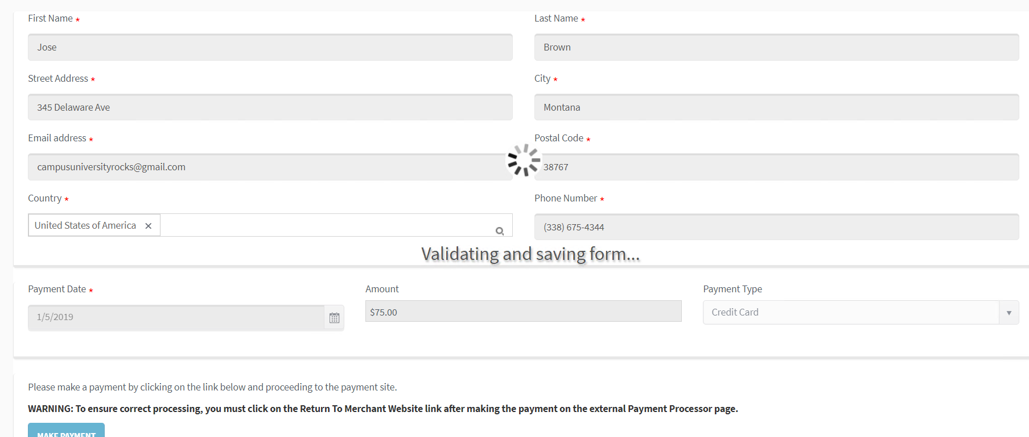

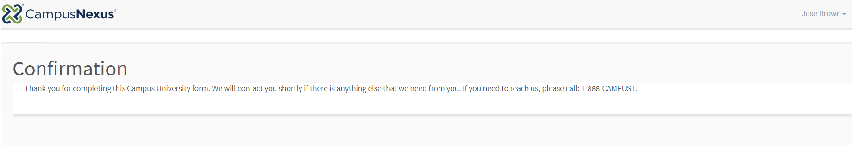

1. Navigate back to ***CampusNexus Student*** to ***Documents*** under ***Contact Manager.*** Verify the ***Application for Graduation*** document is ***Ready for Review*** and you can view the ***PDF.***

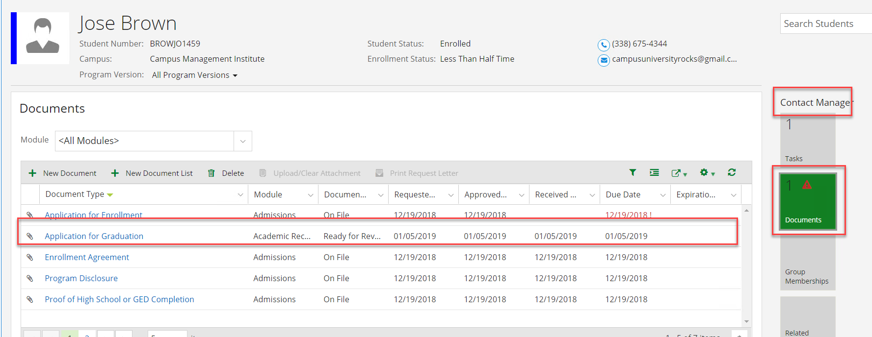

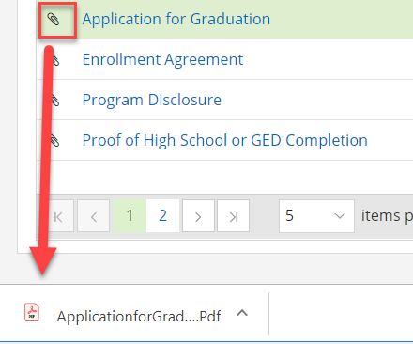

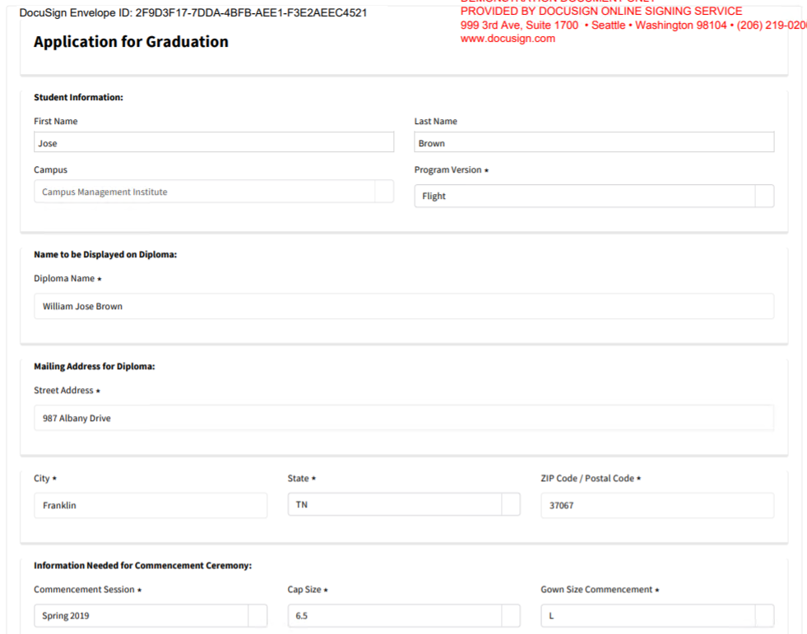

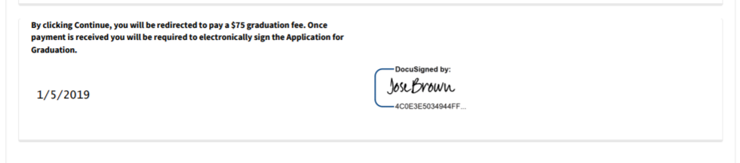

1. Navigate to ***Related Addresses*** under ***Contact Manager*** and verify that the address to mail the diploma was added.

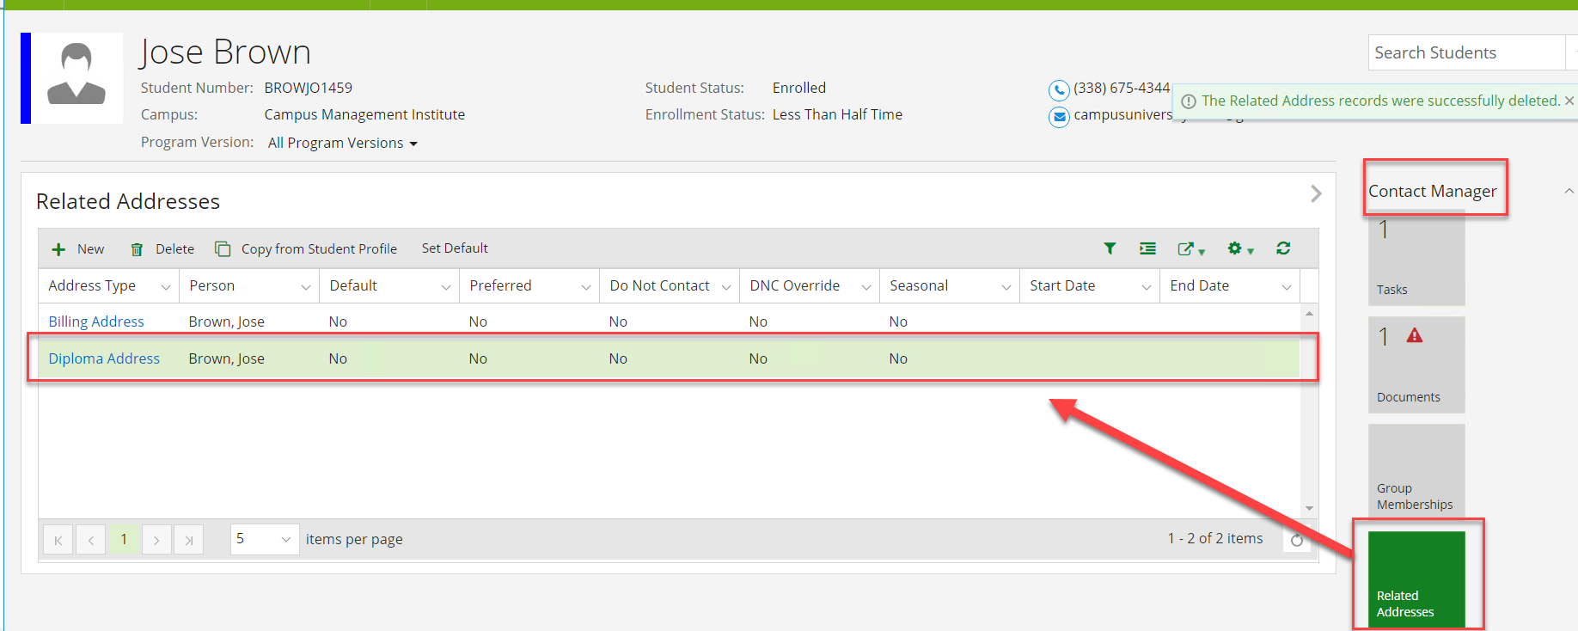

1. Navigate to ***School Fields*** under ***Academic Records*** and verify that the information needed for ***Commencement*** was updated.

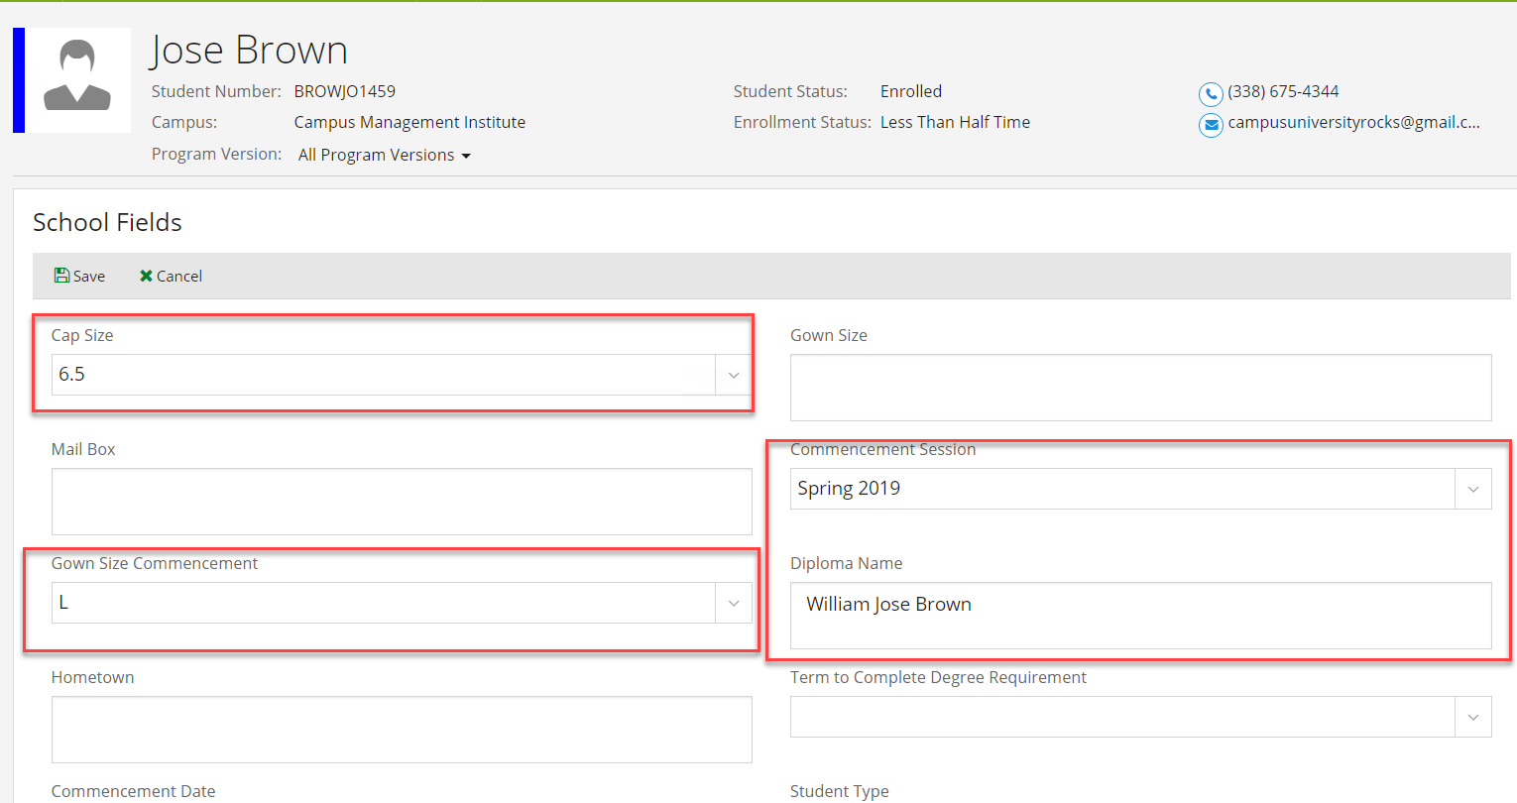

1. Navigate to ***Tasks*** under ***Contact Manager*** and verify the staff member received a task to review the student's information for Graduation. ***Close*** the task (Click on the ***Subject Link*** to edit the task).

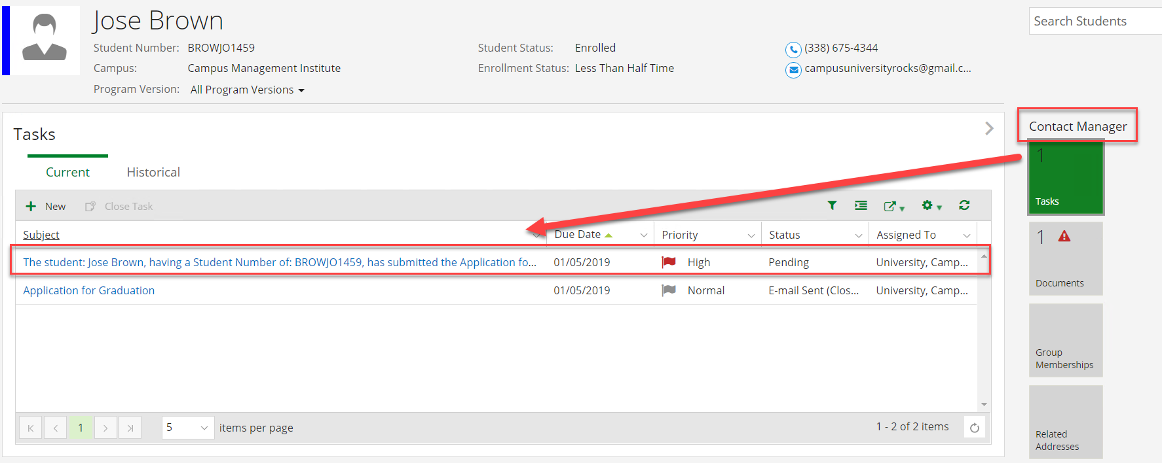

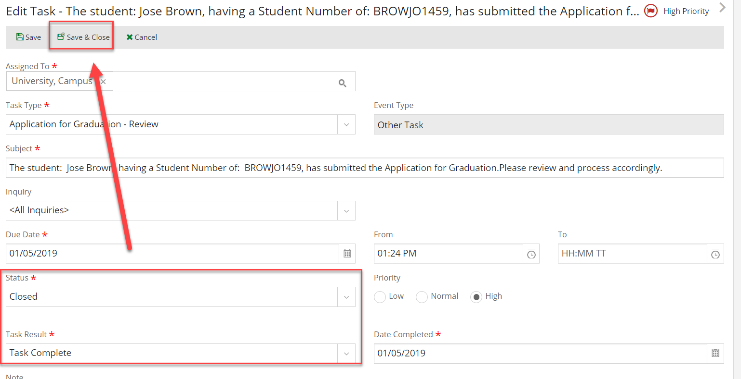

1. Navigate to ***Documents*** under ***Contact Manager*** and change the status of the ***Application for Graduation*** document to ***On File*** (Click on the link for the ***Document Type***).

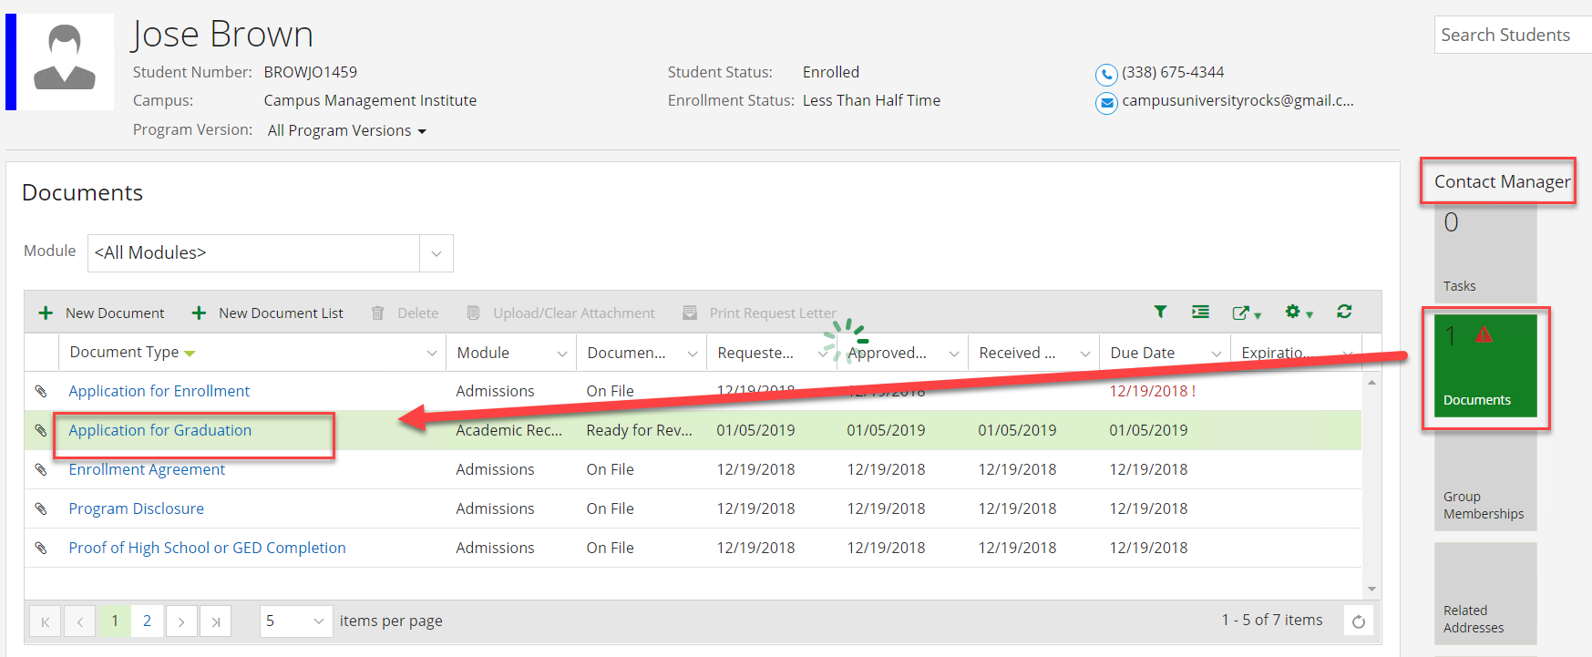

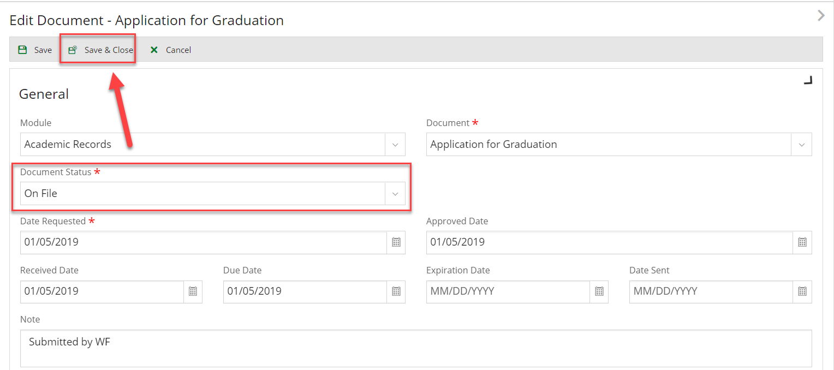

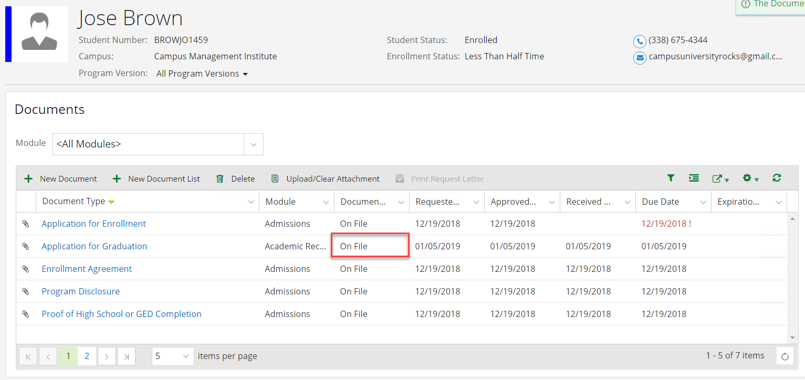

1. Navigate to ***Group Memberships*** under ***Contact Manager*** and verify that the student was removed from the ***Pending Grad*** group. Click on ***Hide Removed Groups*** and then click on ***Show Removed Groups.***

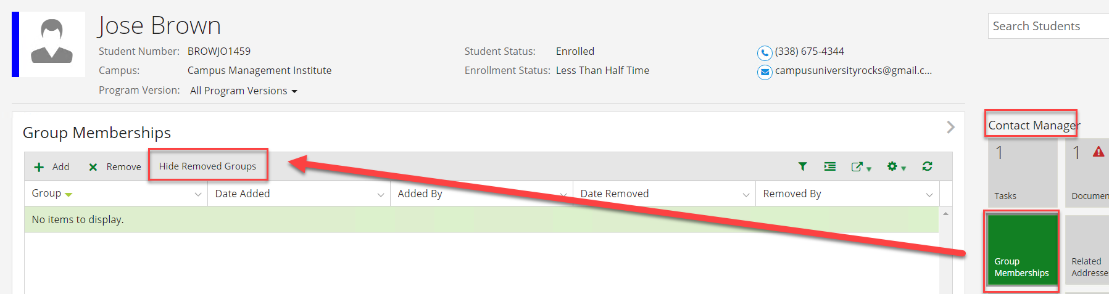

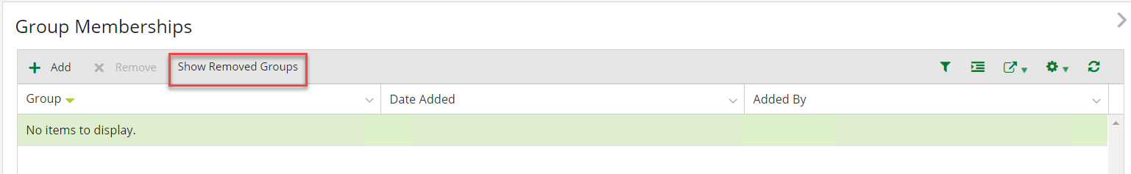

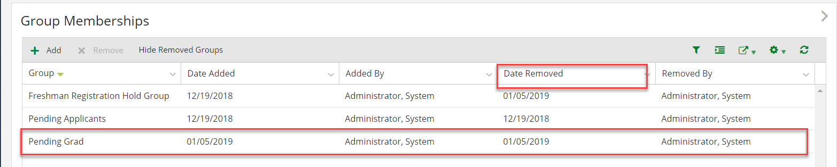

1. Navigate to ***Tasks*** under ***Contact Manager*** and verify that an email task was added for the student.

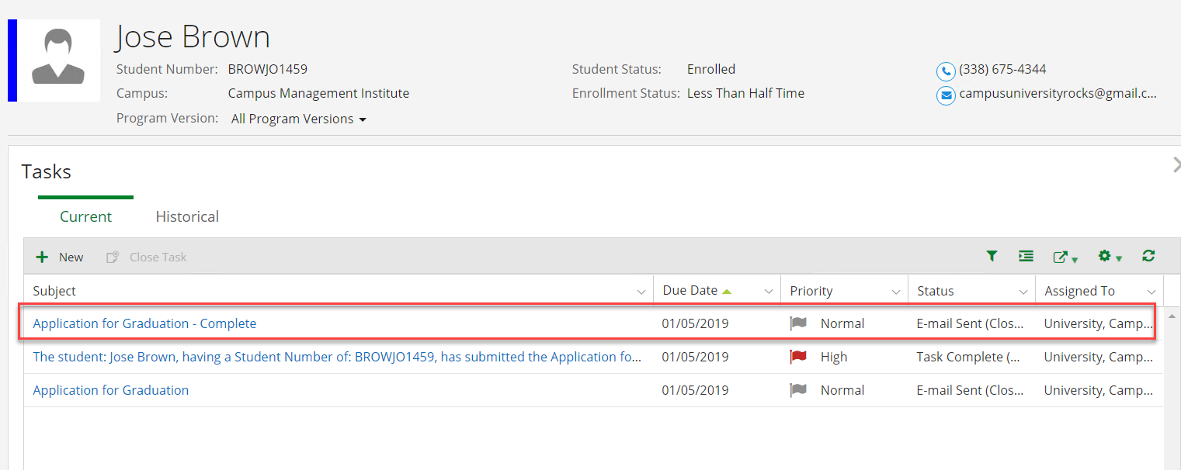

1. Check your email to verify the student received the email.

